National Strategic Plan to end TB

2017-2023

National Tuberculosis Control Programme
Department of Public Health
Ministry of Health
Bhutan

Table of Contents
Abbreviations 4
1. Executive summary 7
2. Country profile 9
3. Socio-economic profile 10
4. Principles of Gross National Happiness (GNH) 12
5. National Health System and Health Care Services 15
Organogram of Health 16
Human Resource for Health 18
Capacity building in TB control Error! Bookmark not defined.
6. TB problem in Bhutan 19
National Tuberculosis Control Program Error! Bookmark not defined.
Case notification and Case Detection 26
RR/MDR-TB cases notification 27
TB/HIV collaboration 28
Treatment outcomes 28
7. Joint Monitoring Mission of the TB control programme, 2016 31
8. The End TB Strategy 38
9. National Strategic Plan to end TB in Bhutan 42
Vision 42
Goal 42
Objectives Error! Bookmark not defined.
10. Strategies, Interventions and Activities Error! Bookmark not defined.

Abbreviations

AFB Acid-Fast Bacilli
AHB Annual Health Bulletin
AIDS Acquired Immunodeficiency Syndrome
ARTI Annual Risk of Tuberculosis Infection
ART Anti-retroviral Therapy
BHU Basic Health Unit
CAG Community Action Group
CPT Co-trimoxazole Preventive Therapy
DHO District Health Officer
DOT Directly Observed Treatment
DOTS Directly Observed Treatment Short-course
DRS Drug Resistance Survey
DST Drug Susceptibility Testing
DVED Drugs, Vaccines and Equipment Division
EMTD Essential Medicines and Technology Division
EPTB Extra-Pulmonary Tuberculosis
EQAS External Quality Assurance Scheme
FDC Fixed-Dose Combination
FYP Five Year Plan
GDF Global (TB) Drug Facility
GDP Gross Domestic Product
GNH Gross National Happiness
GNM General Nurse Midwifery
HIV Human Immunodeficiency Virus
HRD Human Resource Development/Division
ICB Information and Communication Bureau/ Health Promotion Division
IEC Information, Education and Communication
INH Isoniazid
IPT Isoniazid Preventive Therapy
ISTC International Standards for Tuberculosis Care
JDWNRH Jigme Dorji Wangchuk National Referral Hospital
LPA Line Probe Assay
MCH Mother and Child Health
MDG Millennium Development Goal
MDR-TB Multi-Drug-Resistant Tuberculosis
MO Medical Officer
MOH Ministry of Health
MSTF Multi Sectoral Task Force
NACP National AIDS Control Programme
NEQAS National External Quality Assurance Scheme
NFE Non-Formal Education
NGO Non-Governmental Organization
NSB National Statistical Bureau
NSP New smear Positive Tuberculosis
NTCP National Tuberculosis Control Programme
NTRL National TB Reference Laboratory
PHCB Population and Housing Census of Bhutan
PHL Public Health Laboratory
PLWHA People living with HIV/AIDS
PPE Personal Protection Equipment
rGLC regional Green Light Committee
RGOB Royal Government of Bhutan
RRH Regional Referral Hospital
SRL Supranational Reference Laboratory
TB Tuberculosis
TWG Technical Working Group
VCT Voluntary Counselling and Testing
VHW Village Health Worker
WHO World Health Organization
XDR-TB Extensively Drug-Resistant Tuberculosis

Executive summary
Tuberculosis is one of the major public health problems in Bhutan which existed more than three decades and is still prevalent today among the general population. Since the introduction of DOTS program in 1994 and 100% coverage by DOTS in 1997 the programme has performed well and established a strong network of diagnostic and treatment centres across the country. The Royal Government of Bhutan and the Ministry of Health is fully committed to TB control which is one of the priority diseases in the National Health Plan of the 11th five year plan (2013-18) where TB treatment success rate is among one of the ‘key performance indicators’. The government has endorsed the UN Sustainable Development Goals (SDGs) related to TB, as incorporated in the WHO End TB Strategy and reflected in the targets. For TB control, all staffs (TB In-charges) are fully or partially involved in delivery of TB care and services that are employed by the government. The diagnosis, management and treatment of TB patients are made in all the government run hospitals and BHUs and the entire salary of the staff is met from the government annual budget. The major challenge for the National TB Control Programme (NTCP) is to secure financial resources for programme related capital and recurrent expenditure for sustained and improved TB control activities.
The interventions described in this National TB Strategic Plan of 2017-2023 are built upon the achievements made by the NTCP in the past 5 years. The National Strategic Plan to end TB has been developed in line with the principles of the End TB Strategy and National Health Plan (2013-2018) that include government stewardship and accountability through intensive monitoring and evaluation; strong coalition with civil society organizations and communities; protection and promotion of human rights, ethics, and equity; and global collaboration.
The National Strategic Plan for NTCP is developed with technical support from WHO. Series of consultations were held with different units and reviewed by the TB technical working group of the Ministry of Health, Bhutan. The Plan takes into account the recommendations of the Joint Monitoring Mission (JMM) held in June 2016 and the needs for the strengthening delivery of services reaching towards the unreached populations with high quality service for a sustainable and equitable health care delivery in line with the 11th FiveYear Plan (FYP) document. At the end of the six year implementation of the National Strategic Plan by 2023, it is expected that Bhutan will be on target to achieve the End TB Strategy milestones of 35% reduction in absolute number of TB deaths, 20% reduction in TB incidence and zero catastrophic costs to TB patients. It is also expected that the proportion of drug-resistant (DR-TB) cases among bacteriologically confirmed TB patients will drastically be reduced.
A total budget of around US $ 6.3 million is envisaged for implementing the strategy. The Royal Government of Bhutan and the Global Fund (GF) have so far been the main contributors to the TB control programme. The NTCP is exploring various funding sources to address the gap.

Country profile
Bhutan is a small mountainous landlocked (China in the north and India in the south) country with an estimated population of 757,042. With an area of approximately 38,394 sq.kms, Bhutan is administratively divided into three regions (Western, Central and Eastern), 20 Dzongkhags (districts) and 205 Gewogs (blocks). Each block is headed by an elected leader called ‘Gup’ and has a population of 2000-4000 people.
The country has one of the most formidable mountains, the Himalayas ranging from 100 meters above in the south to 7, 500 meters in the vastly uninhabited and dizzy heights of extreme cold of the north. About 72 % of the land area is covered by forests of temperate and sub-tropical species that form a natural habitat to a diversity of flora and fauna.
Bhutan is one of the ten global biodiversity ‘hotspots’ in the world having 3,281 plants species per 10,000 square kilometres.With almost 69 percent of the people living in rural areas, Bhutan is primarily an agricultural economy. More dynamic sectors such as electricity production, construction and tourism to a limited extent now contribute to Bhutan’s healthy economic growth of more than 6 percent per year.
Modern economic development is largely limited to the public sector as Bhutan’s private sectoris relatively underdeveloped. However, with a rapidly growing educated workforce, private sector development is becoming a compelling necessity. Bhutan has developed high environmental protection standards and actively protects its rich culture and traditions. The kingdom became a Parliamentary Democracy in March 2008 upon the command of His Majesty the Fourth King.

Socio-economic profile

The Kingdom of Bhutan is a landlocked country that banks on the generation of hydropower to boost its economy. Hydropower contributes about a fifth of the gross domestic product. Bhutan has achieved exceptional economic growth over the past 3 decades. Significant achievements in social development have also been made in recent years, with the number of poor approximately halved between 2007 and 2012.
Despite notable socio-economic progress, the challenge remains for Bhutan to expand its economic base and make its growth more inclusive, especially for unemployed youth and women.
SL | INDICATOR | DATA  VALUE | SOURCE | YEAR
1 | Mean Monthly Household Consumption | Nu.18,367 | Bhutan Living Standards Survey 2012 | 2012
2 | Mean Monthly House Rent Paid by Households | Nu.3,313 | Bhutan Living Standards Survey 2012 | 2012
3 | Prevalence of Disability among Children 2-9 years | 21.30% | Second Stage Disability Assessment 2011 | 2011
4 | Population using Solid Fuel | 28.60% | Bhutan Living Standards Survey 2012 | 2012
5 | Population Access to Improved Sanitation | 81.00% | Bhutan Living Standards Survey 2012 | 2012
6 | Household with TV Connection | 55.30% | Bhutan Living Standards Survey 2012 | 2012
7 | Secondary School Completion Rate | 74.20% | Bhutan Living Standards Survey 2012 | 2012
8 | Youth Literacy Rate | 86.10% | Bhutan Living Standards Survey 2012 | 2012
9 | General Literacy Rate | 63.00% | Bhutan Living Standards Survey 2012 | 2012
10 | Population Poverty Rate | 12.00% | Bhutan Living Standards Survey 2012 | 2012
11 | GDP real Growth rate | 6.49% | National Accounts Statistics | 2015
12 | GDP per Capita | US$ 2,719 | National Accounts Statistics | 2015
Table 1: Key socio-economic indicators

Policy Framework - Principles of Gross National Happiness (GNH), Five Year Plans for Health Sector
The principle of Gross National Happiness (GNH) guides Bhutan’s unique approach towards development and has four main pillars: good governance, preservation and promotion of cultural values, equitable and sustainable socio-economic development and conservation of the natural environment. The principle emphasizes the need to find an appropriate balance between material, spiritual, emotional and cultural well-being. The policies and programs that are developed in Bhutan are generally in line with the values of GNH, with number of screening tools to ensure the values are embedded in social policy.
Bhutan 2020: A Vision for Peace, Prosperity and Happiness translates the notion of GNH into a series of national objectives or precepts that guide policy-making and are central to all government programmes. The policy document is the basis for the formulation and implementation of successive Five Year Plans.
The eleventh FYP (2013-2018) titled “self reliance and inclusive green socio-economic development” is based on achieving the MDGs and the long term goals articulated in the Vision 2020 document including GNH, and it has adopted poverty reduction as the overarching theme under the National Key result area of “Poverty + reduced/MDG+ achieved”. The Health sector strategies for the Programme emphasizes ensuring the quality of health services, development of human and institutional capacity, decentralization, sustainability and uniformity of health services.
To achieve Universal Health Coverage is one of the goals of the SDGs, which is critical for the achievement of all other targets. The overarching goal of the 11th Five Year Plan is to achieve “Universal health coverage by focusing on providing improved and equitable access to quality health care services." This goal is well supported by the primary health care approach practiced in Bhutan.
In SDG, health is the focus of goal 3: Ensure healthy lives and promote well-being for all at all ages. However, there are other goals and targets related to health.

The broad objectives of the Health Sector in the eleventh Five Year Plan are to:
- Improve access to quality and equitable health services
- Strengthen preventive, promotive and rehabilitative health services
- Promote efficiency and effectiveness in financing and delivery of health services
- Achieve the Millennium Development Goals and Sustainable Development Goals beyond the set targets

HIV/AIDS and Tuberculosis have been identified as important interventions under communicable diseases framework and are being addressed through various strategic initiatives over the plan period. Accordingly, the programme outcome and output as outlined in the 11th FYP are as follows:
- Outcome: Morbidity & mortality due to communicable diseases reduced
- Output: Improved TB case detection and management;
- Activities: Various activities planned under communicable and non-communicable diseases which has direct or indirect affect for the control of Tuberculosis.

There has been remarkable progress towards achievement of MDGs, on the whole, including, poverty reduction, education improvements and increased access to safe drinking water.
Globally, the three health goals and targets have done considerably well. The HIV, tuberculosis and malaria epidemics were “turned around”, child mortality and maternal mortality decreased significantly (53% and 44%, respectively, since 1990), despite falling short of the MDG targets. However, progress has been uneven, and substantial inequalities remain within and across countries.

In Bhutan, Most of the health related indicators have achieved the target as shown in the table below:
MDG indicators
 | Baseline 1994 | Target 2015 | Status 2015
Under-Fiver Mortality Rate (per 1000 live births) | 123 | Reduce UFMR by two- third (41) | 37.3
Infant Mortality Rate (per 1000 live births) | 90 | Reduce IMR by two- third (30) | 30.0
Proportion of Children covered under immunization programme | 84% | Sustaining Immunization Coverage level to above 95% | 97.2
Maternal Mortality Ratio (per 100,000 live births) | 560 | Reduce MMR by 3 quarters (140) | 86.0
Births attended by skilled health personnel | 15% | Increase to 100% | 74.6
Contraception prevalence rate | 18.8% | Achieve 60% by 2012 (national target) | 65.6
HIV cases detected | 0 | Halt and begin to reverse the spread | 432
Number of malaria cases and incidences (cases per 100,000) | 22126 (1991) | -do- | 6.1
Number of TB cases and incidences (cases per 100,000) | 4232 | -do- | 225
Proportion of population without sustainable access to an improved water source | 55% | Reduce proportion of population without sustainable access to an improved water source to halve | 2.3
Proportion of population without sustainable access to an improved sanitation | 33% | Reduce proportion of population without sustainable access to an improved sanitation to halve | 33.7 (Definition of ‘improved sanitation’ broadened)

National Health System and Health Care Services
Health care services in Bhutan are provided free of cost throughout the country ensuring district-specific and regional balance in coverage in line with universal access principle. The Government is committed to implementation of pro-poor policies, which is supported by data on Primary Health Care coverage for more than 90% of the population, through Basic Health Units in distant areas and regular outreach clinics. The health services are provided through a four tiered network. The network constitutes the National Referral Hospital (also Regional for Western region), 2 Regional Referral Hospitals in Mongar and Gelephu, 27 district hospitals, 23 BHU I, 184 BHU II, 28 sub-post, 1 Indigenous hospital, 54 indigenous units and 562 Out Reach Clinics supported by BHU staffs and Village Health Workers at the community level. The management and delivery of TB control services are integrated into the general health system.
The national and regional referral hospital provides specialized tertiary care services. The next level consists of district level hospitals manned by medical officers with X-ray and laboratory facilities. The district hospitals are the health care service management units in the district and also for the TB care and control services. The next lower level consists of 207 Basic Health Units which are either graded as BHU I and II. All district level hospital and BHU I provide secondary level health care services. The BHUs are the primary level of health care facilities providing primary health care services and are manned by three health workers. At the community level, Village Health workers (VHWs) take care of around 20 households and they provide services entirely on voluntary basis. The BHU staffs provide monthly Out Reach Clinics (ORCs) to the most remote area providing preventive and minor curative services to the community at regular intervals. TB diagnostic and treatment services are provided through 27 hospitals including district and referral hospitals and 5 grade I BHUs. All BHU II are also involved in screening and referral of presumptive TB cases, follow up, default and contact tracing and provision of DOT. The private sector is limited to only few laboratory and diagnostic facilities in Thimphu, Phuentsholing and Samdrupjongkhar. There are no NGOs working for TB care and control in the country. The involvement of community systems and village health workers for TB care and services is inadequate.

Organogram of Health
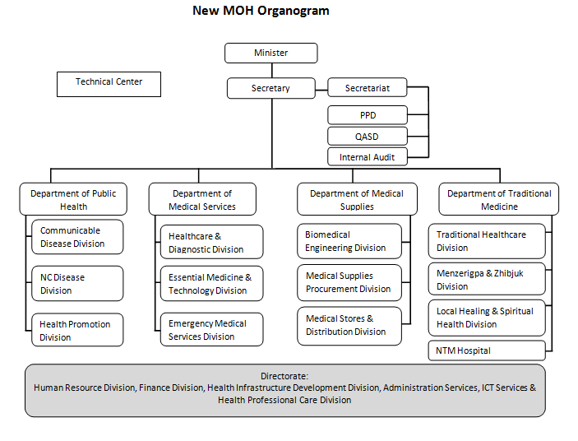
Figure 1: Organogram of Ministry of Health
Source: http://www.health.gov.bt/about/organogram/

Organogram of Department of Public Health-CDD

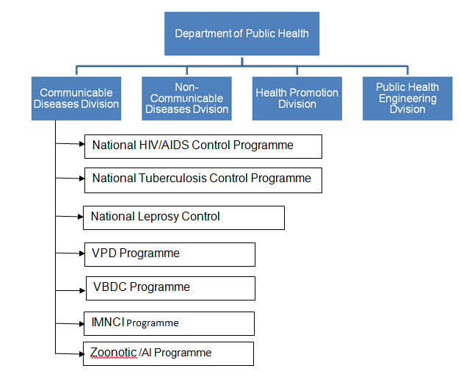
Figure 2: Organogram of Department of Public Health & CDD

Human Resource for Health

It is a known fact that health interventions cannot be carried out without health workers. Developing a competent, motivated, and supported health workforce is therefore essential for overcoming obstacles to achieving national and global health goals. The Human Resources Division in the Ministry of Health is responsible for human resource mapping, projection and planning. The Khesar Gyalpo University of Medical Sciences of Bhutan is primarily mandated for providing pre-service and in-service training programmes. Inadequate skills mixed, distributional imbalances, unfiled vacancies and poor working conditions compounds the problem of Human Resource for health. Total staff strength in the Ministry of Health is as given below:
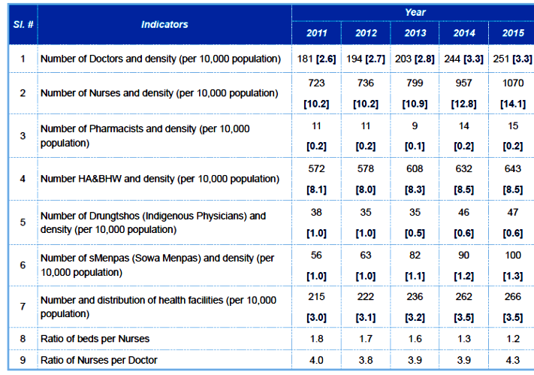Table 2: National Health workforce (2011-2015)

Health Indicators

Sl No | Indicators | Year -2015 | Source
1 | Crude birth rate (CBR) [births per 1000 population] | 17.90 | AHB, 2016
2 | Total Fertility Rate (TFR) [children per woman] | 2.30 | AHB, 2016
3 | General fertility rate (GFR) [births per 1000 women 15-49 years] | 72.00 | AHB, 2016
4 | Crude death rate (CDR) [deaths per 1000 population] | 6.20 | AHB, 2016
5 | Sex ratio of the population [males per 100 females] | 96.00 | AHB, 2016
6 | Proportion of population using an improved drinking water source (%) | 97.70 | AHB, 2016
7 | Proportion of population using an improved sanitation facility (%) | 66.3+ | AHB, 2016
8 | Infant Mortality rate (per 1,000 live births) | 30.00 | AHB, 2016
9 | Under 5 Mortality rate (per 1,000 live births) | 37.03 | AHB, 2016
10 | Proportion of births attended by skilled health personnel (%) | 74.60 | AHB, 2016
11 | Maternal mortality ratio (deaths per 100,000 live births) | 86.00 | AHB, 2016
12 | HIV prevalence among population adult 15-19 years (%) | <0.1 | AHB, 2016
13 | Malaria incidence (per 10,000 population at risk) | 2.00 | AHB, 2016
14 | TB Prevalence rate per 100000 population | 190.00 | Annual TB Report, 2016, SEAR
15 | TB incidence rate per 100000 population | 164.00 | Annual TB Report, 2016, SEAR
16 | Alcohol Liver Diseases incidence (per 10,000 population) | 41.00 | AHB, 2016
17 | Diabetes incidence (per 10,000 population) | 164.00 | AHB, 2016
18 | Pneumonia incidence (per 10,000 under 5 children) | 905.00 | AHB, 2016

Table 3: Selected Health Indicators

National Tuberculosis Control Programme
The National TB Control Programme (NTCP) was initiated in 1976. After a pilot testing of short course chemotherapy (SCC) in 1988, SCC was implemented nationwide in 1994. This was followed by a nationwide introduction of DOTS in 1997. The DOTS Strategy evolved into the Stop TB Strategy and in 2016 WHO has transitioned to a more inclusive and comprehensive End TB strategy. Bhutan has adapted the End TB strategy which is reflected in the updated guidelines and the national strategic plan. The three pillars of the strategy include:
- Integrated, patient-centred care and prevention;
- Bold policies and supportive systems and
- Intensified research and innovation.
The strategy is based on principles of government stewardship and accountability, with monitoring and evaluation; strong coalition with civil society organizations and community; protection and promotion of human rights, ethics, and equity; and adaptation of the strategy and targets at the country level, with global collaboration.
The services for TB care and control are available free of cost for all the citizens of the country without any bias against gender, religion, groups or classes. As per the five year plan development guidelines, all sectors and agencies are required to mainstream gender into their plans, policies and programmes through sectoral gender analysis which is operationalized through the network of Gender Focal Persons who are responsible mainstreaming gender in their sectors and also carrying out awareness and sensitization programmes on gender in their respective sectors.
The services for diagnosis, treatment and care are made available and provided free of cost to migrants and other vulnerable groups as well. Regular awareness programs with health workers, communities, involvement of multi-sectoral task force, and religious groups has increased awareness and accessibility to TB care and services for all, and have helped in reducing associated stigma and discrimination.
The National TB Reference Laboratory (NTRL) under Royal Centre for Disease Control (RCDC) based in Serbithang, Thimphu is responsible for monitoring and maintaining quality diagnostic services. It is supervised and assessed by the Regional Supra National Reference Laboratory (SNRL) in Bangkok, Thailand, and provides facility for culture and Drug sensitivity testing services for diagnosis of Multi-Drug Resistant TB (MDR-TB) cases.
The NTCP at the central level is responsible for policy formulation, planning and budgeting, implementation and management of planned activities, coordination with partners within the ministry and other agencies; resource mobilization with funding/donor agencies, human resources development and capacity building for TB control, coordination with national and international agencies for improving the technical capacity in country to undertake TB related laboratory services including quality assurance; coordination with DoMSHI and HCDD for procurement of anti-TB drugs and other supplies; develop research agenda and coordination with academic institutes for undertaking operational research on priority areas of TB and MDR-TB; monitoring and supervising of TB care and control services and providing regular feedbacks to the reporting centers.
District Level: At the district level TB control activities are carried out by a team comprising of CMOs/Medical Superintendents/MOs/TB in-charges/Laboratory staffs and district health officers. Each district has a TB-in-charge coordinating all TB care and control services under the supervision of the Medical Officer and the District Health Officer. They are responsible for screening, case finding and diagnosis of TB, providing treatment to patients, contacting treatment interrupters, follow-up, reporting of outcomes, and compiling quarterly and annual TB reports for their districts. There are total of 32 reporting centers, 35 microscopy centers and four GeneXpert sites in Bhutan. MDR-TB patients are being managed in three referral hospitals.
BHU II level: The health workers at the Basic Health Units are responsible for identifying presumptive TB cases, referring those presumptive cases to the nearest microscopy and diagnostic center for confirmation of the case. In an event of decentralized treatment, they are responsible for providing DOTs during the continuation phase of treatment, follow-up and contact tracing of loss to follow up cases.
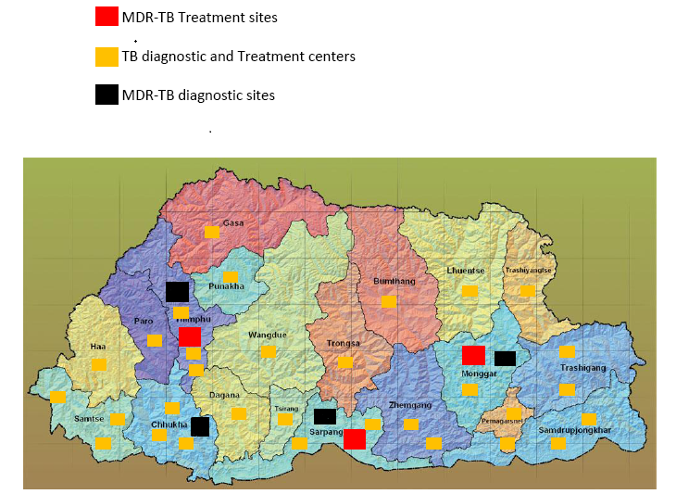
Figure 3: TB services in Bhutan

Tuberculosis- Epidemiological situation in Bhutan
Although statistically Bhutan is considered a relatively low TB burden country as compared to other countries, Tuberculosis (TB) remains a major health problem and the Government accords high priority to NTCP. It is estimated that in Bhutan, TB prevalence rate is 190/100,000 population while the TB Incidence rate is 164/100,000 population. The mortality rate due to TB is 9.5/100,000 population. The prevalence of HIV infection in general population is estimated at less than 0.1%. According to the epi-data assessment report (2015), TB-HIV co-infection among the TB patients are relatively low.
The NTCP has made substantial progress after implementation of DOTS and subsequent Stop TB Strategy components with major budgetary support from the government and the Global Fund and technical support from WHO. The country has now adopted the WHO End TB Strategy. A consistently sustained case detection and high treatment success rate have resulted in preventing increasing trends Tuberculosis.
Given the current estimates of incidence and trends noted so far, Bhutan is a candidate country to enter the pre-elimination stage with further intensified efforts to reach the unreached populations. According to the annual TB report (SEAR,WHO,2016) the estimates of disease burden are as outline in the table below.
Estimates of disease burden for 2014
Incidence of all forms of TB | 1 300 (1100–1400)
Incidence rate of all forms of TB (per 100 000 population per year) | 164 (148–181)
Incidence rate HIV+TB only (per 100 000 population per year) | 12 (9.4–15)
Prevalence of all forms of TB | 1500 (570–2700)
Prevalence rate of all forms of TB (per 100 000 population) | 190 (75–359)
TB death rate (of all forms of TB, excluding HIV per 100 000 population per year) | 9.5 (5.1-15)
Table 4: Estimates of TB burden in Bhutan
(Source: Annual TB Report, SEAR, WHO, 2016)
MDR-TB situation
According to the Drug Resistance Surveillance (DRS, 2013) it was reported that the drug resistance pattern among the notified smear positive TB cases were as follows:
- New cases – 5%
- Retreatment cases – 35%

A high rate of MDR-TB among new cases is alarming and indicates that MDR-TB is being transmitted as primary infection in the general population. With the introduction of new diagnostic tools, Line Probe Assay in 2014 and GeneXpert in 2016, it is expected that more cases of MDR-TB will be detected. TB affects men and women equally but markedly affects the younger age group (15-24), which carries 35% of the total burden of TB, and indicates active transmission of TB.

Case notification and Case Detection

The NTCP has performed well as evidenced by stable treatment success rate for smear positive TB above 90% since 2008 and very low loss to follow-up (1%). However, failure has increased from 2% to 5% in the past 6-7 years, possibly because of increase in primary drug resistance. Case notification rate of all forms of TB was 139/100,000 population in 2014 while case notification rate of bacteriologically confirmed new and relapse TB was 59/100,000 population. A total of 975 all forms of TB cases notified in 2015.There are 6 high TB notification districts - Chukha, Mongar, Samtse, Sarpang, Thimphu and Wangdue that account for 80% of all notified TB cases.
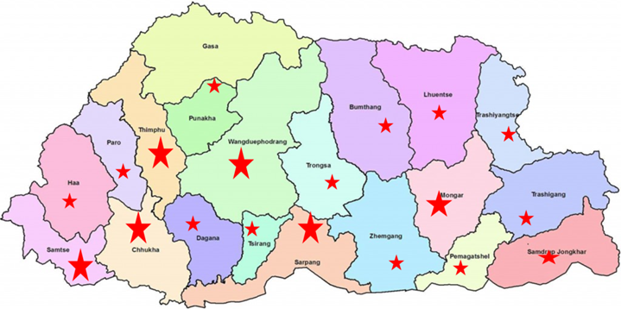
Figure 4: District wise disease burden-size of the star indicates the relative burden of TB
Treatment success rate among new smear positive TB cases was 90% for the 2014 cohort. It must be noted here that number of cases on treatment in Bhutan is small. Hence a small change in absolute numbers leads to significant changes to the percentages.

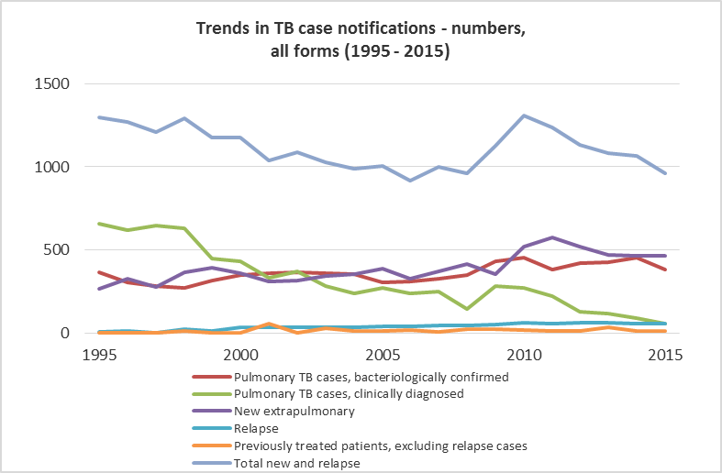
Figure 5: Case notification for various forms of TB

RR/MDR-TB cases notification
The following table shows programme performance in terms of detection and notification of rifampicin resistant (RR) and MDR-TB cases. There has been a substantial increase in number of RR/MDR-TB cases diagnosed in recent years.
 | New | Retreatment | Total
Cases tested for RR/MDR-TB | 53% | 30% | 504
Laboratory confirmed RR/MDR-TB cases |  |  | 49 (9.7%)
Patients started on MDR-TB treatment* |  |  | 49 (100%)
*May include patients who were not laboratory confirmed and those diagnosed before 2015

TB/HIV collaboration
Although HIV prevalence in the country is relatively low, the programme gives due priority to screening of HIV among TB cases and vice versa..

TB/HIV collaboration 2015 | Number | (%)
Patients with known HIV-status who are HIV-positive | 6 | <1%
-on antiretroviral therapy | 6 | 100%
Table 5: TB-HIV collaborative activities

Treatment outcomes
The treatment success rate among new and relapse cases is sustained at >88% while for other previously treated cases, the success rate is >75%. Treatment success rate of RR/MDR-TB achieved at 92% (for cohort of 2013).
Treatment success rate and cohort size | (%) | Cohort
New and relapse cases registered in 2014 | 90% | 1066
Previously treated cases, excluding relapse, registered in 2014 | 79% | 71
HIV-positive TB cases, all types, registered in 2013
RR-/MDR-TB cases started on second-line treatment in 2015 | 92% | 37
XDR-TB cases started on second-line treatment in 2012 | 0 | 0
Table 6: Treatment success rate for various categories of Tuberculosis

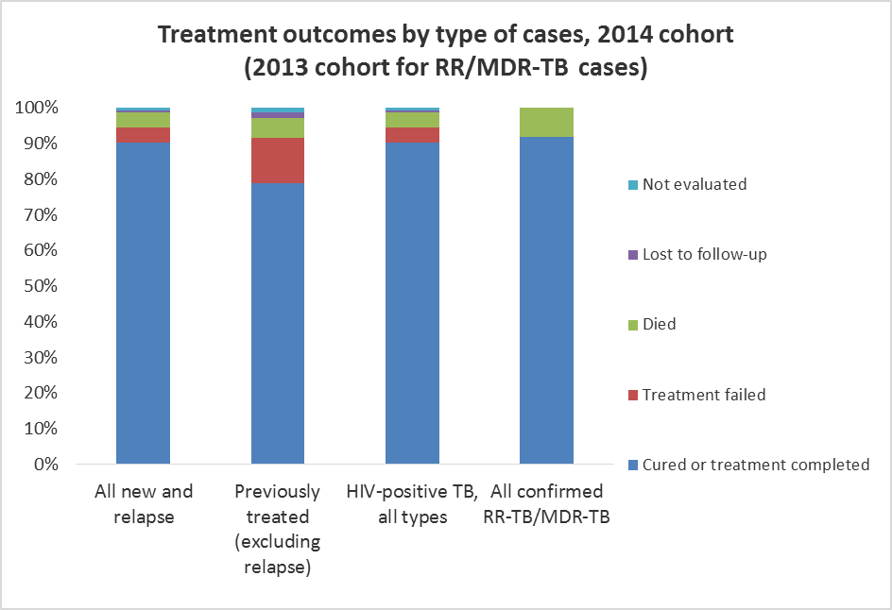

Figure 6: Treatment Success rate for RR/MDR-TB cases

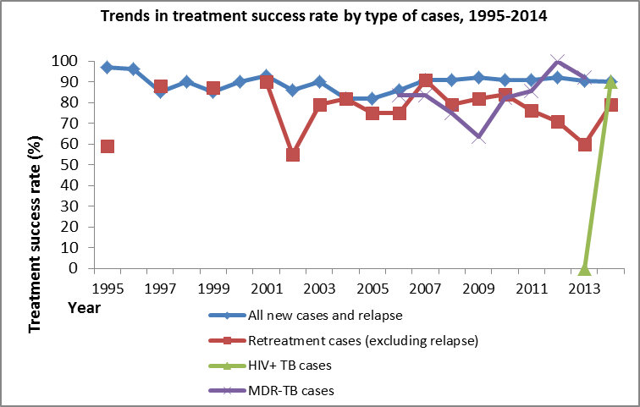
Figure 7: Trends in treatment Success rates

Joint Monitoring Mission of the TB control programme, 2016
Prior to the exercise of updating national guidelines and strategic plans, a Joint Monitoring Mission (JMM) was held in Bhutan in May 2016. The mission team included international and national experts including representatives from CDC Atlanta, WHO Regional and Country Office. During the revision of the current NSP, several recommendations pertaining to policy are being already addressed through an update to the existing guidelines for TB control in Bhutan. Following are key observations and recommendations of the review.

Overall achievements of the programme as reported by the JMM
- Committed and motivated health staff at central and peripheral levels
- Awareness from clinicians and providers at health facilities about concerning epidemiologic trends (increased EPTB and MDR-TB)
- Excellent recording and reporting system through TbISS, reduces recording burden and paperwork
- Support from Royal Government of Bhutan to sustain health financing including procurement of anti-tuberculosis drugs.

TB Case Finding
- Severe delays in diagnosis (up 1 year)
- Passive case finding
- Ad-hoc active case finding is limited
- No epidemiologic analysis of routinely collected data to guide public health action (targeting highly impacted communities)
- No SOP for active case finding activities
- Contact tracing is not consistent
- IPT is not consistent

Recommendations:
- Revise the national guideline to include active case finding activities (e.g. algorithms, budgeting, SOP)
- Engage community health workers for outreach
- Develop and implement suspect register to complement active case finding
- Improve implementation of IPT (children, HIV+, household contacts)
- Broaden/strengthen cross-border screenings

Quality of TB Diagnosis
- Applying older version of TB case definitions
- Confusion about appropriate case classification in the field
- Lab EQA has not been conducted outside Thimphu since 2014 (system is in place, but no focal person)
- Even when EQA was done, there was no follow-up, nor quality improvement for corrective action
- Despite access to LPA, delays in diagnosis
- GeneXpert available and pending

Recommendations:
- Training and clarification of revised in national guidelines to adopt 2013 WHO recommendations (including CXR)
- Re-instate, strengthen EQA
- Fast-track of use of LPA, consider concentrated sputum, and SL DST (with training and supportfrom SRL)
- Consider cross-training and redistribution of HR and workload of laboratory personnel
- Fast-track GeneXpert, consider special consultation for effective distribution of technology and resource allocation (rGLC)

Management of TB Cases
- DOTS is under-utilized
- 2-month compulsory inpatient care (poor infection control, inappropriate isolation and segregation, and limited beds)
- Despite inpatient care, DOT is still not occurring
- Poor follow-up and supervision in continuation phase (monitoring side-effects, follow-up sputum)
- Paediatric formulary not available for IPT

Recommendations:
- Consider 2-week hospitalization for patient education, initiation of ATT, monitoring side effects, bacterial sterilization with appropriate transitioning to enhanced community-based DOT
- Enhance patient education and counselling at CP initiation (consider VHW)
- Strengthen IPT activities
- Intensify planned supervision
- Innovative mechanisms intensifying DOTS (consider incentives for DOT providers)

Management of DR-TB
- DOTS is under-utilized, strict implementation is needed to reduce development of DR
- 3 PMDT treatment initiation sites in country
- Poor follow-up and supervision (monitoring side-effects, follow-up sputum)
- Early diagnosis is needed
- Poor infection control (mixing of sensitive and DR patients)

Recommendations:
- DOT
- Implement appropriate IC, isolation and segregation of DR-TB patients during hospitalizations
- Engage national MDR committee for active review all MDR cases on treatment (pharmcovigilance, clinical monitoring, managing side-effects)
- Consider decentralized MDR-TB management as per recent PMDT guidelines
- Consider appropriate budget for social support

Infection Control
- Infection control guidelines and plans are in place
- N-95 mask not readily available
- No triaging of patients
- No cross-ventilation at outpatient settings
- No policy for healthcare screening

Recommendations:
- Include TB-specific items in national checklist and guidelines (HAMT)
- Develop policy and SOP of HCW screening (include laboratory)
- Segregate MDR patients from non-MDR patients at all facilities

Recording and Reporting
- Overall recording and reporting is good
- District to sub-district level record transfer and feedback is not adequate
- TbISS is in place

Recommendations:
- Current manual recording and reporting needs to be revised using the new case definitions
- TbISS needs to be enhanced (improved connectivity, not all facilities are using it)
- Recording and reporting data needs to be analyzed for public health action

TB/HIV
- HIV screening is excellent (HIV screening amongst TB cases and TB screening amongst HIV cases)
- Amongst HIV cases routine TB screening schedule is not regular
- IPT for HIV is not practiced

Recommendations:
- All HIV patients should be screened for TB at every encounter (revised guidelines)
- IPT should be implemented as per revised national guidelines
- HIV patients should be prioritized for GeneXpert (revised in the national diagnostic algorithm and guideline)

ATT Medicines and Supply Management
- Paediatric IPT formulary not available in all areas
- Drug storage, maintenance is good
- No drug stock-outs nationally
- No electronic logistic management system in place
- Utility vans for supply chain management are old and needing replacement

Recommendations:
- Ensure and forecast adequate reagents for LPA according to new policies for SLD and enhance MDR active case finding
- Planning and budgeting for vehicles to avoid interruption in supply chain
- Prioritize national distribution of paediatric IPT formulary

Paediatric TB
- Few TB cases identified (potential under-diagnosis)
- Mantoux not available in all places
- Paediatric IPT not implemented

Recommendations:
- Update and revise paediatric treatment and management guidelines
- Prioritize national distribution of paediatric IPT formulary
- Implement national IPT policy
- Consider integrating the global Roadmap for Childhood TB into local practice

Human Resource Development
- Shortage of human resources at central level
- Inadequate training/refresher training on program policies and guidelines at the district, sub-district level

Recommendations:
- Designate additional staff for TB at central level
- Intensify initial training and refresher training

ACSM and Community Engagement
- Limited community engagement and social mobilization
- Limited IEC materials available

Recommendations:
- Strengthen the engagement of VHW for community education, case finding, contact tracing, DOT
- Develop country-specific IEC materials for TB and disseminate broadly

Operational Research and Development
- Not using reporting data for public health action
- Operational research agenda developed, however, no priority for action and implementation

Recommendations:
- Develop protocols from the prioritized research agenda
- Engage external partners and mobilize resources
- Consider conducting Operational Research training course with external partners (e.g., SORT-IT)

Guiding Principles for NSP- The End TB Strategy
The revision and development of the National Strategic Plan on Tuberculosis Control is based on equity and sustainable socio-economic development as per the Gross National Happiness policy framework. Consequently the NSP has been aligned with 12th FYP of the Health Sector for the period 2017-2023. The strategic objectives of this plan, under the Department of Public Health are based on the strategic directions on WHO recommended End TB Strategy and Sustainable Development Goals (SDGs).
In May 2014, the World Health Assembly unilaterally endorsed the resolution WHA67.1 adopting the global strategy and targets for tuberculosis prevention, care and control after 2015. The strategy includes (1) bold vision of a world without tuberculosis, and its targets of ending the global tuberculosis epidemic by 2035 with a reduction in tuberculosis deaths by 95% and in tuberculosis incidence by 90% (or to fewer than 10 tuberculosis cases per 100 000 population), and elimination of associated catastrophic costs for tuberculosis-affected households; (2) its associated milestones for 2020, 2025 and 2030; (3) its principles addressing: government stewardship and accountability; coalition-building with affected communities and civil society; equity, human rights and ethics; and adaptation to fit the needs of each epidemiological, socioeconomic and health system context; (4) its three pillars of: integrated, patient-centred care and prevention; bold policies and supportive systems; and intensified research and innovation (Table 7).

The resolution also urges all Member States to:
- Adapt the strategy in line with national priorities and specificities;
- Implement, monitor and evaluate the strategy’s proposed tuberculosis-specific health sector and multi-sectoral actions with high-level commitment and adequate financing, taking into account the local settings;
- Seek, with the full engagement of a wide range of stakeholders, to prevent the persistence of high incidence rates of tuberculosis within specific communities or geographical settings.

While significant progress has been made towards the TB control targets (MDG achieved), several challenges persist in reducing the global burden of TB. These challenges vary according to country-contexts but addressing them effectively calls for a holistic approach in all contexts.

The targets and milestones for the End TB strategy are set for 2020, 2025, 2030 and 2035. The milestones for the End TB Strategy for 2030, the target year for the SDGs, are:
- 80% reduction in TB incidence rate (compared with 2015)
- 90% reduction in TB deaths (compared with 2015)
- 100% families protected from facing catastrophic costs due to TB

The End TB Strategy
VISION | A WORLD FREE OF TUBERCULOSIS  – zero deaths, disease and suffering due to tuberculosis
GOAL | END THE GLOBAL TUBERCULOSIS EPIDEMIC
INDICATORS | MILESTONES |  | TARGETS
INDICATORS | 2020 | 2025 | 2030* | 2035
Reduction in number of TB deaths compared with 2015 (%) | 35% | 75% | 90% | 95%
Reduction in TB incidence rate compared with 2015 (%) | 20%  (<85/100 000) | 50%  (<55/100 000) | 80%  (<20/100 000) | 90%  (<10/100 000)
TB-affected families facing catastrophic costs due to TB (%) | 0 | 0 | 0 | 0
PRINCIPLES
- Government stewardship and accountability, with monitoring and evaluation
- Strong coalition with civil society organizations and communities
- Protection and promotion of human rights, ethics and equity
- Adaptation of the strategy and targets at country level, with global collaboration
PILLARS AND COMPONENTS
1. INTEGRATED, PATIENT-CENTRED CARE AND PREVENTION
- Early diagnosis of tuberculosis including universal drug-susceptibility testing, and systematic screening of contacts and high-risk groups
- Treatment of all people with tuberculosis including drug-resistant tuberculosis, and patient support
- Collaborative tuberculosis/HIV activities, and management of co-morbidities
- Preventive treatment of persons at high risk, and vaccination against tuberculosis
2. BOLD POLICIES AND SUPPORTIVE SYSTEMS
- Political commitment with adequate resources for tuberculosis care and prevention
- Engagement of communities, civil society organizations, and public and private care providers
- Universal health coverage policy, and regulatory frameworks for case notification, vital registration, quality and rational use of medicines, and infection control
- Social protection, poverty alleviation and actions on other determinants of tuberculosis
3. INTENSIFIED RESEARCH AND INNOVATION
- Discovery, development and rapid uptake of new tools, interventions and strategies
B. Research to optimize implementation and impact, and promote innovations
* Targets for the United Nations “Sustainable Development Goals” under formulation
Table 7: Milestones and targets for SDGs and End TB Strategy

National Strategic Plan to end TB in Bhutan II (2017-2023)
Keeping in view the challenges to NTCP identified by the JMM 2016 and the principles of addressing the TB problem laid out in the WHO End TB Strategy, this NSP has been prepared for the period 2017-2023 so as to achieve the needed milestones within the given time frame.

8.1. Vision

A nation FREE OF TUBERCULOSIS
– zero deaths, disease and suffering due to tuberculosis

8.2. Goal
To reduce TB and DR-TB burden until it no longer poses a public health problem in Bhutan.

8.3. Objectives
- To increase case notification rate of at least 90% among estimated TB and MDR-TB cases
- To maintain treatment success rate of at least 90% among drug-susceptible TB and at least 75% among drug-resistant TB cases
- To improve TB/HIV co-infection case detection and register at least 100% of estimated co-infected individuals from 2020 onwards
- To strengthen programmatic management of Tuberculosis at all levels

- Strategies and Interventions

- To detect at least 90% of all forms of TB including childhood TB from 2020 onwards.

  - Improve access to quality diagnostic services:
Currently, TB diagnosis is provided by sputum microscopy in 35 hospital/ Grade I BHU laboratories in 20 districts under the National External Quality Assessment Scheme (NEQAS) network conducted by NTRL at RCDC. As per the WHO guideline, country has adequate number of laboratories to provide sputum microscopy service for its population. However it is expected that with growing population and pockets of unreached area, additional microscopy centers may be needed in future. Further, provisions need to be made for replacement of microscopes while making sure that functional ones are maintained properly. All this will be supported and monitored through laboratory quality assurance (QA) system.

  - Intensifying diagnosis of childhood TB cases
There is an urgent need to improve the diagnosis and treatment of TB in children in the country by ensuring their inclusion in the NTP including the response to TB/HIV and MDR-TB in children. Reducing the burden of TB in children will require changing and improving many existing practices, such as those that relate to diagnosis and contact investigations. Paediatric TB guidelines as per the latest WHO recommendations have been included in the newly revised TB guideline.

  - Identifying TB among marginalised and vulnerable populations:
In country’s context, migrant workers, monks and nuns, and other congregate settings (institutions/dormitories) have been identified as vulnerable population and priority has been given to detection and management of TB in these populations in the past. Since the number of migrant workers in districts bordering India and in road construction and hydropower projects are rapidly increasing, there is an urgent need of developing appropriate intervention based on risk assessment. Further, it is not always possible to establish a diagnostic centre in remote areas with small pockets of populations. Such populations will be screened using clinical methods and all presumptive cases will be offered chest X-rays and rapid molecular test at the nearest center.

  - Improved active case finding and referral of TB symptomatic
To improve case notifications, it is important that all concerned should be able to identify chest symptomatic and be able to refer them to appropriate diagnostic centres. All close contacts with active TB/MDR-TB will be screened for TB through contact tracing SoP. This will include household and workplace contacts. Two mobile vans will be purchased for active screening of TB in remote area and pockets of vulnerable populations particularly where the expected transmission rates are high but case notifications have been low

- To ensure universal access to rapid diagnostics for all TB cases and DST for all bacteriology confirmed cases by 2020
In the recent DRS report, high proportions of drugs resistance have been reported in both new and retreatment cases. Hence it becomes imperative to offer drug susceptibility testing (DST) to all cases irrespective of the history of previous treatment of TB. Given the resource constraints, rapid DST is presently done in high risk categories only. However, it will be gradually expanded to cover all cases by 2023.
As per the existing programme policy, all sputum smear positive patients are screened for drug-resistance in addition to those who are at risk of drug resistance or those where there is a possibility of an unfavourable outcome because of co-morbidities and hence are at high risk of mortality due to drug-resistance. The GeneXpert MTB/RIF test is being used to screen the following categories:
Presumptive DR-TB cases – All the following categories of patients are high or moderate risk of drug-resistance and hence all the symptomatic will be screened directly with a GeneXpert MTB/RIF test:
- All retreatment cases
- All cases on first line drugs not converting at 2/3 months of treatment
- Symptomatic contacts of MDR-TB cases including health care workers, children, or those contacts who have suspicion of TB on physical examination by a physician
Other risk groups and vulnerable groups
- Symptomatic HIV positive and those with known co-morbidity which may suppress immunity (e.g. diabetes, chronic kidney disease and cancer).
- Symptomatic children

The following categories will be included for GeneXpert MTB/RIF screening:
- Elderly
- Migrant workers specifically those in mining industry, cement industry and quarries
- Bridge population – Bhutanese citizens who have been to a neighbouring country for some time and come back with symptoms of TB
- Symptomatic from areas where transmission rates are high
- Prisons
Other congregate settings – hostels/ dormitories.

The country will gear towards screening all presumptive TB cases with rapid diagnostic test by 2023. All bacteriologically confirmed cases will be subjected to conventional culture and DST.

  - Increase access to rapid diagnostics:
Based on the estimates of cases needing to undergo rapid diagnostic test, additional rapid diagnostic machines (like GeneXpert MTB/RIF) will be procured and deployed.

  - Improving efficiency in use of rapid diagnostics:
For proper usage of the available rapid diagnostic machines, staff will be trained on the new diagnostic algorithm and when to use the rapid diagnostics. To improve efficiencies, laboratories and treatment centres are planned to be linked with the electronic system - TB Information & Surveillance System (TbISS). TbISS is online software that was initially introduced to monitor the laboratory and diagnostics investigations for presumptive TB cases and their follow-up investigations. TbISS use is now being expanded to all aspects of patient management and its access is being gradually expanded to all districts. Internet connectivity, however, is still an issue but is expected to be resolved in near future.

  - Improve efficiency in use of conventional culture and DST
With the establishment of NTRL, RCDC at Serbithang, the plan for gradual achievement of universal DST for all bacteriologically confirmed TB cases can be achieved. The HR capacity of National TB Reference Laboratory needs to be strengthened. The second line DST facility at the NTRL will be conducted using LPA.
It is emphasised here again that the NTP envisages provision of high quality diagnosis and treatment to all TB cases including drug-resistant cases. The country will soon be introducing shorter regimen for RR/MDR-TB cases and hence SL LPA will be quickly established by 2017.

- To maintain treatment success rate of at least 90% among drug-susceptible TB and at least 75% among drug-resistant TB cases
The NTCP plans to achieve and sustain treatment success rate of at least 90% among drug-susceptible TB and 75% among drug-resistant TB. The NTCP had engaged government organizations such as the Council for Religious Affairs, Royal Bhutan Police, the Village Health Workers, and Health & Religion Programme within the ministry to improve and maximize access to quality treatment to some targeted vulnerable and hard-to-reach populations. Similarly, the NTCP in this strategic plan period intends to expand the participation of all key players, both governmental and non-governmental to further strengthen the interventions undertaken in the past through innovative approaches for better reach and improve the quality of TB services. In addition to improving case notifications, the programme will also focus on improving service provision to facilitate treatment adherence specifically in the low performing districts and vulnerable populations, strengthening community-based systems and fostering referral from other care providers.

  - Provide standardized a treatment for all forms of TB
The programme will follow standardized treatment guidelines for all forms of TB being treated at all levels as per the accepted international standards and good practices. The updated guidelines will be disseminated and staff will accordingly be trained. For easy remembrance and quick reference, desk reference materials will also be produced and disseminated.

  - Ensure uninterrupted supply of drugs
The anti-TB drugs should meet WHO-prequalification standards. The drugs are normally procured through Global Drug Facility under the STOP TB partnership. The consistent procurement and supply chain management will be maintained and monitored through early warning system and regular stock monitoring.

  - Improving the quality of DOT
Directly Observed Treatment (DOT) is the backbone of the programme. JMM 2016 found some deficiencies with implementation of DOT. The programme will ensure to strengthen DOTs at all levels. TB In-charge in close coordination with Medical Officer shall identify a DOT provider and educate him/her on administering DOTs and identifying the side effects and further management. DOT providers can be anyone residing near the patient. In some cases, it may be necessary to make a family member as DOT provider. In the communities, village health workers (VHW), health assistants (HA) will be trained in DOT. Comprehensive treatment literacy will be given to all the patients and the DOT providers.

  - Adopt recent WHO guidelines on management of DR-TB
The WHO has recently (in May 2016) approved the use of a shorter regimen for the treatment of RR and MDR-TB. Currently the country doesn`t have facilities for second line DST. The country plans for adopting shorter regimen at the earliest alongside with establishment of SL LPA in the country and active tuberculosis drug-safety monitoring and management (aDSM) system is in place. The process will include:
  - Development of a transition plan for adoption of shorter regimen after updating the PMDT guidelines, aDSM and developing necessary SoPs
  - Establishing SL LPA in 2017
  - Training of staff on shorter regimen for RR/MDR-TB. This will include both programmatic and clinical aspects

- To cut the chain of TB transmission through adequate infection control in all treating facilities by 2020 and treat LTBI

  - Increased awareness and strengthen enforcement of Infection Control guidelines
Infection control is found sub-optimal in various internal and external reviews of the health facilities due to inadequate dissemination of guideline and mechanism to regularly monitor the implementation. This will be addressed through sensitisation meetings, training of staffs and monitoring of health facility level infection control practices. Program will coordinate with Infection Control Programme and Quality Assurance Standardization Division for the implementation of infection control measures by Hospital Administration and Management Transformation (HAMT) activities.
  - Diagnose and treat LTBI
Prevention of development of active disease in those considered vulnerable is an important step in cutting the chain of transmission of the disease. Hence treatment of LTBI is considered an important intervention. In Bhutan, LTBI detection will focus mainly on the HIV positives and child contacts of active TB. The Tuberculin skin test (TST) or the Mantoux test will be used to diagnose LTBI after ruling out active TB. All positive cases will be administered IPT for 6 months as per the guidelines. Mantoux test should be available in all hospitals; however, it will not be a limiting factor in deciding whether or not to start IPT. Treating physician can start IPT based on clinical history after ruling out active TB.
- To detect and register 100% of TB-HIV co-infected individuals from 2020 onwards
The Human Immunodeficiency Virus (HIV) destroys the immune system of an individual. Someone who is HIV-positive and infected with TB bacilli is more likely to become sick with TB bacilli than those who are HIV-negative. HIV and TB form a lethal combination, each speeding the progress of the other. TB is a leading cause of death among people who are HIV-positive. HIV is the most potent factor known to increase the risk of progressing from latent tuberculosis infection to tuberculosis disease. In an HIV negative patient infected with M. tuberculosis, the lifetime risk of developing tuberculosis is only 10%, whereas in person dually infected with TB and HIV is 50%. Hence it is important to diagnose all cases of TB with HIV infection and the other way round as well. The programme will ensure this cross referral through strengthening coordination between HIV and TB programme and ensuring proper referral system.

  - Strengthen collaboration between TB and HIV programme management
Have regular dialogues between the two programmes and exchange information through meetings and joint monitoring of programmes including formulation of TB-HIV collaborative guidelines. Also strengthen coordination and awareness level of all stakeholders including community-based organizations. This will involve sensitisation meetings as well as training of staffs.
  - Improved coordination between TB and HIV programme implementation
This part covers the implementation aspects of the programme. To achieve this coordination, sensitisation of medical officers will be organised. For coordination of recording and reporting, joint trainings of TB and VCT focal persons will be held. At the grassroots level, MSTF will be engaged in TB related activities
- Strengthen programmatic management of Tuberculosis at all levels

  - Strengthen partnership for prevention and control of TB at all levels.
In order to improve the efficiency and performance of the programme, it is important to have close collaboration and coordination with the relevant stakeholders. The NTCP will engage various government organizations such as the Council for Religious Affairs, Ministry of Education, Royal University of Bhutan and Armed Forces at the central level. While keeping in mind for holistic engagement of all care providers, NTCP will coordinate and collaborate with Non-governmental Organizations like Youth Development Fund and other relevant partner. Similarly, at the Dzongkhag and community level, programme will involve Dzongkhag health sector, Local government institutions (Tshogdus and Tshogchhungs), Multi-sectorial Task Force, Community Action Groups and VHWs at the lowest level.

  - Enhance advocacy communication and social mobilisation among various partners
For the successful implementation of DOTs and control of TB, it is vital to invest on communication and education awareness programmes to general public through various stake holders and channels of communication. NTCP will have partnership with various governmental, non-governmental organizations including local government and community based institutions for creating awareness, support and implementation of TB control activities.

  - Ensure adequate HR and capacity development.
Currently, there is shortage of human resources in the health system resulting into high workloads and turnovers. In order to achieve the outcomes of this strategic plan, adequate human resource and capacity development is imperative at all levels of health care system with relevant capacity and skills built.

  - Strengthening supervision and monitoring
The supervision and monitoring shall be undertaken as per the M& E framework. This is important for managing setbacks normally occurring during the implementation. It also provides an opportunity for corrective measures and feedbacks. The process will involve planning, recording, reporting and review (including JMM) of strategies, interventions and activities. As a follow-up to call for action that was jointly signed by all Member States of the WHO SEA Region at the Ministerial Meeting in Delhi on 15-16 March 2017, Bhutan will set up a high level committee to constantly review and monitor the progress of programme towards ending TB. Subject to approvals from the Hon’ble minster, the high level committee will be chaired by Health Minister, with members from health sectors, finance, GNHC, NGO representation and civil society representation and other relevant agencies.

  - Improve strategic Information for evidence based programmatic interventions
To improve the quality services, evidence based planning has become critical. In order to achieve this, there is a need to strengthen operational research for making informed decision on public health action. In alignment with the End-TB Strategy, the programme will undertake operational research to assess barriers and develop more effective approaches to case finding, diagnosis and care, and minimise development of drug-resistance among TB patients. The programme will coordinate with international agencies and experts to undertake training of national TB experts on operational research and look for funding sources to support this research.
- Financing health system in Bhutan
All contributions either domestic/ external to the national TB programme are prioritized and allotted based on the Five Year Plan document. The national plan has been prepared using the result based planning approach to ensure that developmental plans are result-oriented. All budget requirements are hence determined on the basis of specific need of each programme which shall be guided by the FYP to achieve the desired outcomes. As per the policy of the government, all recurrent expenditures have to be met from the domestic budget. Only capital works and projects can be funded from the donor and grant funds. The government contributions are in the form of personnel salaries & emoluments, facilities maintenance and other logistic and administration costs. Since start of TB control programme 1st line anti TB drugs are procured through government funding and it will be sustained through Bhutan Health trust Fund which is mandated for funding of all vaccines and essential medicines. Such system has been put in place to ensure all time functioning and sustainability of the programmes even after a specific donor withdraws their support. Total indicative total capital outlay for health sector programme under 10th five Plan (2008 – 2013) is Nu. 4394.336 million, out of which TB programme outlay is Nu. 53.441 million. For TB control, all staffs (TB In charges) fully or partially involved in delivery of TB care and services are employed by the government and health canters diagnosing, managing and treating patients are owned by the government. They are responsible to carry out health education sessions and provide health care services in their catchment area on a regular basis. The services and activities they are engaged are monitored by the district health officers/district medical officers on a regular basis and periodically supervised by the central programmes. Any issues or achievements made by the districts are shared and deliberated during the annual TB review meetings/ Annual Health Conference to seek direction for improvement. The monitoring and evaluation of the tenth plan aligned with the National Monitoring and Evaluation System is a very important component to ensure that the resources are used efficiently, transparently and equitably. All programme activities are directly linked to the web based computerized system, the Planning & Monitoring System (PLaMS) of The Gross National Happiness Commission. Through this system, a proper linkage of the operational plan with the strategic plan can be ascertained which would facilitate planning and monitoring the implementation of sector plans thereby ensuring effective and transparent use of resources. The Internal Audit unit under the MoH also performs auditing of the various programmes and projects through prioritization. Besides, annual audits are also being conducted by the Royal Audit Authority for all programmes and projects to ensure integrity in use of public resources at all levels of public service delivery.

- Technical Assistance
Considering limited technical capacity and limited manpower in Bhutan and absence of any International agencies working on tuberculosis in the country, WHO South Asia office and WHO country office plays an important role in providing Technical Assistance to NTCP in programmatic management in line with the WHO and international standards.
Along with WHO, the Global Fund and the Global Drug Facility has been technical advisor for NTCP and has assisted in different fields like development of TB and MDR-TB guideline, PMDT expansion plan, development of NSP, infection control plan, external review of TB program, GDF monitoring mission, rGLC mission, development of TB concept note for various rounds of GF grants.
Technical Assistance to the overall NTCP and to the various elements of TB control is needed to ensure and sustain the quality of TB control interventions. The NTCP shall continue to seek technical assistance support from WHO and other partners to improve the overall programmatic management. Important areas of Technical Assistance planned from 2017-2023
- JMM review
- Updating M & E framework/plan
- Revision of TB and MDR-TB guideline
- Developing Program Continuation request form/proposal for GF grant
- Transitioning to shorter regimen for RR/MDR-TB cases. TA will be needed within 2017 for
  - Update of PMDT guidelines including aDSM and relevant SoPs for implementing the guidelines
  - Preparation of transition plan
  - Training of programme managers and clinicians
- Setting priority for Operational Research
- Annual Lab Assessment visit by SNRL
- Any other priority technical support required

- Monitoring and Evaluation (M &E) Framework
Through effective monitoring and evaluation, programme results at all levels (impact, outcome, output, process and input) can be measured to provide the basis for accountability and decision making at both programme and policy level. The monitoring and evaluation system also ensures accountability for the resources allocated for activities at the different levels of the programme. In order to materialize and achieve the set milestones and the targets in this NSP; monitoring, supervision, review and the evaluation of plan targets are essential to track the progress and the achievements at all levels.
One of the major strengths of the M & E is that all the indicators listed are clearly linked to the strategic objectives, and technically sound data sources have been established. There are indicators measuring disease trends in terms of TB incidence and mortality based on WHO estimates that have been applied to establish the baselines and will be used to measure trends during the NSP period. The baselines for the impact, outcome and most of the output indicators are available and targets have been set till 2023. The core indicators framework has been outlined in Table 8.
Table 8: Core M & E framework indicators
 | Indicator | Baseline | 2017 | 2018 | 2019 | 2020 | 2021 | 2022 | 2023
Impact indicators | TB incidence per 100,000 population/year | 155 |  |  |  | 124
Impact indicators | TB mortality (in absolute numbers) | 120 | 105 | 95 | 85 | 75⁷ | 65 | 55 | 45
Outcome indicators | Case notification rate: Number of new and relapse bacteriologically confirmed Pulmonary TB cases reported to the national TB programme per 100,000 population per year | 59 | 65 | 70 | 75 | 80 | 80 | 80 | 70
Outcome indicators | Treatment success rate: percentage of new and relapse bacteriologically confirmed Pulmonary TB cases successfully treated (cured plus completed treatment) among the new and relapse bacteriologically confirmed Pulmonary TB cases registered on treatment | 88% | >90% | >90% | >90% | >90% | >90% | >90% | >90%
Output indication | Percentage (% ) of laboratories showing adequate performance among those that receive external quality assurance (EQA) | 90% | >90% | >90% | >90% | >95% | >95% | >95% | >95%
Output indication | Percentage (% ) of Pulmonary TB patients tested for drug resistance using the WHO recommended rapid diagnostics (WRD) | NA | 60% | 70% | 80% | >90% | >90% | >95% | 100%
Output indication | Percentage (%) of treatment units reporting no stock out of first-line and second-line anti-TB drugs on the last day of each quarter out of all treatment units | 100% | 100% | 100% | 100% | 100% | 100% | 100% | 100%
Output indication | Number of districts supervised and feedback provided by the NTP for all reporting centres annually | 32 | 32 | 32 | 32 | 32 | 32 | 32 | 32
Output indication | Proportion of all registered TB patients who are tested for HIV | 73% | 75% | 80% | 85% | 90% | 95% | 100% | 100%
 | SL LPA established and functional | 0 | 0 | 1 | 1 | 1 | 1 | 1 | 1
 | Proportion of laboratory confirmed MDR-TB patients enrolled on second-line drugs | 100% | 100% | 100% | 100% | 100% | 100% | 100% | 100%
 | Proportion of laboratory confirmed RR/ MDR-TB patients enrolled on shorter regimen for RR/MDR-TB patients | NA | 0% | 50% | 60% | 60% | 80% | 100% | 100%

Table 9: Operational definition and measurement of the indicators
 | Indicator | Indicator definition | Data collection method/ source | Frequency of data collection | Person/Agency responsible for collection and reporting
Impact indicators | TB incidence per 100,000 population/year | Number of new TB cases (all forms) per 100,000 population in a given year | - WHO estimates | - Annual | - WHO
Impact indicators | TB mortality per 100,000 population/year | Number of deaths due to TB (all forms) per 100,000 population in a given year | - WHO estimates  - National TB mortality surveys | - Annual  - Periodic | - WHO  - NTP
Outcome indicators | Case notification rate: Number of new and relapse bacteriologically confirmed Pulmonary TB cases reported to the national TB programme per 100,000 population per year | Numerator: number of new and relapse bacteriologically confirmed Pulmonary TB cases recorded in TB registers between 1st January and 31st December of the reporting year  Denominator: estimated mid-year population | District TB register; quarterly reports on TB case registration | Annual | NTP
Outcome indicators | Treatment success rate: percentage of new and relapse bacteriologically confirmed Pulmonary TB cases successfully treated (cured plus completed treatment) among the new bacteriologically confirmed Pulmonary TB cases registered on treatment | Numerator: number of new and relapse bacteriologically confirmed Pulmonary TB cases registered between 1st January and 31st December of the year before the reporting year classified as “cured” or “treatment completed” at the end of the reporting year  Denominator: number of new and relapse bacteriologically confirmed Pulmonary TB cases recorded in TB registers between 1st January and 31st December of the year being reported | Numerator:  Patient treatment cards; District TB register; Quarterly reports on the results of TB patients registered 12-15 months earlier  Denominator: District TB register; Quarterly reports on the results of TB patients registered 12-15 months earlier | Annual | NTP
Output indicators | Number and % of laboratories showing adequate performance among those that receive external quality assurance (EQA) | Numerator: Number of microscopy centres showing adequate performance based on quarterly EQA performed as per national guidelines  Denominator: Number of microscopy centers monitored under the national EQA system during the reporting period | - EQA reports of all microscopy centres  - Feedback forms to all microscopy centres  - EQA register book | Quarterly | NTP and national reference laboratory
Output indicators | Number and % of patients tested for drug resistance using the WHO recommended rapid diagnostics (WRD) | Numerator: Number of patients at risk of drug resistance screened with WRD  Denominator: Number of patients estimated at risk of being drug resistant | - Laboratory register | Quarterly | NTP and DST laboratories
Output indicators | Number of treatment units reporting no stock out of first-line and second-line anti-TB drugs on the last day of each quarter out of all treatment units | Number of treatment units reporting no stock out of first-line and second-line anti-TB drugs on the last day of each quarter out of all treatment units during the reporting period | - Quarterly report on drug stocks from all treatment centres | Quarterly | NTP and Central Drug store
Output indicators | Number of districts supervised and feedback provided by the NTP out of all districts planned to be supervised during each quarter | Numerator: Number of districts supervised and feedback provided by NTP during the quarter  Denominator: Number of districts planned to be supervised by NTP during the same quarter | - Quarterly reports on supervision and feedback | Quarterly | Data collection and reporting: NTP
Output indicators | Proportion of all registered TB patients who are tested for HIV | Numerator: Total number of TB patients tested for HIV during the reporting period  Denominator: total number of TB patients registered in the same reporting period | - Quarterly report on TB case registration | Quarterly | Data collection and reporting:
 | Proportion of laboratory confirmed RR/ MDR-TB patients enrolled on second-line drugs | Numerator: Number of laboratory confirmed RR/ MDR-TB patients enrolled on second line drugs in the reporting period  Denominator: Expected MDR-TB patients among all notified Pulmonary TB cases | - Lab register  - MDR-TB treatment register | Annually | NTP
 | Proportion of laboratory confirmed RR/ MDR-TB patients enrolled on shorter regimen for RR/MDR-TB patients | Numerator: Number of laboratory confirmed RR/ MDR-TB patients enrolled on shorter regimen in the reporting period  Denominator: Total RR/ MDR-TB patients enrolled on second-line drugs in the reporting period | - Lab register  - MDR-TB treatment register | Annually | NTP

Eleventh Five Year Plan Document. Gross National Happiness Commission, Royal Government of Bhutan.2013. ISBN 978-99936-55-01-5
http://www.adb.org/countries/bhutan/main
http://www.nsb.gov.bt/nsbweb/main/indicator.php
Annual Health Bulletin 2016.Health Management & Information System, Policy & Planning Division, Ministry of Health, Royal Government of Bhutan, Thimphu.
Health sector response to HIV in the South-East Asia Region, 2013. WHO SEARO
http://www.phls.gov.bt/web/wp-content/uploads/2015/07/tbiss-Manual.pdf
In alignment with End TB Strategy milestones for 2020 and the SEA Regional Strategic Plan 2016-2020

