BHUTAN NATIONAL MALARIA STRATEGIC PLAN
2015-2020
Vector-borne Diseases Control Programme
Ministry of Health
16th September 2014

FOREWORD
Bhutan having achieved impressive progress in prevention and control of malaria cases over the last decades, the country is now progressing into achieving ‘zero indigenous malaria case’ by 2018 while equally being watchful of preventing the possibility of reintroduction of the malaria cases. The progress was given the impetus by the additional funding support from the past Global Fund Rounds (4, 7 & TFM), technical and financial support of the WHO, GoI and APMEN. As a result, an imperative success was noticed in vector control and surveillance initiatives through drastic reduction in the annual parasitic incidence.
Guided by the principles of the documented best practices across the world and within the region, the Vector-borne Disease Control Programme (VDCP) under the Department of Public Health has drafted the first National Strategic Plan (NSP) in 2008 and subsequently revised in 2012. As Bhutan is moving from ‘control’ to ‘elimination phase’ of the malaria control initiatives, the joint monitoring mission conducted in 2013 recommended the need to revise the current NSP.
Hence, the current NSP was revised based on the recommendations from the joint programme review mission report, 2013. The revision involved TWG from key sectors, and was followed by presentation to stakeholders. Inputs and comments from the stakeholders were accordingly adopted and the bottom-up planning approach followed to strategize the programmatic interventions. The entire process was geared towards acceleration of malaria elimination in Bhutan by 2018 and WHO malaria-free status certification by 2020.

This document is hereby endorsed by the Ministry of Health and will be the country’s guiding document for activities geared towards malaria elimination in the country. We are hopeful that this document, which was jointly developed through consultations at various stages, will have better impact in guiding all of us toward achieving the goal of ‘Zero Indigenous Malaria Case’ in Bhutan by 2018.

LYONPO TANDIN WANGCHUK
MINISTER OF HEALTH
16th SEPTEMBER, 2014

Contents Page No
ACKNOWLEDGEMENT 4
DEVELOPMENT PROCESS 5
EXECUTIVE SUMMARY 6
COUNTRY PROFILE 7
SOCIO-ECONOMIC SITUATIONS 8
NATIONAL HEALTH SYSTEMS, PLANS AND POLICIES 10
VECTOR-BORNE DISEASE CONTROL PROGRAMME 14
EPIDEMIOLOGY OF MALARIA 16
MALARIA INDICATOR SURVEY 2013 24
EXTERNAL REVIEW OF MALARIA PROGRAMME 2013 24
COLLABORATING PARTNERS 27
GFATM & ITS IMPACT ON MALARIA 28
FEASIBILITY OF MALARIA ELIMINATION 29
GUIDING PRINCIPLES 35
KEY ASSUMPTIONS 35
STRATEGIC PLAN 2015-2020 36
Vision, Mission, Goal & Objectives 36
BROAD KEY STRATEGIES & MAIN ACTIVITIES 37
1. Focused prevention and elimination of transmission and prevent re-introduction 37
1.1. Geographical reconnaissance 37
1.2. Mapping, delimitation and classification of foci by gewog 38
1.3 Targeted interventions based on foci classification 40
1.3.1 Macro-Stratification 40
1.3.2 Targeted focused interventions with LLIN and IRS 42
1.4 Empowerment of Community Action Group (CAG) 43
2 Quality assured laboratory diagnosis, treatment and follow up 43
2.1 Diagnosis 43
2.1.1 Case diagnosis 43
2.1.2 Establishment of National Quality Assurance System for malaria diagnosis 44
2.1.3 Accreditation of private laboratories 45
2.2 Treatment 45
2.3. Follow-up of all cases 46
2.4. Sustaining knowledge and skills for malaria case management 46
3. Intensified surveillance and response 47
3.1 Disease surveillance 47
3.1.1 Districts Rapid Response Action 47
3.1.2 National malaria database 48
3.1.3 Case notification, investigation, classification and follow-up 49
3.1.3 Re-active case detection 50
3.1.4 Active case detection (projects sites and in case of outbreaks) 50
3.2 Entomological surveillance 50
3.2.1 Foci based vector surveillance 50
3.2.2 Developmental projects 51
3.2.3 Monitoring of insecticides resistance 51
3.3 Special events surveillance 51
4 Strengthened governance and institutional capacities 52
4.1 Creating enabling environment for elimination and prevention of reintroduction 52
4.1.2 Establish Bhutan Malaria Elimination Commission (BMEC) 52
4.1.3 Bhutan Malaria Elimination Technical working Group (BMETWG) 53
4.1.4 Collaboration with line ministries 53
4.1.5 Cross-border and inter-country collaboration 54
4.1.6 Strengthening partnership with private sectors and other agencies 55
4.2 Institutional strengthening both programmatic and other institutions 55
4.2.1 Institutional capacity building 55
4.2.2 Sustaining technical managerial capacities of VDCP 56
4.2.3 Strengthening district level capacities for malaria elimination 58
4.2.4 Strengthening collaborating agencies within Bhutan 59
4.3 Intensify supervision, monitoring and evaluation 60
4.4 Generate strategic information for malaria elimination 60
4.4.1 Operational research in vector control 60
4.4.2 Operational research in treatment (T3) 61
4.4.3 Parasites genotyping 61
IMPLEMENTATION APPROACHES 61
MONITORING AND EVALUATION FRAMEWORK 63

ACKNOWLEDGEMENT

The Ministry of Health acknowledges the contributions from the following individuals and organizations for the development of NSP 2015-2020.
- Technical Working Group
- Dr. Tashi Tobgay, Director, Planning & HR, UMSB
- Mr. Sonam Dorji, Drug Controller, Drug Regulatory Authority
- Mr. Namgay Tshering, NPO, WHO Country Office
- Mr. Namgay Wangchuk, Programme Officer, Policy and Planning Division, MoH
- Mr. Sherub, Gross National Happiness Commission
- Mr. Sonam Wangchuk, Head, Public Health Laboratory
- Ms. Dechen Wangmo, APO, Ministry of Labour and Human Resource
- Dr. Thinley Yangzom, Medical Officer, JDWNR
- Dr. Choeda Gyeltshen, District Medical Officer, Punakha Hospital
- Mr. Tashi Norbu, District Health Officer, Punakha dzongkhag
- Mr. Rinzin Namgay, Chief Programme Officer, VDCP
- Mr. Tshering Gyeltshen, Programme Officer, Health Promotion Division
- Mrs. Kinley, CAG Member, Chuzagang gewog
- Mr. Hari Lal Phuyal, VHW, Chuzargang
- VDCP personnel:
- Mr. Tobgyel, Deputy Chief Programme Officer, VDCP
- Mr. Pema Samdrup, Sr. Programme Officer
- Mr. Nima Wangdi Gyeltshen, Entomologist, VDCP
- Mr. Sonam Gyeltshen, Assistant Data Manager, VDCP
- WHO
- Dr. Leonard Ortega, Regional Advisor for Malaria, SEAR, New Delhi
- Dr Md. Mushfiqur Rahman, STC for concept note development

The Ministry also acknowledges the technical and financial support of WHO and GFATM and all the collaborating partners and individuals for their comments and contributions.

DEVELOPMENT PROCESS

In 2013, after an in-depth review of the programme (with support from the WHO), the external review team consisting of external and internal reviewers recommended to gear towards elimination of malaria with the revised National Strategic Plan (NSP). Based on the recommendations, a technical working group was formed to revise the strategic plan. The technical working group was composed to represent the technical bodies of the country, people affected by the disease and the technical competencies of the individuals including representatives from VDCP, University of Medical Sciences of Bhutan, WHO Country Office, Drug Regulatory Authority, Public Health Laboratory, Ministry of Labour, member representative from CAG, VHW, people affected by the disease, focal person from the PPD in the Ministry of Health and a short-term consultant from the WHO. The technical working group initially started the revision from 20th - 24th May, 2014 where the CPO and VDCP briefed the group on country malaria situation and the objectives, and the need for the revision of existing strategic plan. Within four days, the 1st draft was formulated. The draft was circulated to all working groups and other stakeholders like WHO, SEARO, APMEN for further comments. The second review meeting was undertaken on 12th June 2014 and was chaired by the Director General, DoPH, Ministry of Health. Together with programme staff and TWG, Dr. Leonard Ortega, the Regional Advisor undertook the revision of the 1st draft. The second draft was shared once again even as comments from various members were incorporated and posted online on the Ministry of Health website so as to garner comments from wider forum. From then on, the strategic plan has been presented and shared with different groups of people including the health workers at different levels and from different districts. Thus, continuous feedback and comments have been taken into account in the whole development process of the NSP.
The third NSP draft with cost implications was finally shared with different groups of people at the national and international forums and with health workers at different levels. It was also shared with different stakeholders like Global Health Group, GFATM, APMEN, WHO HQ and WHO SEARO through emails. Their valuable comments were incorporated. With the support of the WHO consultant, the NSP 2015-2020 which incorporated comments from various national and international stakeholders was finalized in six working days i.e. from 9th-14th September 2014. The Ministry of Health endorsed it on 16th September 2014.

EXECUTIVE SUMMARY

Considering the remarkable achievement on the case reduction of malaria to merely 15 indigenous cases and 33 imported cases with no malaria related deaths, and as per the recommendations of the joint malaria review conducted by WHO in 2013 and the feasibility analysis of the country, Bhutan has now ventured into the malaria elimination phase.
Therefore, this NSP 2015-2020 focused on the elimination strategy has envisioned, “Bhutan free of indigenous malaria” with mission “Achieving malaria elimination through use of evidence based interventions, sustaining political support and mobilizing multi-sectoral and community participation at all levels, and strengthen institutional capacity to prevent reintroduction of transmission”.
The goal is “to achieve zero indigenous malaria in Bhutan by 2018 and obtain WHO-malaria-free certification by 2020” and it is expected to: (i) Eliminate all active foci of malaria by 2018 (ii) Prevent resurgence of malaria from 2018 onwards (iii) Sustained zero malaria death from 2015 onwards and (iv) Further strengthen health system and community system to sustain malaria elimination.
These outcomes will be achieved through the implementation of four main strategies:
- Focused prevention and elimination of transmission and prevent re-introduction.
- Quality assured laboratory diagnosis, treatment and follow up.
- Intensified surveillance and response.
- Strengthened governance and institutional capacities.
The main shift considered within this NSP are micro-stratification to the chiwog level using geo positioning systems, strengthening community systems through community action groups and village health workers, improved laboratory services through institution of quality assurance systems, strengthening information and surveillance systems using mobile phone technology and web-based systems. As we move into elimination strategy, it is of utmost importance to set up institutions to monitor the elimination progress and more importantly setting up system and institutions to prevent resurgence. These NSP will be implemented mainly by the VDCP of MoH and other collaborating partners such as DRA, UMSB and line ministries. The strategies will see the reconsolidation of all control activities by 2015 into elimination strategy, micro-stratification by 2016, implementation of elimination strategies thereby reaching zero indigenous case by 2018, sustain elimination, and achieve WHO certification by 2020. The total budget proposed for the successful implementation of these activities is Nu. 693,675,246.00 equivalent to USD 11,561,254.10 (@Nu 60/USD). The main funding for the NSP would be from RGoB, GFATM, GoI, WHO, APMEN and others.

COUNTRY PROFILE

Bhutan, located in the eastern Himalaya with a total area of 38, 394 km² shares a common border with China to the north and India to the south, west and east. Politically, Bhutan is a Democratic Constitutional Monarchy with the King as the Head of the State and elected Prime Minister, as the Head of the Government. As shown in Figure 1, "gewog" (blocks) and "thromde" municipality area is the lowest administrative block. Each gewog is made up of 5-8 "chiwogs" (sub-block). There are twenty "dzongkhag" (district) and 205 gewogs in Bhutan.
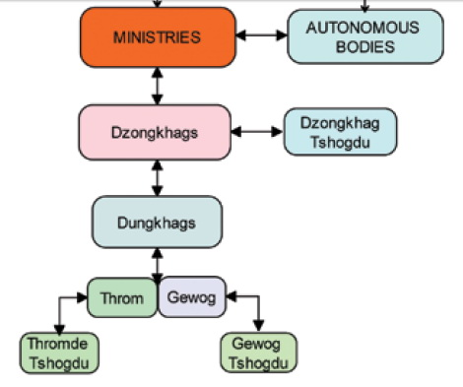
Figure 1: Administrative flow chart

The country has mainly three geographical climatic features with subtropical hot and humid conditions in the southern belt, cool temperate climate in the central and snowcapped mountains with cold alpine climate in the north. The rainfall within these three regions could vary with annual precipitation of 2000-5000 mm in the south, 600-800 mm in the central region and to about 75-200 mm in the north (Figure 2). The panoramic changes of these geo-climatic features are experienced even within a short distance due to steep mountains and deep valleys. This harsh geo-climatic factor has not only developed unique socio-cultural diversities but also different health conditions unique to the locality, which often require unique distinct health systems and delivery mechanisms for these inaccessible localities. In the southern foothills, tropical diseases such as malaria and dengue are more prevalent, whereas in the cold northern region respiratory diseases are more common.
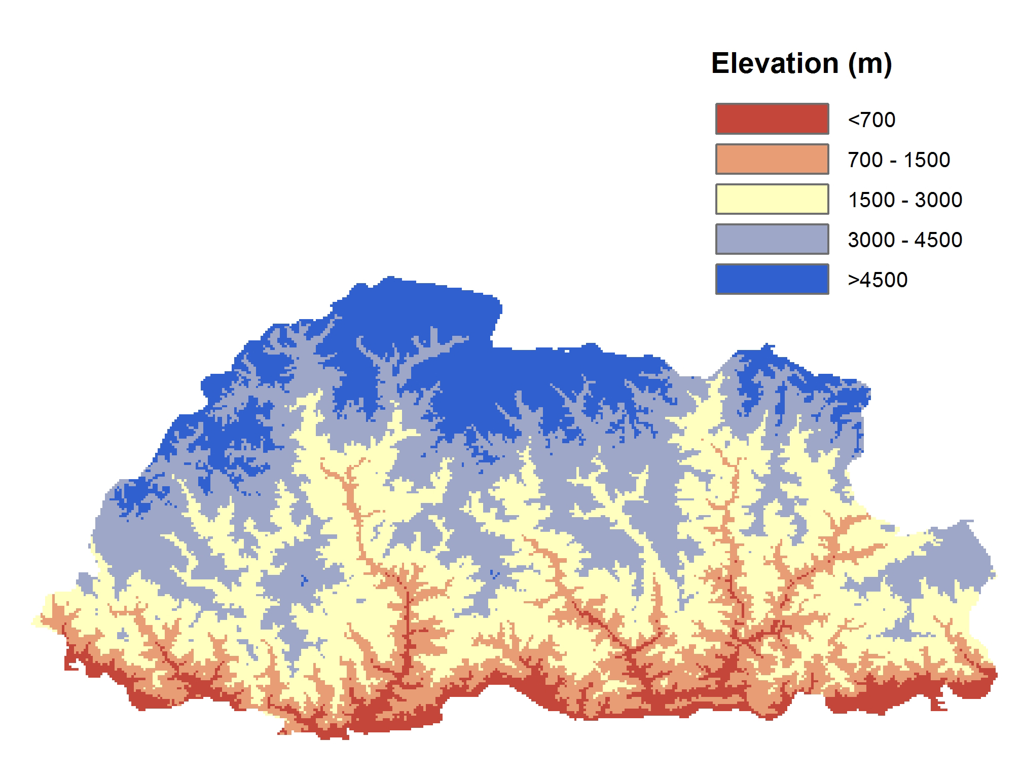
Figure 2: Map of Elevation of Bhutan (Source Malaria case study, draft version)

SOCIO-ECONOMIC SITUATIONS
The population and housing census conducted in 2005 enumerated a population of 672,450 with 37,443 as floating population. The population is estimated to have grown to 720 679 in 2012 with about 70 % people living in rural areas.
The country has made great strides in lifting the socio-economic status and as a result, poverty level has been reduced from 31% in 2003 to 12% in 2012. Life expectancy has increased from 66 years in 1999 to 68 years in 2012 and the population growth rate has stabilized to around 1.3 % in 2012 from 3.1% in 1994.
In 2000, Bhutan launched "Bhutan 2020: A vision for Peace, Prosperity and Happiness" and since then it has been the guiding policy for growth and development. With Gross National Happiness at the pinnacle of developmental philosophy, Bhutan strives to achieve economic self-reliance and full employment (97.5%) by 2020 and also graduate from the Least Developed Country status. Bhutan is also on track to achieve most of the MDG targets by 2015. Malnutrition in children, infant mortality rate, under-five mortality rate are some of the challenges to achieve the targets in total.
Bhutan has been cognizant of gender inequality and violence against women as a universal phenomenon. Therefore, it has always promoted gender inclusive and a gender sensitive developmental agenda. Despite this, The National Health Survey, 2012, has shown that Bhutan is not free of inequality, with 6.1%, 2.1% and 3.2% of married women aged 15-75 years experiencing physical violence, sexual violence and psychological violence respectively in the past year. However, various institutions have been established to promote gender equality and gender protection. With the rectification of the Convention on the Elimination of All Forms of Discrimination against Women (CEDAW) in 1981, Bhutan has achieved addressing gender sensitive issues through various institutions such as National Women's Association of Bhutan, National Commission for Women and Children (NCWC), and Respect, Educate, Nurture and Empower Women (RENEW) among others.
In addition, with the enactment of Civil Society Act, 2007, various civil society organizations are established to contribute to the development of the nation. Since 1960s, Bhutan has created a series of Five Year Plans detailing its economic and development strategies. So, there has been rapid economic and social development particularly in the last decade when the Gross Domestic Product (GDP) rose from $702.7 million USD in 2004 to 1779.6 million in 2012. Although only 2.9% of land is considered arable, Bhutan’s economy is mainly based on agriculture with rice, corn, root crops and citrus being the main agricultural products. Its economy also depends on forestry, tourism and hydroelectric power.
The developmental activities are more significant in western Bhutan, especially in Thimphu, Paro and Phuntsholing. This has resulted in the population movements towards these economic zones especially from eastern Bhutan with about 63% net in-migration to Thimphu as per the 2005 Population and Housing Census.
NATIONAL HEALTH SYSTEMS, PLANS AND POLICIES

Bhutanese people have free health care services from primary to tertiary level. Health care is the right enshrined in the Constitution of the Country, which states, " the State shall provide free access to basic public health services in both modern and traditional medicine" and “the state shall endeavor to provide security in the event of sickness and disability or lack of adequate means of livelihood for reasons beyond one’s control”.
The Bhutan health policy statement states that Bhutan shall continue to pursue the comprehensive approach to primary health care, provide universal access with emphasis on disease prevention, health promotion, community participation and inter-sectoral collaboration and with health services provided with integration of modern and tradition health care systems that respond equitably, appropriately and efficiently to the needs of all Bhutanese citizens. It is guided by the following Vision and Mission:
Vision:
“Build a healthy and happy nation through a dynamic professional health system, attainment of highest standard of health by the people within the broader framework of overall national development in the spirit of social, justice, and equity”.
Mission:
Achievement of national health goals through sustained provision of quality general and public health services.
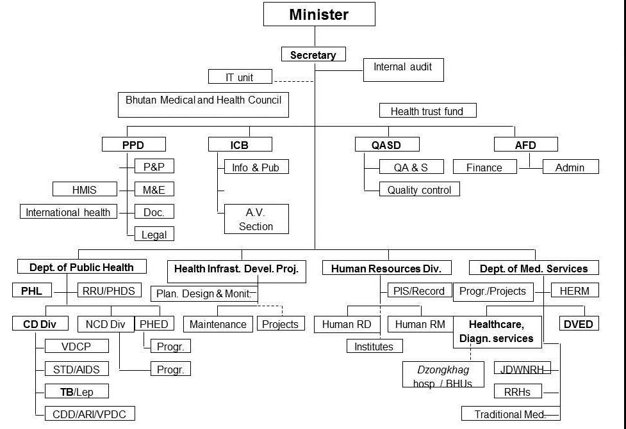
Figure 3: Organogram of Ministry of Health
The health care is delivered through three tiered systems viz. the primary, secondary and tertiary. They provide preventive, promotive, and curative services as shown in figure 4.
Figure 4: Pyramid of health care delivery system

The health workforce working in the above heath facilities consists of 194 doctors, 736 nurses, 578 basic health unit workers, 807 workers under technical categories and 98 traditional health workers working in the health facilities available all across the country as shown in Figure 5.
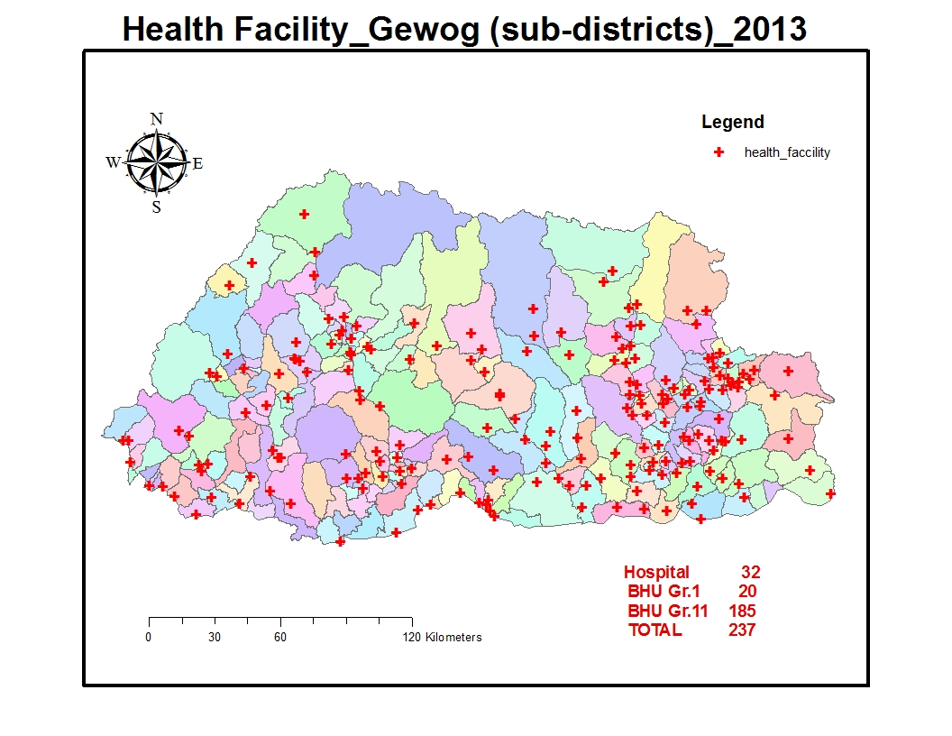
Figure 5: Map of health infrastructure (Annual health bulletin 2014)

With wide coverage of health facilities across the country, most people have reasonable access to health services with only 4.6% of Bhutanese population living at a distance of more than 3 hours walk from the nearest health facility and 81.5 % of the population seeking help from the health professionals as the first line of treatment (National Health Survey 2012).

With GNH as the country’s guiding philosophy, the government has prioritized and addressed a range of health issues, including access to basic health services as well as creating the infrastructure needed to sustain these programmes. As a result of the importance accorded by the government on health of the people, the health status of the Bhutanese has improved dramatically in the last decade although there are still various areas in need of development.

The main indicators as per the National Health Survey 2012

Indicators | Year
Indicators | 1984 | 1994 | 2000 | 2012
Crude rate of natural increase(Natural Growth rate of population) | 2.6 | 3.1 | 2.5 | 1.2
Total Fertility Rate (Births per women) | - | 5.6 | 4.7 | 2.3
Crude Death Rate | 39.1 | 39.9 | 34.1 | 17.9
Infant Mortality Rate/1000 live births | 102.8 | 70.7 | 60.5 | 30.0
Under-five Mortality Rate | 162.4 | 96.9 | 84.0 | 37.3
Maternal Mortality Ratio/ 100000 live births | 777 | 380 | 255 | 86
Table 1: Indicators of Health Survey - 2012
Bhutan launched 11th Five Year Plan (2013-2018) with focus on "Self-reliance and inclusive green socio-economic development" with an ability to meet all our national development needs by 2020. The 11th FYP has identified sixteen National Key Result Areas (NKRA) with clear measurable Key Performance Indicators (KPIs). The four pillars of the GNH are: 1) Sustainable and equitable socio-economic development 2) Prevention and promotion of culture 3) Conservation and sustainable utilization of environment and 4) Good governance. The GNH survey conducted in 2010 reported 26% contribution of sufficiency of each domain to overall happiness by the psychological well-being (11.97%) and health (14.07%), which is one of the highest among the nine domains. The health sector of the 11 FYP has 24 key performance indicators, and the performance indicator for malaria is “reduce malaria incidence per 10,000 population from 0.5 in 2012 to 0.35 in 2018 baseline. The share of budget for the MoH is Nu. 8146.34 millions consisting of 3.82% of the total budget.
The implementation of the FYP activities is monitored using the integrated planning, budgeting and expenditure management system through a web-based planning, budgeting and expenditure management system. The programmatic budget allocation of the VDCP is around Nu. 40 million which is about 8.6% of the total public health budget allocation. However, in real terms, the budget would be much higher as it does not include the district budget (it is integrated within the district plan and also the recurrent cost of the programme).

VECTOR-BORNE DISEASE CONTROL PROGRAM

The Vector-borne Disease Control Programme (VDCP) under the Department of Public Health (DoPH) is strategically located in Gelephu, Sarpang district, to facilitate efficient prevention and control activities of malaria and other vector-borne diseases. Sarpang district is one of the malaria endemic districts and has contributed maximum number of malaria cases. As compared to other public health programmes, VDCP as indicated in following organogram (Figure 6), enjoys some degree of financial autonomy, programme management and has adequate staff to carry out the routine prevention and control activates of malaria and other vector-borne disease.

Figure 6: Organogram of VDCP
In addition, the malaria programme has dedicated malaria technicians to take care of solely vector-borne disease in high malaria risk areas, although malaria related activities are also carried out in an integrated manner by village health workers at the village level, Health Assistants at the basic health units, and District Health Officers at the district level (Figure 7).
Figure 7: Organogram of decentralized activities in VDCP
Till date, malaria prevention and control was guided by the current National Strategic Plan (NSP) 2012-2016 which has the following five broad objectives:
- To intensify vector control and other preventive measures against malaria.
- To provide early diagnosis and prompt treatment of malaria.
- To strengthen surveillance system.
- To strengthen technical and managerial capacities for efficient and effective control of malaria leading towards malaria elimination.
- To sustain political and inter-sectoral support geared towards malaria elimination.
Through the implementation of this NSP and with the support of Global Fund and other partners, it resulted in only 45 malaria cases with no deaths in 2013. The budgetary support from the national and international partners are given in Table 2.
Programmatic budget 2008-2014
Budget (million) | 2008-2009 | 2009 -2010 | 2010-2011 | 2011-2012 | 2012-2013 | 2013-2014
RGoB (only for programme) | 7.96 | 9.91 | 9.628 | 11.706 | 10.17 | 12.00
GFATM | 48.146 | 59.216 | 18.352 | 19.133 | 12.958 | 35.99
GoI | 8 | 9.26 | 8.322 | 7.301 | 8.232 | 8.00
WHO | 2.16 | 2.418 | 1.158 | 2.3 | 0.797 | 0.86
Total | 66.266 | 80.804 | 37.46 | 40.44 | 32.157 | 56.852
Table 2: Programmatic budget 2008-2014

EPIDEMIOLOGY OF MALARIA

Bhutan has two species of malaria parasites namely Plasmodium falciparum and Plasmodium vivax. Anopheles minimus, An.fluviatilis and An.dirus were assumed to be the malaria vectors in Bhutan, however, over the recent years, these species have not been recorded and An.pseudowillmori and An.culicifacies are suspected to be the vectors because of their behaviour (both endo and exo-phagic and anthropophillic) and their relative abundance during the peak transmission season. Other Anopheles fauna record of 25 species out of which An. pseudowillmori, An. vagus, An. subpictus, An. culicifacies, An. jamesii, An. pseudojamesii, An. annularis, An. philippinensis, An. kochi, An. peditaeniatus, An. acinitus, An. barbirustris, An. barbumbrosus and An.umbrosus are more common in plains. The mountain species encountered are An. maculatus, An. willmori, An. lindesayii, An. baileyii, An. Aitkenii, and An. bengalensis. Recorded species but not encountered during the past few years are An. minimus, An. fluviatilis, An. dirus, An. tessellates, and An. Jaiporeiensis.

Epidemiologically, there was a declining trend of malaria cases over the past decade prompting to move into the elimination phase of malaria strategy. Details are shown in the following Table 3.
Year | BSC | Total +ve | Total PF | Pf% | ABER | API | SPR | Death | CFR/ 100
2004 | 54892 | 2670 | 1090 | 41 | 12 | 6 | 5 | 5 | 0.5
2005 | 60152 | 1825 | 954 | 52 | 13 | 4 | 3 | 5 | 0.5
2006 | 66079 | 1868 | 905 | 48 | 14 | 4 | 3 | 6 | 0.7
2007 | 51446 | 793 | 379 | 48 | 11 | 2 | 1.5 | 2 | 0.5
2008 | 47268 | 329 | 181 | 55 | 10 | 0.7 | 0.7 | 2 | 1.1
2009 | 62341 | 972 | 559 | 58 | 13 | 2 | 2 | 4 | 0.7
2010 | 54709 | 436 | 175 | 40 | 11 | 1 | 1 | 2 | 1.1
2011 | 44481 | 194 | 102 | 53 | 9 | 0.4 | 0.4 | 1 | 1.0
2012 | 42512 | 82 | 35 | 43 | 8 | 0.2 | 0.2 | 1 | 2.9
2013 | 31632 | 45 | 14 | 31 | 6 | 0.1 | 0.1 | 0 | 0.0
Table 3: Malaria data for the past 10 years

Seasonal trend of malaria & key population affected
The malaria peak and trough seems to follow the seasonal change of the country. The first peak is usually in the spring season i.e. April-May with the onset of monsoon season and when the weather becomes warmer. The other peak which is typically higher, is in the autumn season i.e. (August-September) when the monsoon rain becomes less frequent before giving way to cool dry winter (Figure 8).
In terms of the population at risk, farmers are the most affected as the peak transmission coincides with peak agriculture work. During the April month, farmers usually start to till their land for rice plantation and other crops, and in August it is their harvest time.
The second largest populations at risk are the students. This risk is likely due to their habits of staying late night watching TVs and occasionally studying outside under street lamps. As per the Malaria indicator survey, only 22% of the students go to bed before 9 p.m. Usually during these timings, they are not protected by LLIN. Therefore, IRS use is important in addition to use of other mosquito repellents.
As the programme moves towards elimination phase, the areas affected by malaria have declined. The estimated population living in malaria risk within the seven endemic districts has reduced to 181,955 in 2013 compared to 294,296 in 2010. Micro-stratification of malaria cases have revealed that even within the districts, in some chiwogs (blocks), no malaria cases were reported within the past few years. However, considering the prevalence of vectors, population movement and other factors, there is a high potential for outbreak if proper measures are not put in place.
In the endemic districts, the high risk groups are between 15-49 years of age (considered be to be the most productive age group). Again the males and the most affected occupational groups are farmers followed by the students who appear to be exposed to outdoor biting. The vulnerability of such productive groups and subsistence farmers has negative impact on the productivity and impede socio-economic development making the poor, poorer.
Bhutanese in non-malaria areas often travel or migrate to the southern malaria risk areas for commercial or other purposes. Therefore, all the population may be considered at risk of malaria. Besides, the movement of population is very high in the southern bordering towns owing to commercial reasons (Figure 9).
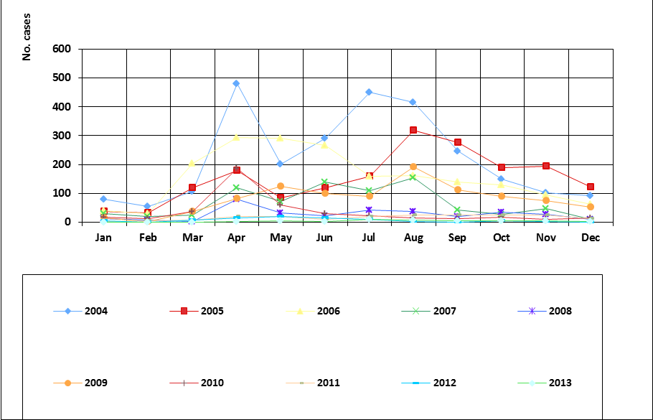
Figure 8: Seasonal tread of malaria cases
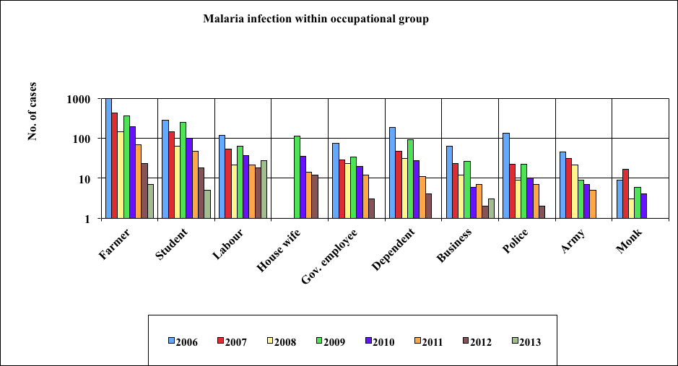
Figure 9: Malaria infection within occupational group

Classification of malaria transmission
Previously, the classification of malaria transmission was done as endemic districts which have perennial transmission of malaria, seasonal districts which have malaria transmission during summer months, and malaria-free areas where cases were not reported and there were neither vectors nor favorable climatic conditions due to high elevation (Figure 1).
However, as the programme shifts to an elimination phase and as malaria transmission has reduced drastically in some gewogs, even in endemic districts which do not have malaria transmission for the past few years, there is a need for re-stratification of malaria transmission areas so that the interventions could be better targeted.
Retrospective case mapping using GIS for the past three years was conducted in order to develop evidence-based strategies and interventions in the malaria at risk. Based on the case prevalence of malaria for the past 3 years (2011-2013) irrespective of indigenous or imported cases, sharing direct border, vector prevalence and climatic factors that favour vector survival, districts have been stratified as high, low, potential and no transmission zones (Figure 10).
During the phase of the malaria elimination, further micro-stratification at the gewog and chiwog level was carried out in all the districts using case mapping for three years with GPS at the point of case reporting. It took into account of climatic factors, vector prevalence, and presence of projects with migrant workers (hotpops). This micro-stratification is used to develop strategic interventions (LLIN, IRS, Surveillance and Trainings). This is necessary because there are non-transmission gewogs in high transmission dzongkhags and likewise there are hotspots and hotpops in low and potential areas that need attention and vigilance.
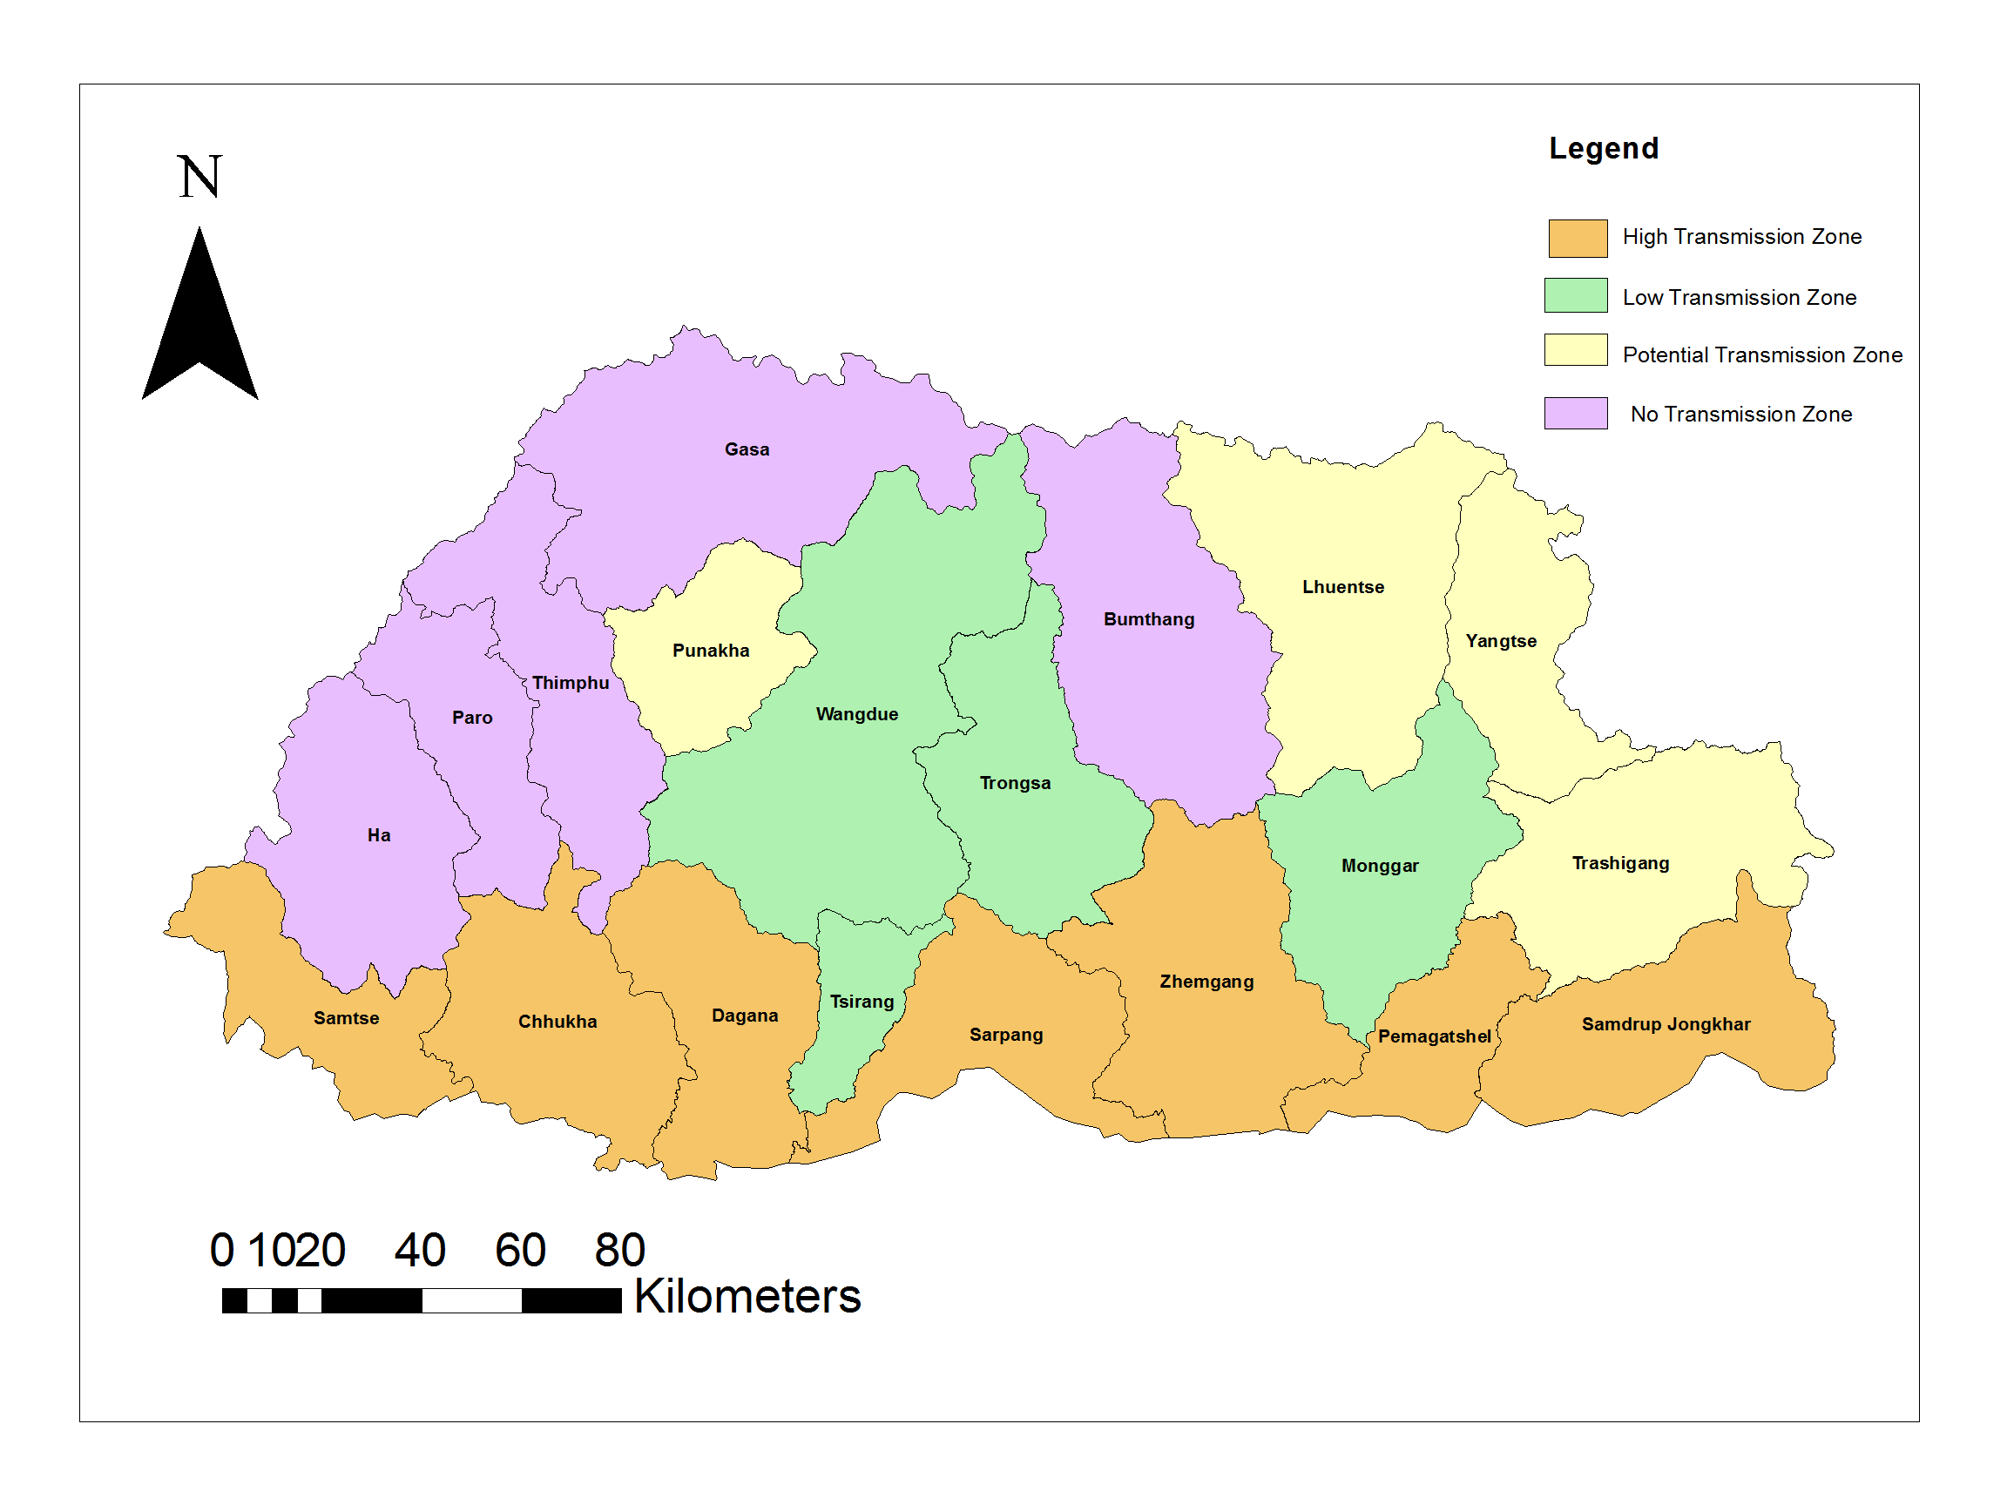
Figure 10: Dzongkhag wise stratification map of malaria risk in Bhutan

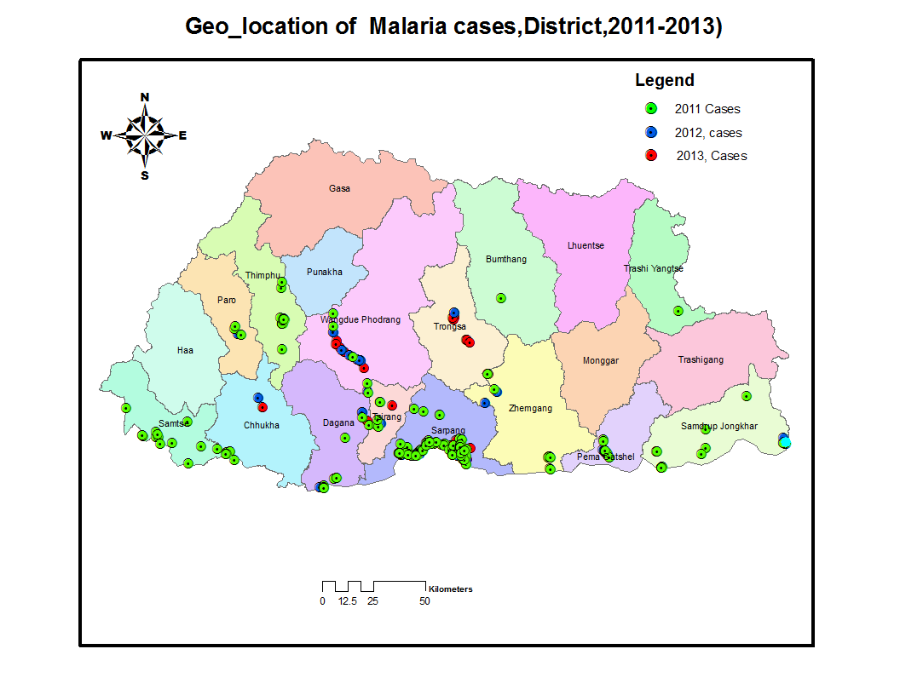
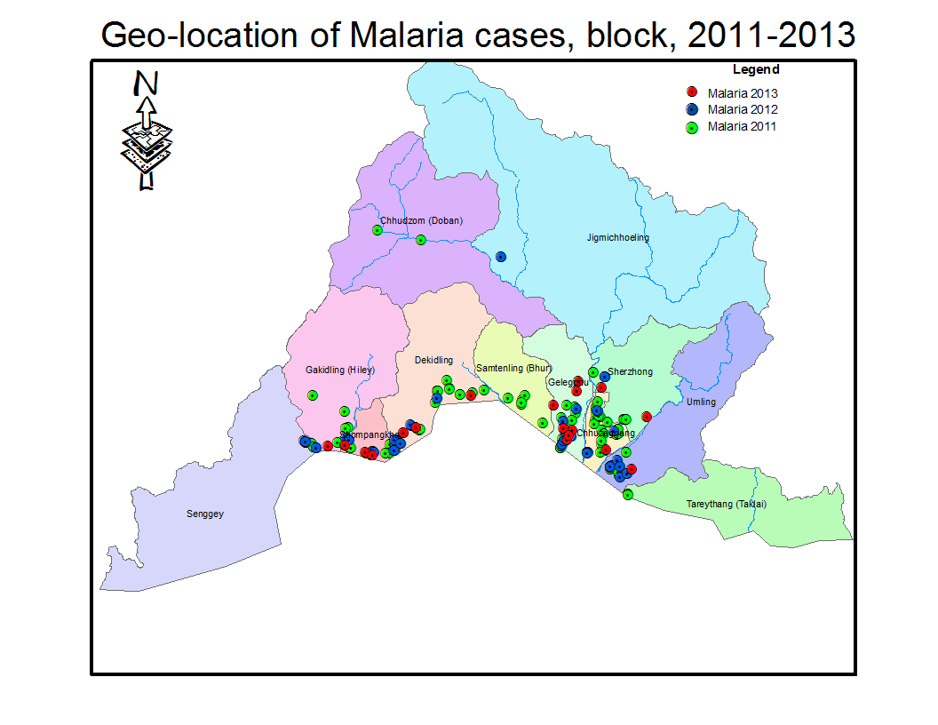
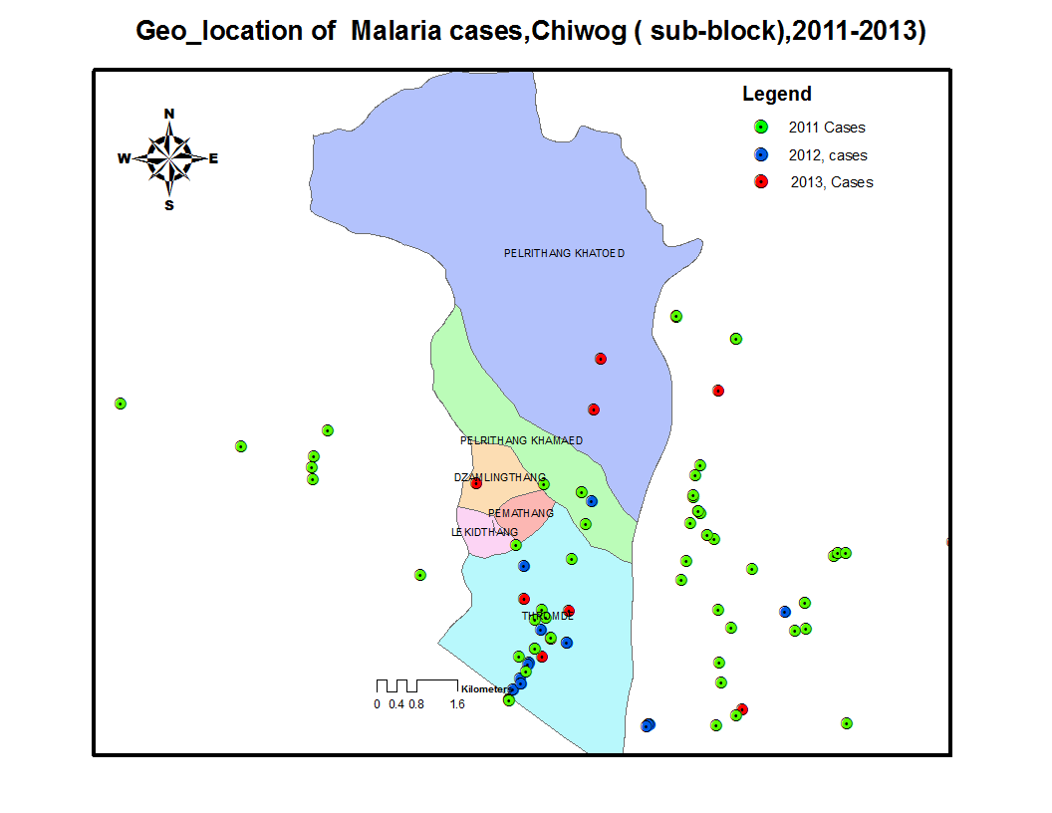
Sarpang District
Gelephu Block

Figure 11: Geo-location of malaria cases

Cross-border and imported malaria cases
Bhutan shares an unfettered border with malaria endemic Indian states (Figure 13). Therefore, cross-border malaria initiatives are very crucial for malaria elimination.
Figure 12: Bhutan map showing bordering districts of Assam and West Bengal

In 2013, there were more malaria cases in non-Bhutanese detected in Bhutan than the Bhutanese (Figure 13).
Figure 13: Case of Bhutanese and Non-Bhutanese 2006-2013

As shown in following graph (Figure 15), the foreign laborers screened for medical check-up at the two hospitals located in the international border areas which are also the entry points of labourers, show an increasing trend.

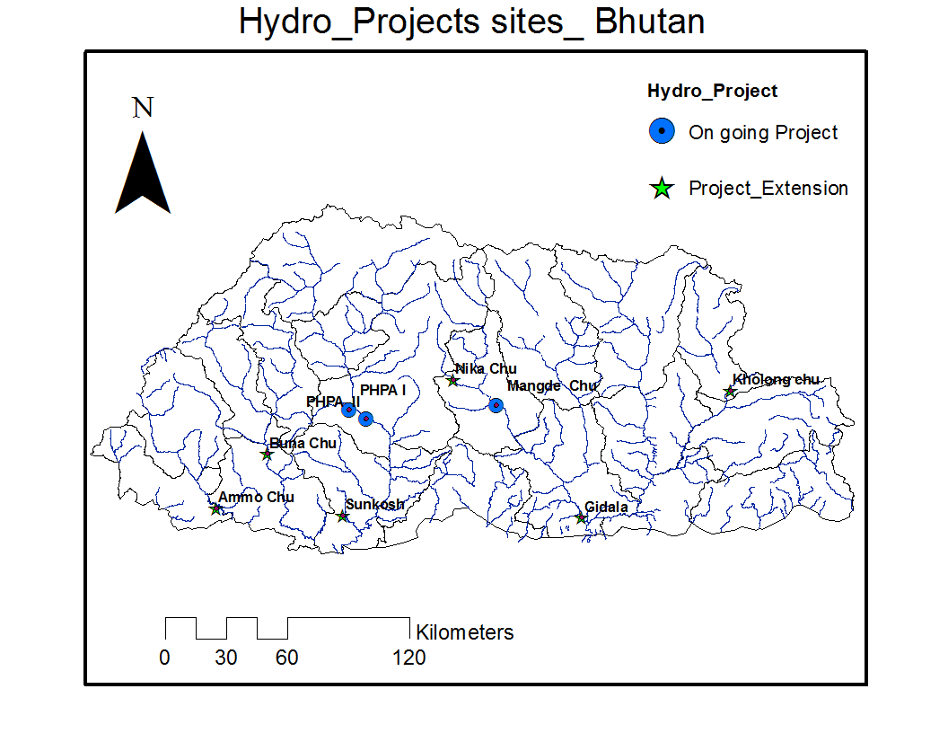

Figure 14: Hydro-power projects under 10,000MW development initiative (Source: Malaria case study draft version)

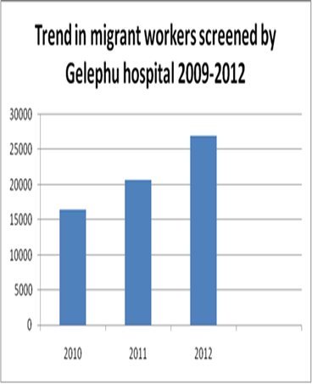 | 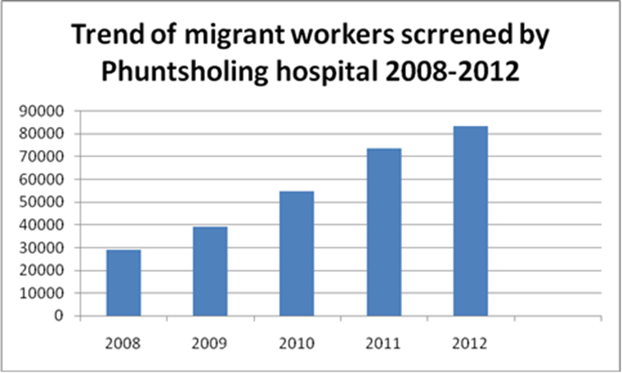
Figure 15: Screening of migrants workers at Gelephu & Phuntsholing hospitals (correct the spelling of ‘screened’ in the table 2 above RINZIN pls do necessary as I don’t have figure)
Surveillance conducted at the mega projects has detected both Plasmodium falciparum and P. vivax cases as shown in Table 4. Although the cases detected are few, considering the availability of conducive climatic conditions, there is potential for outbreak in the locality. Hence screening of malaria among expatriates is very important.
Active surveillance data done in project areas in 2011 – 2013
Year | Project area | BSC | Pf | Pv | Total +ve.
2011 | PHPA | 987 | 0 | 1 | 1
2011 | DHPA | 307 | 0 | 0 | 0
2012 | PHPA | 4595 | 3 | 4 | 7
2012 | MDPA | 1438 | 0 | 1 | 1
2013 | PHPA | 2678 | 0 | 2 | 2
2013 | MDPA | 111 | 0 | 0 | 0
Table 4: Active case surveillance data from 2011 to 2013

MALARIA INDICATOR SURVEY 2013

With the support of the Global Fund, the VDCP has conducted malaria indicator survey to know the extent of programme coverage and to measure the reach of the malaria interventions to the community. The major findings of the survey are given in Figure 17.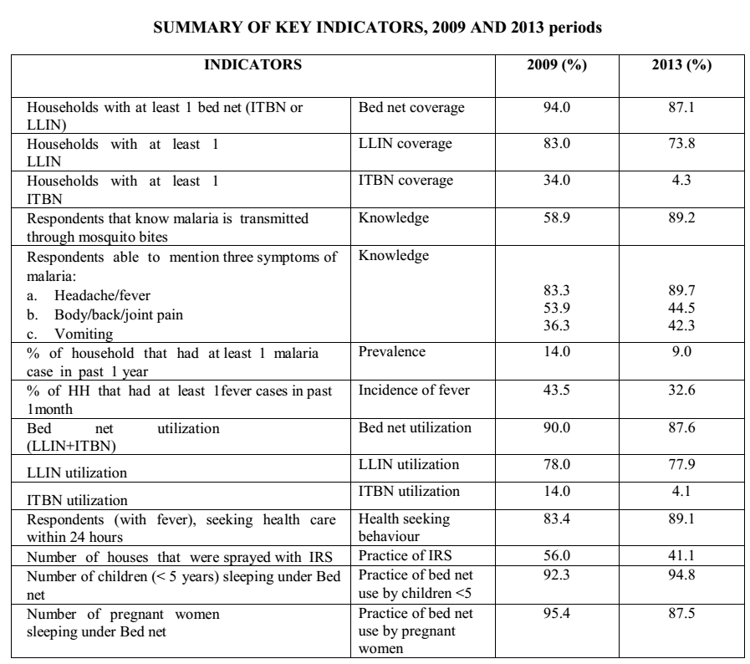
Figure 16: Summary of key indicators, 2009 & 2013 (Source: Malaria Indicator Survey 2013)

EXTERNAL REVIEW OF MALARIA PROGRAM 2013
The recent External Review conducted in collaboration with WHO for malaria programme in September 2013 made the following recommendations (Table 5):
Strategic Areas | Recommendation
Case management | - Update the clinical treatment guideline and clinical algorithm.  - Update BHU and DH staff on case management and the 24-hour notification reporting of positive cases especially those in “seasonal transmission areas”.  - QA/QC system to be strengthened in malaria diagnosis.  - Management of P. vivax infections to be implemented (e.g. PQ 14-day on DOT).  - Provide adequate RDTs, ACTs and ASU at all health facilities in case of emergencies.
Vector control | - Continue the combined use of LLINs and focal IRS in active foci as per the classification using past three years. Implement IRS first in new detected foci to be followed by maximum LLIN coverage during three years.  - To address the potential appearance of insecticide resistance, phase out cyfluthrin from IRS programme and develop a cost-benefit plan for rotations of OP/or carbamate class of insecticide. Incorporate this recommendation into the national chemical policy.  - Develop and implement a study protocol to monitor the survival of LLINs in field studies in households, following WHO technical guidelines  - Consider setting up a mechanism to ensure the availability of the LLIN in the private sector.  - Expand IVM activities to other “perennial districts”.  - Establish a Vector Control Inspector post responsible for malaria and other vector-borne diseases including a comprehensive training curriculum to be approved by the Bhutan Medical & Health Council and Royal Institute of Health Sciences.  - Conduct vector surveillance in representative ecological zones and collaborate with a PCR lab to incriminate Anopheles vectors.  - In collaboration with EHP, develop a landscape receptivity index of malaria based on current EHP project in Gasa, Punakha, Wangdue, and Dagana districts, 2013-2016.
Advocacy, IEC BCC | - IEC/BCC strategy to be updated in the context of elimination and prevention of re-introduction of malaria and other VDCs.  - Updated IEC/BCC materials to be adjusted to essential community activities made available to VHWs and CAG members targeting farmers and students.  - Appropriate IEC/BCC materials to be piloted to target migrant workers (from India) at various project sites.
Community-based activities | - Better involving VHWs/CAG members in monitoring the use and maintenance of LLINs on a regular basis, in report on HH LLIN gaps and in index case investigation (including hand-made or electronic mapping).  - Take advantage of the annual HH survey by BHU to monitor the use and maintenance of LLINs.  - Provide CAG members/VHWs with proper guidance and materials and refreshing training pertaining to malaria and VDC IEC/BCC community interventions including immediate reporting of suspected cases or unusual events in the community “migrant strategy/policy” pertaining to VDC diseases.
Mega projects | - MOUs between MOH and new/ongoing projects to be signed and should incorporate all health concerns & components.  - Health staff of projects to be trained or retrained by VDC in essential interventions (e.g. immediate notification/investigations and reporting of positive cases by using VDC forms).  - All cases to be recorded and properly classified into the national malaria register to be consolidated.  - IEC/BCC materials to be made available in project areas with messages adjusted to migrant workers’ behaviours and background.
Surveillance | - Keep routine surveillance (passive cases) such as from BHU to district and BHMIS.  - Clearly keeping national records of N1, N2 and N3 (single reporting system to be consolidated).  - Case notification of all cases (N1, N2 and N3): clarifying notification and feed-back channels (hotline). Mail, SMS, fax or calls (known call numbers).  - Subsequent actions: SOPs for Index case investigation and decision tree for different actions including use of PCR and feed-back on results.  - 3-year data of confirmed cases to be reviewed by chiwog and further confirmed by villages to decide next 3-year operations: see VC part.  - Input data into GIS for action at chiwog level with other essential components to be mapped like BHU, breeding sites, HH, current operations.  - Updating TORs of the malaria technician to be VDC inspector to include above surveillance tasks and actions including epidemic detection and response.  - Better engaging/supporting project authorities and their health personal into passive and active surveillance with regular feed-back from VDC.  - IEC/BCC materials to be made available in all active chiwogs.  - Training session to be organized.
Cross Border Malaria | - Sharing data for inter-country network for BBIMNS.  - Bhutan – India Specific-sharing of information regularly through WHO or through WHO Collaborative Centres- Field Station, National Institute of Malaria Research (NIMR), Guwahati, Assam.  - Meeting of Ministers of Bhutan, Union Govt. of India and States of Assam and West Bengal.  - Policy decision – sharing data on across the border.  - Frequent meeting of district level officers for sharing information and for developing/planning joint cross-border activities.  - Institutional collaboration on the following areas:  - Training for biologists,  - Molecular technique for malaria vector and parasite, support for QA of Microscopy and RDT,  - Operational Research for Monitoring for Therapeutic Efficacy of Anti-malarial drugs, insecticide resistance as well as research on -  forest-related malaria and malaria related to population movement.
Malaria NSP and M & E Framework | - Establish TWG and seek technical support from WHO as needed.  - Update National Strategic Plan.  - Update framework to monitor progress and evaluate outcomes and impact.  - Include estimated costs in the NSP.
Program management and staff capacity | - VDCP should be re-structured to deal with the challenges of malaria elimination and prevention of re-introduction of malaria and other vector-borne diseases.  - Include epidemiologist at central VDCP.  - Revise the post and the post description of the District Malaria Supervisor and Malaria Laboratory Technician to VDCP Supervisor and VDCP Inspector respectively to deal with malaria and other vector-borne diseases.  - Transfer the supervision VDCP Inspector to DHO.  - Update the operation manual and training materials to ensure standardized implementation at each level.  - Conduct training/re-training to support integrated approach to implement malaria elimination and other vector borne disease control programmes.
Table 5: External Malaria Review 2013

COLLABORATING PARTNERS

The success of malaria programme was mainly due to the support from the national and international collaborating partners. The main international collaborating partners are WHO, Government of India and GFATM which provided both fund and technical support. Although traditionally, GoI and WHO were the main partners, Bhutan managed to secure funds from GFATM in Round 4 (2006), Round 7 (2008) and Transitional Grant (2013), and that made huge impacts in case reduction. As shown in figure 18, the mass LLIN distribution through GFATM is likely to be related to reduction in malaria cases. In addition, Bhutan is also one of the founding members of APMEN and APMEN provides assistance in conducting operational research grants and fellowships for capacity building (Table 6). The fellowship in malaria mapping has enabled the country to move towards micro-stratification.
Funding support from various collaborating partners
Budget (million) |  | 2008-2009 | 2009 -2010 | 2010-2011 | 2011-2012 | 2012-2013 | 2013-2014
RGoB (only for programme) |  | 7.96 | 9.91 | 9.628 | 11.706 | 10.17 | 12.00
GFATM |  | 48.146 | 59.216 | 18.352 | 19.133 | 12.958 | 35.99
GoI |  | 8 | 9.26 | 8.322 | 7.301 | 8.232 | 8.00
WHO |  | 2.16 | 2.418 | 1.158 | 2.3 | 0.797 | 0.86
Total |  | 66.266 | 80.804 | 37.46 | 40.44 | 32.157 | 56.852
Table 6: Funding support from various collaborating partners

GFATM & ITS IMPACT ON MALARIA

Bhutan received two rounds of grants Round 4 (2004) & 7 (2008) followed by the transitional grant with a total grant of amounting to USD 4810126 (R4 $1 343 198 R7 $2 646 162, TG $820766). The Round 4 and 7 grants allowed for the scale up of prevention and control strategies and the introduction and dissemination of new tools, in particular a new artemisinin combination therapy antimalarial treatment for P. falciparum (artemether-lumefantrine) and LLINs. In 2012, Bhutan received an “A” rating (approved without any recommendations) for its proposal for the Global Fund Transitional Funding Mechanism, which covers July 2013 to June 2015, with the goal to sustain API at 1 per 1000 population or less and to achieve zero malaria-related deaths. The objectives of the grant are to: sustain malaria control and prevention in malaria endemic areas; sustain early diagnosis and prompt treatment; and sustain an essential health workforce in malaria control and prevention. The funds will be used to sustain the supply of LLINs and treatment. The Round 4 grant provided funding for increasing access to early detection and prompt treatment of malaria through community participation along with dissemination of IEC materials. Activities were also supported to strengthen microscopy capacity in the public sector and procurement of RDTs for epidemics, investigative surveys and other contexts. Enhanced quality assurance of diagnostics through extension of cross checking activities and procurement of ACTs for P. falciparum was supported. Extensive training was conducted including training on topics such as referral and procurement of pre-referral drugs, training of trainers for diagnosis and patient management, health care providers on malaria prevention and control, laboratory technicians and other health staff on microscopy, and others.

The Round 7 grant focused in the endemic and epidemic-prone dzongkhags, the main activities being LLIN distribution to those populations that were considered hard to reach, and to issue replacement LLINs and provide IRS as an epidemic control tool. Training, improved laboratory services, and use of RDTs were implemented to lead to scale-up of early diagnosis and prompt treatment for malaria since it was particularly hard to reach populations. Village health workers were supported to detect fevers and refer to health facilities in hard-to-reach areas, and BCC activities were scaled up through village health works, malaria technicians, community leaders and mass media outlets. In addition, the VDCP and hospital systems were strengthened through equipment and staff training. Staff recruitment and training in the areas of management, entomology and vector control, clinical case management and service delivery for the malaria programme were also biffed up. Community leadership was also enhanced to support the formation of the Community Action Groups which carried out the malaria activities in the communities. Surveillance activities were enhanced through support for reporting, database use and mapping.

Due to the main funding from the GFATM over the past years added by support from other partners namely GoI, WHO and Asia Pacific Malaria Elimination Network, reported malaria cases in 2013 was reduced to only 46 cases with no death taking the programme into the elimination phase.
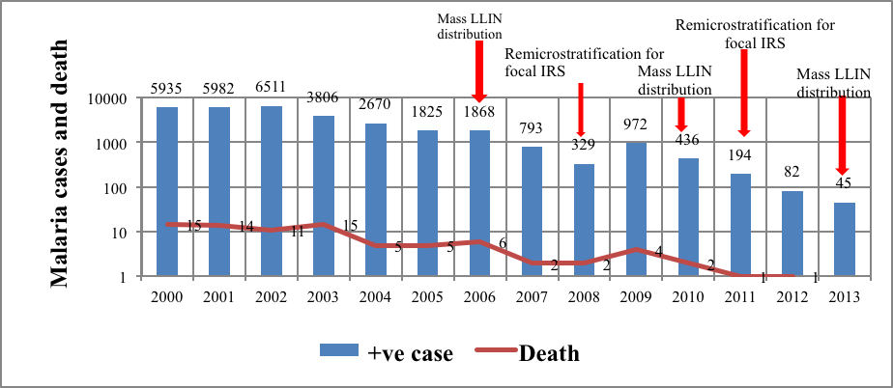
Figure 17: Interventions and achievement of malaria programme

FEASIBILITY OF MALARIA ELIMINATION
The information on elimination in the data basis available in country will form the basis for WHO-certification procedure (Source: Weekly Epidemiological Record 2014, 89,321-336). This information will include but not limited to (i) a national malaria case register with individual case investigation forms on all malaria infections detected in the country for the past 3 years; (ii) annual malaria surveillance reports covering the past 10 years; (iii) full information about active malaria foci in the 5 years before the last indigenous case (iv) reports of quality-assurance activities for diagnosis; and (v) a central repository of information related to entomological monitoring and application of the chosen vector control interventions. As of now, Bhutan in collaboration with WHO has conducted the elimination feasibility and found that it is feasible to eliminate malaria from Bhutan as shown in table 7.

Main determinants | Area | Favourable factors and indicators | Feasibility
(1) Vectorial capacity/Receptivity
Is vectorial capacity low at the outset? | Entomology | - Low vectorial capacity: Vectors short-lived, not very anthropophilic, low vector density.  - Low prevalence rates and entomological inoculation rates. | - Yes (pseudowillmori is the possible vector)  - Yes  - Overall favourable
Can it be reduced to a level compatible with elimination? | Entomology | - Highly endophilic and endophagic vectors; mainly night-biting.  - Focal distribution.  - Man-made and/or easily identifiable, well delimited breeding sites.  - Not insecticide-resistant (though we have alternative insecticides).  - Short transmission season.  - Evidence of rapid and major impact of vector control.  - Inability of certain vectors to transmit P.falciparum from certain heterologous zoo-geographic regions. | - No. The vector bionomics have changed in recent years due to the specific vector control interventions (IRS, LLIN).  - No. widespread distribution.  - Yes, man-made/easily identifiable.  - No  - Yes  - Yes  - Not relevant  - Overall favourable
Can it be reduced to a level compatible with elimination? | Physical environment | - High altitude with temperature-dependent transmission, often small houses with sprayable walls (highland fringe).  - Arid with precipitation-dependent transmission (desert fringe).  - Terrain does not pose permanent or seasonal access problems. | - High-altitude - no risk.  - Mountains & deep valleys – seasonal low risk.  - Plains, forest & forest-fringes, border areas - significant risk.  - Overall favourable
Can it be reduced to a level compatible with elimination? | Human ecology | - Houses with sprayable walls, not multi-storied.  - Spontaneous use of personal protection measures.  - High quality housing, air-conditioning.  - No activities outside in late evening/night/early morning.  - No nomadic habits/forest plot agriculture.  - Tap water available.  - Not very low population density. | - Yes  - Generally yes  - Usually no  - Yes  - No  - Yes  - Yes  - Overall favourable
Can it be reduced to a level compatible with elimination? | Control effectiveness | - Possible to achieve and maintain high effective coverage with selected intervention(s).  - Collaboration of all affected communities and potential partners (inter-sectoral). | - Yes  - Present, can be further strengthened.  - Overall favourable
Can it thereafter be maintained below a threshold? | Environment, development | - Ongoing or expected changes in natural or human ecology favouring lower vectorial capacity, depending on zoo-geographic region and local vector bionomics (e.g. deforestation, desertification, pollution, urbanization).  - Absence of natural or man-made disasters. | - Yes, improvement in urban planning, housing and water supply.  - No natural man-made disasters.  - Overall favourable
(2) Duration of infectivity
Can duration of infectivity be reduced to and maintained at very low level? | Parasitological | - No P. vivax, especially in tropical areas.  - No resistance to antimalarials (though resistance is a reason to attempt elimination!). | - Pv still present (50%).  - Yes, no resistance.  - Favourable since the numbers are very low.
 | Human ecology | - Possible to secure adequate treatment seeking behaviour and treatment adherence.  - No cultural, political or legal barriers or fault-lines.  - No sub-groups of patients (among indigenous or imported cases), who are less likely to obtain timely quality case management. | - Generally yes  - No  - Minimal  - Overall favourable
 | Control effectiveness | - Possible to achieve high effective coverage of case management/ surveillance.  - Adaptation of treatments to any resistance, inclusion of anti- gametocyte and -hypnozoite medicines. | - Achievable  - Yes  - Overall favourable
(3) Vulnerability
Can importation of infections be reduced or maintained at low level? | Social and economic | - No, or little and controllable, population movement leading to importation of malaria.  - Low malaria risk in neighbouring countries, especially in border areas.  - No expectation of major increase in the rate of immigration of potential parasite carriers, resulting for example from political instability in neighbouring country or increasing domestic demand for foreign labour.  - Adequate services for all migrants (respect for human rights). | - Yes. Significant population movement present  - High risk  - Increasing risk  - Services are being expanded, further improvements are possible.  - Less favourable for elimination, BUT the risk of transmission is low since there screening mechanisms in place, interventions are in place for them, and they stay in high-altitude areas.
Table 7: Feasibility of malaria elimination

Operational feasibility
Contextual
  - Political and social stability especially in malaria risk areas - Favourable
  - Effective government with clear geographical demarcations and division of responsibilities - Favourable
  - Good, collaborative relations with countries from where carriers could be imported–Favourable (GoI Fund for Bhutan)
  - Collaborative private sector (health and non-health) in malaria risk areas - Favourable
  - Good demographic data and databases of villages with mapping - Favourable
General health system
  - Governance
    - Politically and technically strong leadership; political stability - favourable
    - Culture of relying on evidence and reliable HIS data - favourable
    - Regulation of private health care sector including pharmacies - favourable
  - Health services
    - Geographically, economically and culturally accessible in risk areas (distance to provider, out-patient consultations per year) - favourable
  - Human resources for health
    - Sufficient, educated, trainable, motivated, properly remunerated, stable - favourable

Malaria control programme
  - Technical and administrative capacity and leadership - favourable
  - Able to mobilize financial resources - favourable
  - Enough fiscal space (can be authorized to expand budget as required) - favourable
  - Enough “human resource space”: can be authorized to recruit enough people with requisite skills – favourable, since the available resources are adequate
  - Excellent malaria microscopy services or strategy for achieving that – favourable, may need further improvement
  - Excellent surveillance or strategy for achieving that – favourable, needs further improvement
  - Good entomological and epidemiological support – Not favourable
  - Good management of preventive and curative services including supply chain and human resources - favourable
  - Good capacity in communication and advocacy – favourable with some limitations
  - Good information technology support including mapping, capacity to obtain and use meteorological information and to stratify the national malaria problem- favourable, needs further improvement

Research institutions
  - Good research capacity for public health problems in the country - Needs further improvement
  - Capacity for genotyping plasmodia is also an asset - Needs to be established

Overall impression on technical feasibility: Favourable for elimination although some areas need establishment or strengthening as indicated above. These areas which need strengthening or establishment including the ‘requirements for’ are addressed in this NSP.

GUIDING PRINCIPLES

Achievement of overall malaria elimination targets set in this malaria strategic plan will be guided by the following broad principles:
  - Forge national ownership of malaria elimination through establishment of a Malaria Elimination Commission (MEC) to garner political support, resources and provide oversight and accountability.
  - The Vector-borne Disease Control Program (VDCP), DoPH shall coordinate the consultative planning, implementation, research, monitoring and evaluation of malaria prevention and elimination activities.
  - Build strong mechanisms for partnerships with line ministries and agencies, local leaders and private organizations involving multi-sectoral collaboration for effective implementation of this plan to achieve malaria elimination.
  - Strengthen decentralized malaria elimination with district health taking the onus of malaria elimination and promoting community empowerment to initiate malaria elimination activities.
  - Establish and strengthen institutions to train and support malaria competent health human workforce, to tackle any resurgence, re-introduction or outbreaks and to keep malaria on the agenda through research and development.
  - Collaborate and networking with neighboring local leaders, countries, international organizations and agencies.
  - Utilize modern technology for micro-stratification, surveillance and disease notification, conduct research and epidemiology analysis to generate evidences to guide malaria elimination strategies and interventions.

KEY ASSUMPTIONS

The following key assumptions are important to achieve malaria elimination within the time frame of this National Strategic Plan (NSP) and sustain beyond:
  - Continued political commitment by leadership at all levels to support the national strategic plan for malaria control and provide adequate financial and human resources.
  - Continued international support both in technical and financial aspects.
  - Further improvement in the socio-economic developments of the people of Bhutan.
  - Availability of armamentarium to tackle new situations if arises such as drug and insecticidal resistance.

STRATEGIC PLAN 2015-2020

Vision, Mission, Goal & Objectives

Vision
Bhutan free of indigenous malaria

Mission
Achieving malaria elimination through use of evidence based interventions, sustaining political support and mobilizing multi-sectoral and community participation at all levels, and strengthen institutional capacity to prevent reintroduction of transmission.

Goal
To achieve zero indigenous malaria in Bhutan by 2018 and obtain WHO malaria-free certification by 2020.

Outcome objectives
- To eliminate all active foci of malaria by 2018.
- To prevent resurgence of malaria from 2018 onwards.
- To sustain zero malaria death from 2015 onwards.
- To further strengthen health system and community system to sustain malaria elimination.

To support the objectives, the following strategies will be implemented. The strategies are interconnected, mutually inclusive and complementary to each other. This NSP 2015 – 2020 is a living document and therefore, it will be reviewed every two years and if required amended to address the epidemiological and programmatic situations and aligned accordingly with other national plans.

BROAD KEY STRATEGIES & MAIN ACTIVITIES

The main strategies include reduction of foci to zero indigenous cases through focused supply of LLINs, IRS and investigating every case. The effective treatment will be provided on DOTS either at the health facility by the health worker or by the VHW in the communities. These will be backed by quality assured laboratory services and use of web-based mobile networks for real time reporting and geographical reconnaissance. The governance structures to provide elimination oversight will be instituted at all levels and monitoring, evaluation and supervision will be strengthened. Community mobilization and participation will be pursued through community led interventions. History has shown that malaria elimination without readiness for the institutions to take up outbreaks leads to catastrophic epidemics and mortality as the health facility would not be prepared both in skills and supplies to absorb the epidemics. Therefore, learning from these lessons, training institutions will be established and strengthened, which will conduct research and training and also keep malaria on the agenda beyond the elimination phase. The specific strategies and activities for each strategy are described below.

Focused prevention and elimination of transmission and prevent re-introduction

Geographical reconnaissance

Geographical Reconnaissance (GR) operations using Global Positioning Systems (GPS) is initiated to map retrospectives malaria cases of the past three years by the programme. During the current NSP, the stratification will be conducted throughout the country and the maps will be linked together to define spatial malaria case, vectors and breeding sites distribution for targeted strategic interventions. The district health personnel, programme leaders and health workers can use the data for stratification at gewog (block) and chiwog (sub-block) level. Data will be uploaded and analyzed in customized Geographic Information System (GIS) databases to produce case distribution maps and generate relevant summary information pertaining to the GR operations. GIS software and GPS equipment will be procured to facilitate these operations.
Geographical Reconnaissance (GR) operations using GPS has been piloted in few health facilities of Sarpang districts using mobile phone technology and this will be expanded to other districts. Activities include:
    - Procurement of equipment for GIS (severs, scanner, printers & computers) and Android gadgets.
    - Procurement of GIS software.
    - Training on GIS software & application development.
    - Development of system and operational/training manuals.
    - Training of districts health workers on GIS mapping.
    - Vector and breeding site mapping in moderate, low and potential transmission areas.

Mapping, delimitation and classification of foci by gewog

In line with the WHO guideline for "Disease surveillance for malaria elimination: An operational manual", the foci classification is operationalized for Bhutan under the following classification.
- Free: No evidence of local transmission for the last 3 years and not receptive.
- Potential (cleared up foci): No evidence of local transmission for the last 3 years but receptive.
- Residual non-active foci: No current transmission but had the history of transmission in the past 3 years.
- Active/new foci: a) Residual Active: Transmission at low level at present and had transmission in the past three years; b) New foci: Currently has the evidence of active transmission but no history of transmission during the past 3 years.

Category | Definition | Variables to be considered
Free | No evidence of local transmission for the last 3 years and not receptive. | API (API=0), No indigenous cases, absence of anopheline vector, good quality of surveillance.
Potential (Cleared up foci) | No evidence of local transmission for the last 3 years but receptive. | API (API=0), No indigenous cases, presence of anopheline vector, risk groups and other factors (Migrant, new settlement, occupation related workers, developmental projects), geo-ecological factors, good quality of surveillance.
Residual non-active foci | No current transmission but had the history of transmission in the past 3 years. | API (API=0.1 – <1), Very low number of indigenous cases, decrease in number of foci, presence of risk groups and factors (Migrant, new settlement, occupation related workers, developmental projects), geo-ecological factors. Quality of surveillance requiring improvement.
Active/new foci | - Residual Active: Transmission at low level at present and had transmission in the past three years.  - New foci: Currently has the evidence of active transmission but no history of transmission during the past 3 years. | API (API= >0.1), presence of indigenous cases, presence of foci, presence of risk groups and factors (Migrant, new settlement, occupation related workers, developmental projects), geo-ecological factors. Quality of surveillance requiring improvement.

Levels: API (per 1000 pop at risk): A = 0, B = 0.1 – <1, C = 1+

Process of micro-stratification
- Sensitization of decision makers about the importance of micro-stratification for elimination of malaria.
- Developing standardized user friendly format and guidelines for data collection.
  - National programme at central level in participation with other stakeholders.
- Orientation and re-orientation of staff at all levels.
- Collection of village-wise data on epidemiological and other core variables.
  - Coordination to be done by the District Programme Unit.
- Compilation, analysis and interpretation of data at district level in consultation with sub-national/central level as applicable in the country.
- Data quality assurance at all levels as per norms laid down in the guidelines (national/sub-national).
- Decision making about micro-stratification/re-stratification on annual basis.
- Countries may use modern technology to facilitate the process (e.g. remote sensing and IT).
- Ensuring adequate and continuous resources.

Validation
Confirmation of data should be validated by independent competent institute by malaria microscopy annually.

Use of IT tools
- Integrating user-friendly IT tools (GIS features) in the health information system.
- Capacity building of the local staff in the use of IT tools and feedback to all levels.
- Support by the government for basic infrastructure for establishment of IT technology and its sustenance.
The stratification as per the above will be carried out firstly as per gewog and then by chiwogs. During classification, the border districts will be classified as high risk even though the classification criteria might group otherwise. This will be done due to proximity of malaria endemic areas across the border within mosquito flight range and high number of population influx and reflux to and fro the endemic areas.
    - Collection of household and demographic GR data per chiwog.
    - TA for map generation.
    - Printing of Foci delimitation maps.

Targeted interventions based on foci classification
The interventions will be targeted both at macro-stratification and micro-stratification depending on the interventions.

1.3.1 Macro-stratification
The interventions will be targeted based on both macro-stratification and micro-stratification. Some interventions such as M & E, medical supplies, and review meetings require district level intervention as these districts are stratified by risk of transmission malaria into no risk. Risk during seasonal and perennial risk districts is shown in Table 8.
 | No risk | Risk only seasonal transmission | Perennial risk
Drugs supply | Yes | Yes | Yes
RDT | Conditional | Yes | Yes
Microscope | Yes | Yes | Yes
Health worker training on case management | Yes | Yes | Yes
Monitoring & Supervision | Annually | Quarterly | Monthly
Event monitoring | No | Yes | Yes
IEC/BCC | Yes | Yes | Yes
District Rapid Response Team | Yes | Yes | Yes
Meteorological monitoring sentinel sites | Yes | Yes | No
District Malaria Review Meeting | Annual | Bi-annual | Quarterly
Table 8: Macro-stratification table
Gewog is the lowest administrative boundary. Although initially the micro-stratification will be done as per the gewog, as the elimination progresses, the micro-stratification by gewog may still be a big area (Table 9). Therefore, stratification by chiwog (sub-block) will be done during the course of this strategy period and interventions will be done accordingly. However, the mosquito flight range will be taken into account regardless of the boundary of the chiwog. Chiwogs along the international border will be given priority too (Table 10).
Interventions | Free foci | Potential (Cleared-up Foci) | Residual Non active | Residual Active focus | New active Focus
LLIN | No | No* | Yes | Yes | Yes
IRS | No | No* | Yes | Yes | Yes
Case management | Yes | Yes | Yes | Yes | Yes
Follow up (Pf) | 28 days | 28 days | 1 year | 1year | 1 year
Follow up (Pv) | 28 days | 28 days | 3 years | 3 years | 3 year
Case investigation | Yes | Yes | Yes | Yes | Yes
Screening for malaria in developmental projects | No | Yes | Yes | Yes | Yes
Screening for malaria cases as per algorithm in health facilities | Yes | Yes | Yes | Yes | Yes
Re-active case detection | No | Yes | Yes | Yes | Yes
Entomological surveillance | Conditional | Annually (selective sites) | Annually (selective sites) | quarterly | Quarterly
Insecticides susceptibility test | No | No | No | Yes | Yes (conditional)
TES | Yes | Yes | Yes | Yes | Yes
Laboratory services at health facilities (microscopy) | Yes | Yes | Yes | Yes | Yes
IEC/BCC | Yes | Yes | Yes | Yes | Yes
CAG | No | Yes (Selective) | Yes (Selective) | Yes | Yes (Selective)
Table 9: Interventions by foci classification (Gewog boundaries)
*Except in border areas and very high risk of malaria transmission

1.3.2 Targeted focused interventions with LLIN and IRS

Long Lasting Insecticidal Nets (LLINs) will be provided to all households in residual non active, residual active, new active focus and new potential focus. On emergence of cases in cleared up areas, households of 1 km radius around the index case will be issued LLINS. The mass distribution of LLINs was carried out in 2014 and is expected to do the same in 2016 and every three years thereafter. LLIN will also be distributed to mobile population including migrant workers and mobile population. Cross-border risk and fringe areas will also be given importance for LLIN distribution, considering the risk, although they may fall in different categories during micro-stratification.

Like LLIN, two rounds of IRS with cyfluthrin 10% WP, which is the current chemical used, will be done in areas of Residual active, Residual non-active and New Potential focus. Cross-border risk and fringe areas will also be given importance for LLIN distribution, considering the risk, although they may fall in different categories during micro-stratification. To prevent pressure of insecticide resistance due to longer period use of same insecticide, the alternate chemical (Organophosphate/Carbamates) for IRS will be explored using WHOPES guidelines and incorporated within national chemical policy framework. For the effectiveness of IRS, training and re-training of the spray squads including their supervisors are necessary. For this, every year all the spray squads including their supervisor will be trained by the districts on proper spray technique and how to supervise based on the existing guidelines.

WHO external review conducted in 2013, recommended the VDCP to continue with the current strategy of ‘LLIN/IRS combination’ considering the current success in the country. The training will also include how to do the maintenance of sprayer parts and take safety precautions. Activities include:
        - LLIN procurement/distribution for mass distribution and yearly additional.
        - Enumeration of households & population for distribution planning.
        - Piloting and promotion of LLIN social marketing.
        - Review and revision of chemicals and insecticides.
        - Procurement of yearly insecticide.
        - Procurement of spray pumps.
        - Procurement of fogging machine.
        - Training of spray squads by districts (yearly).
        - Spray operational cost per annum.
        - Ad hoc focal spray depending in case emergence.
        - Procurement of protective attire for sprayers.

Empowerment of Community Action Group (CAG)

The Community Action Group (CAG) was specifically formed with the overall objective to carry out social mobilization activities including community level awareness raising programmes. Village health Volunteers (VHW) who are the main drivers of the CAG will be the main persons in the community. CAG will also carry out the Integrated Vector Management (IVM) at the community level. The current NSP will not only strengthen the existing CAG members but will also expand the scale of these groups. The CAG members will be oriented on the identification and management of breeding places in addition to diagnosis of cases and its referral and strengthening surveillance. Training package includes:
    - Training of new CAG members.
    - Refresher course for CAG members.
    - Exposure trip to learn from best practices from the region (India/Sri Lanka) for CAG members.
    - Provision of remunerations for CAG members for fever surveillance.
    - Supporting innovative ideas for vector control at communities.
    - Development of IVM/CAG training manuals and guidelines.
    - Training of CAG members on IVM in gewogs of high transmission districts.
    - TA for comprehensive IEC/BCC malaria elimination strategy.
    - Develop IEC/BCC materials to be piloted and published.
    - Enable CAG members to influence political leaders within their constituents.

Quality assured laboratory diagnosis, treatment and follow-up

Diagnosis

Case diagnosis

The malaria case diagnosis will be done as per the diagnosis algorithm. The community systems especially VHW shall be trained to provide active referrals of the fever cases to the health facility. All the fever cases in the residual active focus will have to be screened either by microscopy or RDT methods. However, in other areas, screening will be done after assessing the individual cases such as travel history, malaria outbreak, reactive cases or other suspicion of malaria.
The quality of diagnosis will be improved through trainings and refresher trainings to enhance the capacity of in-service and pre-service health workers. Existing guidelines will be updated periodically and new guidelines developed. Availability of diagnostic equipments including microscopes and RDTs will be ensured in all facilities. PCR facilities will be available at the central level. The use of RDTs will be expanded up to the community level for active case detection. Activities to strengthen case management include:
      - Revise and update guidelines.
      - Training/retraining of health workers on diagnosis of malaria.
      - Procurement of microscopes.
      - Procurement of RDTs.
      - Training of Trainers (ToT) on malaria diagnosis.
      - Pre-service training programme for RIHS trainees.
      - Transportation of sample for PCR test for those diagnosed cases by (RDT/Microscopy).

Establishment of National Quality Assurance (NQA) system for malaria diagnosis

Quality system will be strengthened through trainings/re-training of health workers based on updated National Quality Assurance (NQA) system framework and guidelines. Quarterly proficiency tests will be conducted and spot trainings provided. National Malaria Reference Laboratory will be established at the PHL. The districts laboratory technicians will be trained on the QA)/QC systems. Activities for the establishment of NQA systems include:
      - Establishment of malaria reference laboratory (PHL, microscope, filtration and equipment).
      - Ex/in country training of laboratory personnel on QA.
      - Shipment cost for transportation of sample for cross checking out country.
      - Update national QA guideline for diagnosis.
      - Develop SOP for reference laboratory.
      - QA supervisory visit to districts.
      - Procurement of slide, slide box, racks, slides mounting materials & reagents.
      - TA for establish and preparation of slide bank.
      - Establishment of slide bank (rack, AC etc.).
      - Proficiency testing and spot trainings of health workers (TA & shipment).
      - Attend QA workshops and seminars in the region.
      - Training of health workers on QA.
      - Annual QA review meeting (once in a 2-3 years).

Accreditation of private laboratories
With the economic development, there are already a few diagnostic private laboratories in Bhutan (Around four as of 2014) and additional facilities may come up in future. Therefore, it is important that the quality assurance systems are instituted in these facilities and these facilities are accredited by the National Malaria Reference Laboratory (NMRL). The activities to institute accreditation will include:
      - Capacity assessment in private diagnostic clinics.
      - Training of laboratory staff for private diagnostic clinics.
      - Monitoring and supervision for QA follow-up.

Treatment
The current treatment guideline is being updated in 2014. This guideline will be used for the next three years. In 2016, it will be reviewed if required to incorporate the changes. The patients with uncomplicated cases will be given an option to stay in hospitals or go home. To ensure effective and prompt treatment, anti-malarials will be made available to all the health centers. Treatment guideline will be updated and health workers and professionals including health workers working at project sites will be trained/re-trained.
The treatment will be given on DOTs by the health worker in the health facility and VHW will administer the DOTS in the community. VHW shall be paid the minimum wage for taking care of the patients equivalent to the number of hours lost for his field work in accordance with the minimum wage labour i.e. approx. USD 5/day. The health workers will also be trained on the ADR monitoring and reporting and VHW will be trained on monitoring any events and reporting to the health facility.
There will be a 24-hour notification reporting of any positive cases. And all cases will be thoroughly investigated to differentiate whether a case is indigenous or imported within 24 hours. Follow up of cases will be mandatory and a total of five visits (Day 3, 7, 14, 21, 28) will be made after initial investigation or discharge from the health center. The follow up visits will be done by the health worker to know the outcome of the treatment, treatment adherence, therapeutic efficacy studies at sentinel sites, screening of fever cases, vector control and mapping among others. Activities on strengthening treatment include:
    - DOTs on 14 days Primaquine by VHW-(Wages) & Pf not admitted in Health facility.
    - Training/Re-training of VHWs for prevention and fever surveillance and DOTS.
    - Training on ADR reporting and monitoring.
    - Update treatment guideline.
    - Development and printing of treatment charts.
    - Training/re-training of health workers on treatment of malaria.
    - Training of health professionals in the region on management of severe malaria and complications.
    - Procurement of Anti-malarials (ACT and others).

Follow-up of all cases

All cases will be followed up to check the relapse of cases and to check the foci. Pf cases will be followed for only 28 days in pseudo-focus and cleared up focus but will be followed up for a period of one year in new potential, residual non-active cases. The follow up for the residual active focus will be done on monthly basis for all indigenous cases.
Pv cases will be followed for 28 days in pseudo-focus and cleared up areas. However, in new potential focus, new active focus, residual non-active and active focus, the follow up will be done for the next three years on an annual basis to check the relapse cases (in the first year it will be done monthly, and thereafter it will be done annually for the next two years). Activities will include:
    - Development of case follow-up procedures and reporting systems.
    - Training of VHW on case follow-up.
    - Involving VHW for bringing the case for blood check-up.
    - Case investigation and follow-up for all cases.

Sustaining knowledge and skills for malaria case management

The strategy is targeted at strengthening the comprehensive management of malaria cases including severe malaria management at the hospitals including nursing care. The health workers will be also trained on the mortality related to malaria (mortality investigation) and the actions to be taken. The mortality investigation report will be presented to the Malaria Technical Group as and when death occurs to revisit the interventions and amend if necessary.
Considering severity of malaria cases and the requirement for prompt treatment, current Health Help Centre information systems through 112 will be used to impart and advise patient to visit hospital for fever cases based on risk. HCC health workers and EMT will be trained on imparting malaria information to those who seek advice for fever illness. Activities include:
    - Ex-country of faculty members of UMSB for conducting for institutionalize the training course on management of sever malaria.
    - Development of training modules for training case management of malaria cases.
    - Incorporation of severe malaria course into GP course, pediatric, HA, Nursing and other relevant courses.
    - Malaria death investigation.
    - Formation of Malaria Technical Working Group and development of ToR.
    - Conduct quarterly MTWG meeting.
    - Training the Health Help Centre staff & Emergency Medical Team on fever case management.
    - Establishment of referral systems for severe malaria through alert networks.
    - Procurement of ambulance (RGoB).
    - Review of malaria death by TWG.

3. Intensified surveillance and response

Disease surveillance

Districts’ Rapid Response Action

Although, a Rapid Response Team (RRT) is instituted at all levels for investigation and response of any disease outbreak, it lacks a clear mandate and SOPs for efficiently carrying out the investigation and containment. Therefore, this team will be strengthened to utilize the same systems for malaria outbreak. However, during malaria outbreak investigation, the RRT will be joined by an entomologist or health workers working in entomology (Entomology Inspector). The RRT will be trained to carry out the malaria outbreak investigation, contentment and prevention. Further, their mandates and SOPs for malaria related RRT will be also developed and instituted. Activities to strengthen district RRT include:
      - Development of ToR and SOP for malaria outbreak investigation for the district RRT.
      - Integration and training of malaria outbreak response for the district RRT.

National malaria database

At the central level, Bhutan Health and Information system (BHMIS) is used for information management and data collection. However, it collects only the most important information per diseases. For example, only malaria cases and mortality are reported by the VDCP on quarterly basis, which in practice, does not suffice the information required for rapid operations.

Bhutan now has internet and mobile services throughout the country. Despite these developments, the existing reporting system is still done by using conventional technology like faxing, postal or email. This has been the main constraint in getting real time information from the field for quick response from programme and managing reliable data. To address these constraints, VDCP has piloted the web-based reporting systems, Bhutan Malaria and Febrile Information System (BMFIS) (Figure 19) and its feasibility for expansion. The pilot project was successfully conducted and expansion of this system to other areas is found to be feasible. However, current system although piloted, needs to update and incorporate some more features to make it comprehensive including integration of sms reporting and alert systems.
The system also includes GIS to map cases, and environmental risk factors including vector breeding habitat for implementation of interventions. Since the web-based system has been piloted successfully, it is proposed that such systems be replicated in all health centers for real time reporting. However, GIS reporting tools will be made available only in high and low malaria transmission areas. Activities include:
      - Procurement of computer and PDA (mobile pad).
      - Procurement of servers and accessories for web based reporting.
      - Integration of SMS fever surveillance into the web-based system.
      - Ex-country study visit for IT and programme personnel on web- based, mobile technology application and data management.
      - In-country training of health professionals and health workers on web-based reporting system and mobile technology application.

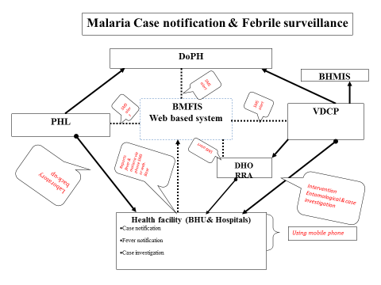
Figure 18: Malaria case notification & febrile surveillance

Case notification, investigation, classification and follow-up

Malaria is a notifiable disease and as per the health policy, malaria should be reported to PHL, which is the nodal division for all notifiable diseases. Piloted web-based reporting system can be integrated with existing web-based notifiable reporting system of PHL for data sharing. Existing malaria surveillance system is an enhanced passive surveillance system supplemented by case-based follow-up intervention. The surveillance reporting centers are all health centers in the country. As a preparatory step towards malaria elimination, the existing surveillance will be scaled up to an active surveillance whereby every fever case will be screened as per the algorithm outlined in the treatment guideline. As part of the active case finding, VHW will be involved in detecting and reporting malaria cases. Nonetheless, communities especially in moderate and low transmission areas will also be involved to assist VHW and health workers in detecting malaria cases. Activities include:
      - Revised malaria surveillance guideline.
      - Develop surveillance guideline training modules for health professional and health workers.
      - Develop surveillance guideline training modules for VWH.
      - Training of health workers on revised surveillance guideline.
      - Training of VHW on revised surveillance guideline.

Re active case detection

The cases will be followed up to identify the cases around the index cases. Such a measure will prevent outbreaks by screening the potential risks within the geographical risk which is set at 1 km radius of Index cases. Fever surveillance will be conducted around the index cases and LAMP will be used for screening populace. Activities include:
      - Geographical reconnaissance after identification of index case.
      - Screening of potential populace for malaria.
      - Procurement of LAMP & reagents.
      - Development of SOPS and manuals for LAMP.
      - Training of health workers on LAMP.
      - Increase awareness within the risk population around index case.
      - Implementation around the Index case (case diagnosis and treatment, LLIN & IRS).

Active case detection (projects sites and in case of outbreaks)
Due to increase in hydropower projects and other economic developments, many dams are being constructed bringing in many foreign workers. This poses a threat to malaria elimination. Therefore, following activities will be initiated:
      - Provide technical support to the project areas.
      - Screen febrile workers for malaria.
      - Perform Index case investigations in camps/settlements of workers to identify secondary cases.
      - Conduct IEC/BCC activities.
      - Conduct consultative meeting to evaluate, plan and conduct Health Impact Assessment during the design, construction and operation of water development projects.

Entomological surveillance

Foci based vector surveillance
Monthly entomological vector surveillance will be conducted in cleared up, new potential areas and residual Non active areas, and quarterly for New active focus and Residual active focus areas, and annually in cleared up and new potential areas.

      - Collection of entomological data
      - Data analysis and preparedness plan
      - Provide feedback for any risk

Developmental projects
Entomological surveillance will be done in the developmental projects to determine the potential for transmission to identify the level of receptivity. The surveillance will be necessary to ensure that the appropriate vector control measures are in place to prevent onward transmission. If vectors are present, appropriate interventions will be done to prevent transmission. The survey will also include the determination of potential breeding sites created during the project development and mitigations. The activities include:
      - Consultative meeting with project management.
      - Conduct of survey.
      - Feedback and recommendations.
      - Follow-up on the implementation of the recommendations.

Monitoring of insecticides resistance

Bio-assay test will be carried out quarterly as per the WHO guidelines in the sentinel sites. In addition to the three existing sentinel sites, two more sites will be identified for the study in other high transmission districts. The activities include:
      - Procurement of Bio-assay cones, Impregnated papers and WHO insecticide susceptibility test kit.
      - Conduct quarterly insecticide and bioassay monitoring in five sentinel sites.
      - Training of health workers on bioassay insecticide susceptibility test.

Special events surveillance
The event surveillance will include population movements, construction of developmental projects, monitoring of climatic data, fever monitoring in the communities and reporting any potential malaria risk developments. This will be done through the multi-sectoral collaboration and community monitoring. Since vector survival and geographical spread is sensitive and dependent to climatic change, climatic data like temperature, humidity and rainfall will be collected to understand the impact of climate change on vector in the country to facilitate in planning of future vector control interventions. Activities include:
    - Training VHW and urban health workers on fever reporting and monitoring.
    - Collect environmental and climatic data in collaboration with environmental health and Hydromet Department.
    - Develop and implement malaria-risk mitigation measures.
    - Ex-country training of entomologists and health workers (involved in vector surveillance) in entomological surveillance.
    - Meeting with Hydromel Division, Department of Energy on climatic data collection and sharing of data.
    - Periodic surveillance for vector surveillance to develop landscape receptivity index along the Punatshangchu river belt.
    - Integration of climatic & vector data into web-based reporting system.

Strengthened governance and institutional capacities
  - Creating enabling environment for elimination and prevention of reintroduction

Although Bhutan has reduced the reported malaria cases to a very minimal level, it is important that the country has the institutions and the technical capacity to successfully eliminate malaria and prevent reintroductions. Therefore, following enabling strategies will be adopted during this NSP.

  - Updating of policies & guidelines
As the elimination progresses, it is necessary to review and update the tools such as manuals, guidelines, strategic documents, forms etc. to adopt the changing situations. During the course of this NSP, following guidelines and manual maybe updated:
      - Treatment guideline.
      - Update National Strategic Plan.
      - Surveillance manuals.
      - Forms and other documents.
      - Monitoring and supervision guidelines.
      - Training modules and guidelines on all aspects of malaria including entomological modules/guidelines.
      - Consultative meeting to develop the guidelines.
      - Printing of the reporting forms and format.

    - Establish Bhutan Malaria Elimination Commission (BMEC)

The Malaria Prevention and Control Division under the Ministry of Health has benefited the political will and support for the implementation of its activities. The political support is required more than ever as the country moves into elimination phase, and any dwindling of support and focus would relax the malaria prevention activities resulting in malaria rebounds. Therefore, this strategy focuses on garnering political support and instituting governance for malaria elimination. Malaria Elimination Commission (MEC) will be constituted as the highest overseeing body and support policy directives for malaria elimination. This body will be established under the approval of the Cabinet constituting the key decision making bodies. MEC, after the approval of the Cabinet, will liaise with WHO to align the elimination activities for certification within the global perspective. MEC will be supported by the technical committee comprising of various key stakeholders to recommend appropriate interventions for the elimination. Activities include:
      - Sensitization of politicians and law makers on malaria elimination.
      - Formation of Malaria Elimination Commission and Technical committee.
      - Development of TOR and endorsement.
      - Endorsement from the Cabinet.
      - Meeting of the commission and technical members.
      - Site visit by the commission and technical committee for monitoring and status of elimination activities.

Bhutan Malaria Elimination Technical working Group (BMETWG)

BMETWG will be the main working group in all technical matters of the malaria elimination. This group will be composed of multi-sectorial members and communities to have wider inclusion in the decision making process. It is also important that they are equipped and trained in order to carry out the mandates competently. Activities include:
      - Development of TOR and endorsement.
      - Endorsement of the membership and power of authority.
      - Meeting of the commissioners and technical members.
      - Training of the members on malaria elimination.
      - Site visit for monitoring and supervision by members on malaria elimination.

Collaboration with line ministries

To successfully achieve the elimination and sustain it, there is a need for programmatic shift involving private organizations and line ministries/agencies. Their involvement will lead to incorporation of malaria prevention and control activities in all their developmental activities. The main line ministries may include but not limited to Ministry of Education, Ministry of Agriculture, Ministry of Labour and Human Resources, Ministry of Economic Affairs, and local government agencies such as thromde, etc.
Role of private and autonomous agencies will be pivotal during the elimination phase. The private companies, NGOs, CBOs can also be utilized in community mobilization for malaria preventions. With the changing global situation in relation to development and climate change, diverse involvement of stakeholders is of utmost importance. The possible line agencies are Ministry of Work and Human Settlement for incorporation of vector reducing planning and construction designs, thromdes for urban planning and taking a lead role for reducing mosquito breeding sites, Ministry of Labour for implementation of malaria activities in migrant workers and labour activities, and Ministry of Agriculture and Forest for incorporation of mosquito elimination activities in fishery ponds, IPVM, etc.
The stakeholders will be involved based on the potential and relevance of the malaria elimination initiatives. Activities include:

      - Identification of key stakeholders.
      - Conduct stakeholders’ meeting.
      - Development of proposals by these agencies.
      - Incorporation of malaria activities in their respective agencies/ organizations.

Cross-border and inter-country collaboration

Bhutan shares a porous border with Indian States of Assam, West Bengal, and Arunachal Pradesh which are all endemic to malaria. Without the effective collaboration and coordination, the elimination of malaria in Bhutan would be strenuously challenged. Although various initiatives have been conducted by WHO and other agencies, the implementation success has been rather weak. It requires the need for strengthened actions. Bhutan and India has always enjoyed an exemplary friendship. To deepen this good and cordial relationship, Indo-Bhutan Friendship Association was formed, which in time, was strengthened through local exchanges and initiatives. Bhutan and India conduct regular meetings to enhance peace and security across the borders, both at the local and central level. These platforms can be expanded to address public health related diseases affecting across the borders.

To create malaria awareness for the travellers, pamphlet will be kept at the immigration checkpoints, both at the airport and the land ports for free distribution. The programme will also initiate to strengthen institutional linkages by developing collaboration with the international partners and institutions to conduct research and provide technical backup. The possible institution could be AFFRIMS, VCRC, NICD, Mahidol University, WHO collaborating centres, APMEN, UCSF Global Health Group, etc. Activities include:
      - Coordination meeting.
      - Exchange of information and networking.
      - Coordinate awareness activities.
      - Malaria agenda in the existing structures such as SAARC & Indo- Bhutan Friendship Association.
      - Putting malaria agenda in local governance cross-border coordination meetings.
      - Sensitization of private retail pharmacies on cross-border movements of counterfeit anti-malaria and reporting.
      - Study visit to the collaborating institutions malaria network.
      - Conduct training, seminars and workshops on malaria elimination in collaboration with these international partners UMSB.

Strengthening partnership with private sectors and other agencies
The elimination demands partnership with all sectors especially with private partners so that elimination is sustained beyond elimination phase. Therefore, private partnership will be fostered during this NSP. They will be imparted technical competencies to take malaria elimination beyond 2020. The priority sectors may include constructions companies, labour agents, fishery, private diagnostics centres, food processing industries and pharmaceuticals and media agencies. Activities include:
      - Consultative meeting to develop roles of private agencies in malaria elimination.
      - Develop work plan for malaria elimination.
      - Provide financial support to private agencies as per the priority work plan developed.

Institutional strengthening both programmatic and other institutions

Institutional capacity building
History has shown that elimination of malaria without institutional capacity to sustain and tackle rebounds would lead to disaster. Therefore, it is very important that institutional capacity is developed to sustain malaria elimination and keep the technical and malaria agenda through research and training. University of Medical Sciences of Bhutan is established as an autonomous agency under the Act of the Parliament in 2013. Therefore, in collaboration with the university, training courses will be developed and implemented. The faculty capacity will also be built to retain the expertise within the country. In addition, Centre of Tropical and Zoonotic will be established in collaboration and affiliation with the university.
In order to sustain the clinical and public health response to effective malaria control and other vector-borne diseases, it is crucial to institute the mechanisms to ensure long-term impact through consistent and ongoing capacity development for both the pre-service and in-service health care providers. This will be realized only if the clinical management programmes and the public health intervention approaches are integrated into the curriculum of the University of Medical Sciences (UMSS) and the Royal Institute of Health Science (RIHS). This will also contribute to the development of overall health systems through sustained capacity building and ensure long-term impact of addressing human resource constraints. During the 11 FYP, Centre for Tropical and Zoonotic Diseases will also be established. Funded by the RGoB, the construction of the Programme Office and the Centre is already underway. Activities include:
      - Preliminary consultative meetings to discuss on the key areas to be incorporated in the teaching curriculum.
      - Incorporation of malaria in the pre-service training curriculum of UMSB.
      - Finalization and validation of curriculum for entomology technicians for the Diploma Certificate Course.
      - Conduct of diploma course for malaria technicians (5 per year).
      - Construction of the VDCP office and CTZD.

Sustaining technical managerial capacities of VDCP

Entomology service will be the main backbone for malaria elimination and sustenance of elimination. Therefore, strengthening entomology capacity in the programme and establishment of regional entomological service is critical for the successful malaria elimination in the country. The regional entomological service will serve as technical backstopping in carrying for high and low transmission areas in the respective regions. It will be carrying out entomological surveillance, vector control interventions and operational research studies. The regional entomological services will also provide programmatic backups and links between programme and health centers in the respective regions including carrying out of M & E (which is weak at the moment).
Entomological studies are crucial both during the elimination stage and thereafter to sustain elimination and prevent reintroduction. Resistance studies require data on generations of mosquitoes for susceptibility status. Establishment of insectary had been a long-felt need of the programme and it will be initiated in the programme laboratory within the 11th FYP. For this, insectary laboratory equipment and training of laboratory technician on mosquito colony development and maintenance are the foremost need of the programme.
The success of malaria control and prevention is always supported by the entomology in every work settings. The vectors and climate ecological changes play an important role for the transmission of malaria cases. As efforts to combat the global burden of malaria continue, there is a renewed focus on the need to strengthen vector surveillance throughout all phases of intensified malaria control and elimination. There is a renewed emphasis on surveillance and its ultimate role in identifying and rapidly tackling potential breeding sites and presence of vectors in high risk areas. The capacity of entomology staff, both at national and district level should be well defined and equipped with adequate knowledge and skills so that they are able to address the vector surveillance and modification of environmental management, do vector mapping, integrated concept and management, and monitor insecticides resistance and operational management. In the phase of elimination, the surveillance should be intensified and probable evidence-based and other factors provided for the development of programme planning and strategy.
Development of health infrastructure to strengthen the national response to malaria and other vector-borne diseases is primary to accelerate the programmatic interventions to control, reduce and eliminate indigenous cases of malaria. The infrastructure development in terms of building physical infrastructures, improving laboratory diagnostic facilities and building strong collaboration with other sectors/agencies will promote the quality-based sustainable programmatic response. Activities include:
      - Training of districts health officers and programme personnel on elimination strategy and report writing.
      - Training of programme personnel on evidence-based programme planning.
      - Training of M & E personnel.
      - Training of financial personnel on financial management.
      - Study tour to learn from the best practices from countries which have already eliminated malaria or are in the progress of elimination (programme personnel and district health representative).
      - Overheads and recurrent operational cost.
      - Office management training.
      - Hiring of vehicles.
      - Procurement of insectary laboratory equipment.
      - Training three technicians on insectary development and maintenance.
      - MSc in Entomology.
      - Training of entomology inspectors.
      - Procurement of office equipment.
      - Procurement of entomological equipments & reagents.
      - Procurement of entomological microscopic.
      - Recruitment of insect collectors.
      - Routine entomological surveillance.
      - Outbreak response.
      - MSc Training of entomologist (2 nos.), Tropical Medicine (1 no.), Epidemiology (1 no.), Pharmacology, major in drug research and molecular studies (1 no.).
      - Training on vector control operations (training & equipments maintenance).
      - Training on entomologist on IVM.
      - Training on malariology (3 Nos.).
      - Training VDCP staff in PCR for 4 weeks in the region (2 nos.).
      - Diploma training in parasitology and entomology.
      - Construction of programme office.
      - Salary of staff.
      - Maintenance of vehicle.
      - Operational cost for the programme.

Strengthening district level capacities for malaria elimination

Bhutan has been following the decentralized and integrated health policy. The VDCP will initiate compact signing between the districts for malaria elimination from their districts. At the district level, malaria elimination will be decentralized under the district health with VDCP providing only technical and budgetary support to the districts. Therefore, it is very important to train people from the districts on malaria elimination. Activities include:
      - Ex-country training of a few DHOs for malaria elimination.
      - Developing ToT manuals for district level implementation.
      - Conducting ToT training on malaria elimination of DHOs to train other health workers in the district.
      - Conducting district level training by trained people to the health workers within the district.
      - Monitoring and supervision by DHO to health facilities.
      - Maintenance of existing infrastructure.

Strengthening collaborating agencies within Bhutan
The quality of anti-malarials will be ensured by strengthening the capacity of the DRA. Support will be extended to the DRA in collection of anti-malarial drug samples for testing and in procuring reference materials for anti-malarial drug quality. Health workers will be trained on pharma-covigilance. The programme through its Global Fund R7 has procured minilab for testing the quality of anti-malarial drugs.
This strategy will strengthen the inventory system at the health facility and at DVED in terms of procurement management, distribution, stock maintenance and mobilization. The inventory system should be sensitivity to detect the stock-outs as it is very crucial to maintain at least some anti-malaria drug stock in all health facilities. Further, the store management of supplies needs alignment with the regulatory mandates enshrined in the "Bhutan Medicine Rules and Regulation 2012." Activities include:

      - Training of national drug testing laboratory staff on drug quality testing.
      - Training on WHO pre-qualification of anti-malarial drugs.
      - Training of health workers on adverse drug reactions.
      - On site testing of anti-malarial drugs using minilab.
      - Procurement of reference materials for minilab.
      - Training on procurement management.
      - Training on good store management for pharmacy storekeepers.
      - Establish coordination mechanism into outbreak response and stock mobilization mechanisms.
      - Support DVED for inventory management systems and development of inventory software- RGOB/HIV/TB.
      - Forklift for medical supplies.
      - Walk-in cold room.

Intensify supervision, monitoring and evaluation

M & E is the weakest link at all level in monitoring routine activities and tracking progress towards elimination. The existing programme M & E will be reviewed and comprehensive M & E tool developed. Activities include:
    - Integration with DHI.
    - Revision of M & E framework and tools.
    - Training of DHO/DMO/DMS on M & E framework.
    - Conduct KAP /MIS survey.
    - External review.
    - Strengthen household survey.
    - Publication of quarterly and annual reports.
    - Quarterly and annual visits by DHO, programme personnel & regulatory inspection.
    - Outbreak response tool development.
    - Outbreak investigation causality assessment-Meeting for national technical committee.
    - Observation of World Malaria Day to raise awareness.
    - Annual Malaria Review Meeting.

Generate strategic information for malaria elimination

As the country moves on to elimination phase, it is imperative that the operation research is conducted to understand the local context and generate strategic information for malaria elimination. The topics listed below are some of the priority areas but not limited to following. The research will be conducted in collaboration with private and collaborating partners.

Operational research in vector control
      - To conduct study of the survival and durability of LLINs in field level.
      - Entomological survey and vector incrimination using PCR (EPR 2013).
      - Rearing and inundation of indigenous and exotic larvivorous fish in permanent breeding sites in collaboration with national warm water fishery programme (NWWFP).
      - Procurement of PCR machine and laboratory equipments, reagents and consumables.

Operational research in treatment (T3)
      - Survey to find out asymptomatic parasitemia.
      - Survey to find out prevalence of G6PD deficiency.

Parasites genotyping
      - Procurement of PCR machine, sequencer and laboratory equipment.
      - Procurement of reagents and consumables.
      - Training of laboratory people/health workers on samples collection, preparation and shipment.
      - Ex-country training of laboratory personnel in PCR and genotyping.
      - Institutional linkages with WHO collaborating centre on malaria.
      - Collaborative studies on genotyping.

IMPLEMENTATION APPROACHES

The Department of Public Health under the Ministry of Health will lead the malaria elimination with VDCP at the helm of driving day-to-day co-ordination of the strategy and its activities, ensuring that all implementing partners have financial, policy, human resources and infrastructure capacity necessary to efficiently and effectively carry out their respective malaria elimination functions. VDCP will also provide technical and programmatic support on case management, entomological monitoring and vector control, surveillance, information and communication for behavioral change and community empowerment, as well as providing monitoring, supervision and evaluation of the activities that are implemented. VDCP will be the nodal agency for resource mobilization besides liaising and reporting to the international partners.
While VDCP develops policies and guidelines, the implementation of the elimination will continue and expand in a decentralized manner with elimination onus given to the district health through signing of the compact agreement. The districts may further decentralize to gewogs and chiwogs with Basic Health Units playing the central role at the community level. The BHUs have to initiate malaria elimination through community empowerment by mainly utilizing the Community Actions Groups (CAG) and Village Health Workers (VHW). The entomological services will be provided through the regional entomological units. The District Rapid Response Agent will attend to any outbreak with technical and entomological backup provided by the VDCP and public health laboratory.
The Malaria Elimination Commission is formed to serve as the main body to provide policy directions, oversight for the activity implementation and mobilize national budgetary resources. The commission will be backed up by the Technical Working Group (TWG) which would provide technical support and ensure that the NSP 2015-2020 is implemented successfully.
Public health laboratory will ensure the quality of malaria diagnosis through institution of quality assurance systems. In addition, it will also provide technical backup not only in malaria diagnosis and parasite genotyping, but also in strengthening surveillance systems.
The Drug Regulatory Authority and the Drugs Vaccines and Equipment Division will ensure the quality anti-malaria drugs, diagnostics and other medical supplies are procured and distributed throughout the country and are available all the time.
The University of Medical Sciences will collaborate to ensure that malaria is taught in pre-service training, maintain expertise among the faculties, and also offer diploma course in entomology to ensure that malaria is kept on academic agenda beyond the elimination period.
The malaria case notification, fever surveillance, case follow-up and geographical reconnaissance will be done through the sms or web-based real time data management systems.
The establishment of Centre of Tropical and Zoonotic Disease and collaboration with the University of Medical Sciences will ensure that health workforce specialized in malaria is retained to ensure sustainability of malaria elimination and address future re-introduction through research and development.
The RGoB will mobilize fund and resources for the malaria elimination. The international donor fund will be channeled through the Gross National Happiness Commission and the GNHC will monitor the overall planning, budgeting and expenditure through the web-based planning, budgeting and expenditure management system.

TABLE 10: PERFORMANCE FRAME WORK FOR MONITORING AND EVALUATION (2015-2020)
Indicator/Targets | Baseline (2013) | 2015 | 2016 | 2017 | 2018 | 2019 | 2020 | Source | Frequency/comments
Annual Parasite Incidence (API) (indigenous malaria) per 1000 population at risk | 0.06 | 0.05 | 0.04 | 0.02 | 0 | 0 | 0 | VDCP | Annually
Number of malaria deaths | 0 | 0 | 0 | 0 | 0 | 0 | 0 | VDCP | Annually
Number of confirmed indigenous malaria cases | 15 | 12 | 10 | 5 | 0 | 0 | 0 | VDCP | Annually
Number of gewogs malaria-free (No indigenous cases) | 199 | 199 | 199 | 200 | 205 | 205 | 205 | VDCP | Annually
Percentage of foci fully investigated | 0 | 0 | 50% (102/205) | 73% (150/205) | 100% (205/205) | 100% (205/205) | 100% (205/205) | VDCP | Annually
Proportion of health facilities participating in QA programmes | 0%  (237/237) | 10% | 80% | 100% | 100% | 100% | 100% | Quality Audit Reports | Quarterly
Number of people tested for malaria (including screening ) | 31,632 | 80000 | 125632 | 125632 | 125632 | 125632 | 125632 | VDCP | Annually
Proportion of health facilities with no stock-outs of RDT and ACT in the last three months | 100% (237/237) | 100% (237/237) | 100% (237/237) | 100% (237/237) | 100% (237/237) | 100% (237/237) | 100% (237/237) | Six Monthly Drug Report | DVED
Percentage of households with at least two LLIN in risk areas | 73.8% | >90 | >90 | >90 | >90 | >90 | >90 | MIS | Every 3 years
Percentage of health centers submitting timely reports according to national guideline | 89% (211/237) | 89% | 100% | 100% | 100% | 100% | 100% | VDCP | Annually
Percentage of cases treated within 24 hours of onset of fever according to the national treatment guidelines | 90% | 100% | 100% | 100% | 100% | 100% | 100% | MIS | Quarterly
Percentages of all indigenous reported cases investigated, classified & followed up. | 100% | 100% | 100% | 100% | 0% | 0% | 0% | VDCP (Web- based) | Quarterly
Number of health facilities reporting real time fever data (web- based) | 0 | 30 | 60 | 90 | 120 | 150 | 180 | VDCP (Web- based) | Cumulative
Proportion of population that slept under an insecticides treated net in the previous night | 77% | 90% | 90% | 90% | 90% | 90% | 90% | MIS | Every Three years
 | 95% | 95% | 95% | 95% | 95% | 95% | 95% | MIS | Every Three years
  Proportion of children < 5years old who slept under insecticides treated net in the previous night | 77% | 90% | 90% | 90% | 90% | 90% | 90% | MIS | Every Three years
No. of LLIN distributed to risk population after every three years and yearly additional supplies | 100017 | 10000 | 26100 | 130371 | 26100 | 26100 | 130371 | VDCP | Annually
Proportion of population protected by IRS in the last 12 months | 104 % (73000/70000) | 100% | 100% | 100% | 100% | 100% | 100% | VDCP | Annually
No. of suspected malaria cases that received parasitological test in public sector health facilities | 31632 | 31632 | 31632 | 23467 | 23467 | 23467 | 23467 | VDCP | Annual Report
Proportion of confirmed malaria cases that received the first line anti-malarial treatment according to national policy at public health facilities | 100% (45/45) | 100% (45/45) | 100% (42/42) | 100% (37/37) | 100% (32/32) | 100% (32/32) | 100% (32/32) | VDCP | Annual Report. It is assumed that the number of imported cases will remain same
No. of border screening centers established (centres) | 11 | 11 | 11 | 11 | 11 | 11 | 11 | VDCP | Cumulative
Number of sentinel sites where insecticide resistance monitoring carried out as per WHO protocol (sites) | 3 | 5 | 8 | 8 | 8 | 8 | 8 | VDCP | Cumulative
Number of health workers trained on malaria elimination | 0 | 0 | 60 | 120 | 180 | 180 | 180 | VDCP | Cumulative
Number of Community Action Group members trained for implementing malaria elimination activities | 3 CAG (2014) | 0 | 8 | 8 | 6 | 0 | 0 | VDCP training Report | Annually
Number of BCC session conducted in the community | NA |  | 100 | 100 | 100 | 100 | 100 | VDCP report | Annually
Number of Malaria Elimination Technical Working Group (METWG) Meetings held | 0 | 0 | 4 | 4 | 4 | 4 | 4 | VDCP | Annually
Number of site visit conducted by TWG/MEC | 0 | 0 | 2 | 4 | 4 | 4 | 4 | VDCP | Annually

 |  | DETAILED WORKPLAN FOR NSP 2015-2020
 |  |  |  | Activities |  |  |  |  | Y 1 | Y2 | Y3 | Y4 | Y5 | Total( in USD)
1 | Focused prevention, elimination of transmission and prevent re-introduction
 | 1.1 |  | Geographical reconnaissance
 | M&E |  | 1.1.1 |  |  | Procurement of equipment for GIS (severs, scanner, printers & computers) and Android gadgets |  |  | 25400 | 0 | 0 | 0 | 0 | 25400
 | M&E |  | 1.1.2 |  |  | Procurement of GIS software |  |  | 6000 | 0 | 0 | 0 | 0 | 6000
 | M&E |  | 1.1.3 |  |  | Training on GIS software & application development |  |  | 11025 | 0 | 11025 | 11025 | 11025 | 44100
 | M&E |  | 1.1.4 |  |  | Training of districts health workers on GIS mapping |  |  | 10800 | 10800 | 0 | 10800 | 10800 | 43200
 | VC |  | 1.1.5 |  |  | Vector and breeding site mapping in High, Low and Potential transmission areas. |  |  | 0 | 0 | 0 | 0 | 0 | 0
 | total |  |  |  |  |  |  |  | 53225 | 10800 | 11025 | 21825 | 21825 | 118700
 | 1.2 |  |  |  |  | Mapping, delimitation and classification of foci by gewog
 | M&E |  | 1.2.1 |  |  | Collection of household and demographic GR data as per gewog |  |  | 78750 | 0 | 0 |  |  | 78750
 | M&E |  | 1.2.2 |  |  | TA for map generation (10,000) |  |  |  | 10000 | 0 |  |  | 10000
 | M&E |  | 1.2.3 |  |  | Printing of foci delimitation maps |  |  | 1600 | 0 | 1600 |  | 1600 | 4800
 | total |  |  |  |  |  |  |  | 80350 | 10000 | 1600 | 0 | 1600 | 93550
 | 1.3 |  |  |  |  | Targeted interventions based on foci classification
 | VC |  | 1.3.1 |  |  | LLIN procurement for mass distribution and yearly additional procurement (to do gap analyses) |  |  | 88740 | 443264.8 | 88740 | 88740 | 443264.8 | 1152749.6
 | VC |  | 1.3.2 |  |  | Enumeration of households & population for distribution LLIN |  |  | 101250 | 0 | 101250 | 101250 |  | 303750
 | VC |  | 1.3.3 |  |  | Promotion of LLIN social marketing |  |  | 0 | 7000 | 0 | 7000 |  | 14000
 | VC |  | 1.3.4 |  |  | Develop chemicals and insecticides guideline and printing |  |  | 4050 | 0 | 0 | 4050 |  | 8100
 | VC |  | 1.3.5 |  |  | Procurement of insecticide for IRS |  |  | 112903.23 | 112903.23 | 112903.23 | 112903.23 | 112903.23 | 564516
 | VC |  | 1.3.6 |  |  | Procurement of spray pumps |  |  | 3375 | 3375 | 3375 | 3375 | 3375 | 16875
 | VC |  | 1.3.7 |  |  | Procurement of fogging machine |  |  | 0 | 12000 | 0 | 12000 |  | 24000
 | VC |  | 1.3.8 |  |  | Training of spray squads by districts (yearly) |  |  | 3990 | 3990 | 3990 | 3990 | 3990 | 19950
 | VC |  | 1.3.9 |  |  | Two rounds spray operational cost per annum |  |  | 28225.81 | 28225.81 | 28225.81 | 28225.81 | 28225.81 | 141129.03
 | VC |  | 1.3.10 |  |  | Focal spray around index case |  |  | 3225.81 | 3225.81 | 3225.81 | 3225.81 | 3225.81 | 16129.03
 | VC |  | 1.3.11 |  |  | Procurement of protective attire for sprayers |  |  | 8064.52 | 8064.52 | 8064.52 | 8064.52 | 8064.52 | 40322.58
 | VC |  | 1.3.12 |  |  | Transportation of LLIN distribution |  |  | 7000 | 7000 | 7000 | 7000 | 7000 | 35000
 | total |  |  |  |  |  |  |  | 360824.35 | 629049.15 | 356774.35 | 379824.35 | 610049.15 | 2336521
 | 1.4 |  | 1.4 Empowerment of Community Action Group (CAG)
 | CSS |  | 1.4.1 |  | Training of new CAG members |  |  |  | 7460.00 | 7460.00 | 5595 | 7460 | 7460 | 35435.00
 | CSS |  | 1.4.2 |  | Refresher course and six monthly/annual review for CAG members |  |  |  | 5320.00 | 5320.00 | 5320 | 5320 | 5320 | 26600.00
 | CSS |  | 1.4.3 |  | Exposure trip to learn from best practices within the region (SAARC countries) for CAG members. |  |  |  | 0 | 19400 | 0 | 19400 |  | 38800.00
 | CSS |  | 1.4.4 |  | Provision of remuneration for CAG members for fever surveillance |  |  |  | 9360 | 9360 | 9360 | 9360 | 9360 | 46800.00
 | CSS |  | 1.4.5 |  | Supporting innovative ideas by CAG members for vector control at communities |  |  |  | 10000 | 0 | 10000 |  | 10000 | 30000.00
 | CSS |  | 1.4.6 |  | Development of IVM/CAG training manuals |  |  |  | 0 | 2700 | 0 | 0 | 0 | 2700.00
 | CSS |  | 1.4.7 |  | Training of CAG members on IVM in gewogs of high transmission districts |  |  |  |  |  |  |  |  | 0.00
 | PM |  | 1.4.8 |  | TA for development of comprehensive BCC/IEC strategy for malaria elimination |  |  |  | 0 | 10000 | 0 | 0 | 0 | 10000.00
 | PM |  | 1.4.9 |  | Develop IEC materials then pilot it and print |  |  |  |  | 9500 |  | 0 | 0 | 9500.00
 | total |  |  |  |  |  |  |  | 32140.00 | 63740.00 | 30275.00 | 41540.00 | 32140.00 | 199835.00
2 | 2 |  | Quality assured laboratory diagnosis, treatment and follow up
 | 2.1 |  | Diagnosis
 | 2.1.1 |  | Case Diagnosis
 | CM |  | 2.1.1.1 |  |  |  | Training/retraining of lab. & malaria technicians on diagnosis of malaria |  | 9450 | 9450 | 9450 | 9450 | 9450 | 47250.00
 | CM |  | 2.1.1.2 |  |  |  | Procurement of microscopes |  | 7000 | 0 | 7000 | 0 | 7000 | 21000.00
 | CM |  | 2.1.1.3 |  |  |  | Procurement of RDTs |  | 31059.07 | 31059.07 | 31059.07 | 31059.07 | 31059.07 | 155295.36
 | CM |  | 2.1.1.4 |  |  |  | Training of trainers on malaria diagnosis after updating the guidelines |  | 0 | 0 | 6750 | 0 | 0 | 6750.00
 | CM |  | 2.1.1.5 |  |  |  | Pre-service training programme for RIHS trainees |  | 900 | 900 | 900 | 900 | 900 | 4500.00
 | CM |  | 2.1.1.6 |  |  |  | Transportation of samples for PCR for all diagnosed case (RDT/microscopy) |  | 1000 | 1000 | 1000 | 1000 | 1000 | 5000.00
 | Total |  |  |  |  |  |  |  | 49409.072 | 42409.072 | 56159.072 | 42409.072 | 49409.072 | 239795.36
2 | 2.1.2 |  | Establishment of National Quality Assurance System for malaria diagnosis
 | CM |  | 2.1.2.1 |  |  |  |  | Establishment of malaria reference laboratory (PHL, microscope, filtration and equipment) | 0 | 5000 | 0 | 0 | 0 | 5000.00
 | CM |  | 2.1.2.2 |  |  |  |  | Ex-country training of laboratory personnel on QA | 5820 | 0 | 5820 | 0 | 5820 | 17460.00
 | CM |  | 2.1.2.3 |  |  |  |  | Shipment ckost for transportation of samples for PCR cross chec | 0 | 0 | 0 | 0 | 0 | 0.00
 | CM |  | 2.1.2.4 |  |  |  |  | Update national QA guideline for diagnosis and printing | 0 | 4725 | 0 | 0 | 4725 | 9450.00
 | CM |  | 2.1.2.5 |  |  |  |  | Develop SOP for reference laboratory | 0 | 2250 | 0 | 0 | 0 | 2250.00
 | CM |  | 2.1.2.6 |  |  |  |  | On site QA supervisory visit to districts | 1125 | 1125 | 1125 | 1125 | 1125 | 5625.00
 | CM |  | 2.1.2.7 |  |  |  |  | Procurement of slide, slide box, racks, slides mounting materials & reagents- | 1500 | 1500 | 1500 | 1500 | 1500 | 7500.00
 | CM |  | 2.1.2.8 |  |  |  |  | TA to establish slide bank |  | 5000 | 0 | 0 | 0 | 5000.00
 | CM |  | 2.1.2.9 |  |  |  |  | Establishment of slide bank (rack, AC, etc.) | 0 | 2000 | 0 | 0 | 0 | 2000.00
 | CM |  | 2.1.2.10 |  |  |  |  | Proficiency testing and spot trainings of health workers | 3000 | 3000 | 3000 | 3000 | 3000 | 15000.00
 | CM |  | 2.1.2.11 |  |  |  |  | Attend QA workshops and seminars in the region(ex) | 0 | 3910 | 0 | 3910 |  | 7820.00
 | CM |  | 2.1.2.12 |  |  |  |  | Training of health workers on QA | 0 | 0 | 6750 |  | 6750 | 13500.00
 | CM |  | 2.1.2.13 |  |  |  |  | Biennial QA review meeting | 1575 | 0 | 1575 |  | 1575 | 4725.00
 | total |  |  |  |  |  |  |  | 13020 | 28510 | 19770 | 9535 | 24495 | 95330
 | 2.1.3 |  | Accreditation of private laboratories
 | CM |  | 2.1.3.1 |  |  |  | Training of laboratory staff for private diagnostic clinic |  | 2700 | 0 | 2700 | 2700 | 2700 | 10800.00
 | M&E |  | 2.1.3.2 |  |  |  | Monitoring and supervision of QA follow up |  | 2250 | 2250 | 2250 | 2250 | 2250 | 11250.00
 | total |  |  |  |  |  |  |  | 4950 | 2250 | 4950 | 4950 | 4950 | 22050.00
 | 2.2 |  | Treatment
 | CM |  | 2.2.1 |  |  |  | DOTs on 14 days Primaquine & 3days for Cortiem by VHW-(Wages) |  | 2225 | 1985 | 1700 | 1500 | 1300 | 8710.00
 | CM |  | 2.2.2 |  |  |  | Training/Retraining of VHWs on malaria prevention and fever surveillance |  | 3500 | 3500 | 3500 | 3500 | 3500 | 17500.00
 | CM |  | 2.2.3 |  |  |  | Update treatment guideline and printing |  |  |  | 4875 |  | 4875 | 9750.00
 | CM |  | 2.2.4 |  |  |  | Development and printing of treatment charts/fever algorithms |  | 0 | 1800 | 0 |  | 1800 | 3600.00
 | CM |  | 2.2.6 |  |  |  | Training of health professional in the region on severe malaria management and complication |  | 0 | 0 | 0 | 0 | 0 | 0.00
 | CM |  | 2.2.5 |  |  |  | Training/retraining of health workers on treatment of malaria |  | 9450 | 9450 | 9450 | 9450 | 9450 | 47250.00
 | CM |  | 2.2.7 |  |  |  | Procurement of Anti-malarials other than ACT |  | 3000 | 3000 | 3000 | 3000 | 3000 | 15000.00
 | CM |  | 2.2.8 |  |  |  | Procurement of Artemether - Lumefantrin |  | 1078.5 | 1078.5 | 1078.5 | 1078.5 | 1078.5 | 5392.50
 | total |  |  |  |  |  |  |  | 19253.5 | 20813.5 | 23603.5 | 18528.5 | 25003.5 | 107202.5
 | 2.3 |  | Follow up of all cases
 | M&E |  | 2.3.1 |  |  |  |  | Develop case follow up guideline training modules for VWH | 4725 | 0 | 0 | 0 | 0 | 4725.00
 | M&E |  | 2.3.2 |  |  |  |  | Training of VHW on case follow up guideline | 0 | 3500 | 3500 | 3500 | 3500 | 14000.00
 | M&E |  | 2.3.3 |  |  |  |  | Involving VHW for bringing the case for blood check up | 0 | 0 | 0 | 0 | 0 | 0.00
 | M&E |  | 2.3.4 |  |  |  |  | Case investigation and follow up for all cases | 12600 | 11100 | 9600 | 9600 | 9600 | 52500.00
 | total |  |  |  |  |  |  |  | 17325 | 14600 | 13100 | 13100 | 13100 | 71225
 | 2.4 |  | Sustaining knowledge and skills for malaria case management
 | CM |  | 2.4.1 |  |  |  |  | Ex-country training for the faculty members of UMSB for institutionalization of training course on management of severe malaria. | 8180 | 0 | 8180 | 0 | 8180 | 24540.00
 | CM |  | 2.4.2 |  |  |  |  | Development of training modules for training severe malaria cases and printing 100 copies | 3675 | 0 | 0 | 0 | 0 | 3675.00
 | CM |  | 2.4.3 |  |  |  |  | Incorporation of severe malaria course into GP course, pediatric, HA, Nursing and other relevant courses. | 0 | 0 | 0 | 0 | 0 | 0.00
 | M&E |  | 2.4.4 |  |  |  |  | Review of malaria death by TWG | 750 | 750 | 750 | 750 | 750 | 3750.00
 | P&G |  | 2.4.5 |  |  |  |  | Death investigation | 0 | 0 | 0 | 0 | 0 | 0.00
 |  |  | 2.4.6 |  |  |  |  | Reform of Malaria technical working group and development of TOR
 | P&G |  | 2.4.7 |  |  |  |  | Conduct quarterly MTWG Meeting | 0 | 0 | 0 | 0 | 0 | 0.00
 | PM |  | 2.4.8 |  |  |  |  | Training the Health help Center (HHC) staff & EMT on febrile case management | 4500 | 0 | 4500 | 0 | 4500 | 13500.00
 | M&E |  | 2.4.9 |  |  |  |  | Procurement of ambulance | 0 | 100000 | 0 | 0 | 0 | 100000.00
 | total |  |  |  |  |  |  |  | 17105 | 100750 | 13430 | 750 | 13430 | 145465.00
3 | 1 |  | Intensified surveillance and response
 | 3.1 |  | Disease surveillance
 | 3.1.1 |  | Districts Rapid Response Action |  |  |  |  |  |  |  |  |  |  | 0.00
 | PM |  | 3.1.1.1 |  |  |  |  | Development of TOR and SOPs and printing | 5625 | 0 | 0 | 0 | 0 | 5625.00
 | PM |  | 3.1.1.2 |  |  |  |  | Integration and training on malaria outbreak response for district RRT | 10800 | 0 | 10800 |  | 10800 | 32400.00
 | total |  |  |  |  |  |  |  | 16425 | 0 | 10800 | 0 | 10800 | 38025
 | 3.1.2 |  | National malaria database
 | M&E |  | 3.1.2.1 |  |  |  |  | Procurement of IT accessories for web-based reporting | 3500 | 0 | 0 | 3500 | 0 | 7000.00
 | M&E |  | 3.1.2.2 |  |  |  |  | Ex-country training for IT and programme personnel on web-based, mobile technology application and data management. | 8600 | 0 | 8600 |  | 8600 | 25800.00
 | M&E |  | 3.1.2.3 |  |  |  |  | In-country training of health workers on web- based reporting system and mobile technology application | 5400 | 5400 | 0 |  | 5400 | 16200.00
 | Total |  |  |  |  |  |  |  | 17500 | 5400 | 8600 | 3500 | 14000 | 49000
 | 3.1.3 |  | Case notification, investigation, classification and follow-up
 | M&E |  | 3.1.3.1 |  |  |  |  | Revise malaria surveillance guideline including SOPs and printing | 4725 | 0 | 0 | 4725 | 0 | 9450.00
 | M&E |  | 3.1.3.2 |  |  |  |  | Training of health workers on revised surveillance guideline | 0 | 9450 | 9450 | 9450 | 9450 | 37800.00
 | total |  |  |  |  |  |  |  | 4725 | 9450 | 9450 | 14175 | 9450 | 47250.00
 | 3.1.4 |  | Re-active case detection
 | M&E |  | 3.1.4.1 |  |  |  |  | Geographical reconnaissance after identification of index case | 0 | 0 | 0 |  |  | 0.00
 | M&E |  | 3.1.4.2 |  |  |  |  | Screening of potential populace for malaria | 10125 | 10125 | 10125 | 10125 | 10125 | 50625.00
 | VC |  | 3.1.4.3 |  |  |  |  | Procurement of LAMP& reagents | 10000 | 0 | 10000 |  | 10000 | 30000.00
 | CM |  | 3.1.4.4 |  |  |  |  | Development of SOPS and manuals for LAMP & printing | 1125 | 0 | 0 | 0 | 0 | 1125.00
 | CM |  | 3.1.4.5 |  |  |  |  | Training of health workers on LAMP | 2250 | 0 | 2250 | 2250 | 2250 | 9000.00
 | M&E |  | 3.1.4.6 |  |  |  |  | Increase awareness within the risk population around index case (group meeting) | 7200 | 7200 | 7200 | 7200 | 7200 | 36000.00
 | M&E |  | 3.1.4.7 |  |  |  |  | Intervention around the index case (case diagnosis and treatment, LLIN & IRS) | 19200 | 19200 | 19200 | 19200 | 19200 | 96000.00
 | total |  |  |  |  |  |  |  | 49900 | 36525 | 48775 | 38775 | 48775 | 222750
 | 3.1.5 |  | Active case detection (project sites and in case of outbreaks)
 | M&E |  | 3.1.5.1 |  |  |  |  | Provide technical support to the project areas | 2250 | 2250 | 2250 | 2250 | 2250 | 11250.00
 | M&E |  | 3.1.5.2 |  |  |  |  | Index case investigations to be performed in camps/settlements of workers to identify secondary cases | 0 | 0 | 0 | 0 | 0 | 0.00
 | M&E |  | 3.1.5.3 |  |  |  |  | Conduct IEC/BCC activities | 7500 | 7500 | 7500 | 7500 | 7500 | 37500.00
 | M&E |  | 3.1.5.4 |  |  |  |  | Consultative meeting to plan and conduct health impact assessment during the design, construction and operation of water development projects. | 2025 | 2025 | 2025 | 2025 | 2025 | 10125.00
 | total |  |  |  |  |  |  |  | 11775 | 11775 | 11775 | 11775 | 11775 | 58875
 | 3.2 |  | Entomological surveillance |  |  |  |  |  |  |  |  |  |  | 0
 | 3.2.1 |  | Foci based vector surveillance |  |  |  |  |  |  |  |  |  |  | 0
 | M&E |  | 3.2.1.1 |  |  |  |  | Collection of entomological data | 22500 | 0 | 0 | 0 | 0 | 22500.00
 | M&E |  | 3.2.1.2 |  |  |  |  | Data analysis and preparedness plan |  |  |  |  |  | 0.00
 | M&E |  | 3.2.1.3 |  |  |  |  | Provide feedback for any risk to the districts |  |  |  |  |  | 0.00
 | total |  |  |  |  |  |  |  | 22500 | 0 | 0 | 0 | 0 | 22500
 | 3.2.2 |  | Developmental projects |  |  |  |  |  |  |  |  |  |  | 0
 | M&E |  | 3.2.2.1 |  |  |  |  | Annual Consultative Meeting with project management to plan control activities at project site | 0 | 0 | 0 |  |  | 0.00
 | M&E |  | 3.2.2.2 |  |  |  |  | Conduct of survey for mass screening and vector prevalence | 7500 | 7500 | 7500 | 7500 | 7500 | 37500.00
 | M&E |  | 3.2.2.3 |  |  |  |  | Feedback and recommendations | 0 | 0 | 0 | 0 | 0 | 0.00
 | M&E |  | 3.2.2.4 |  |  |  |  | Follow up on the implementation of the recommendations | 0 | 0 | 0 | 0 | 0 | 0.00
 | total |  |  |  |  |  |  |  | 7500 | 7500 | 7500 | 7500 | 7500 | 37500
 | 3.2.3 |  | Monitoring of insecticides resistance |  |  |  |  |  |  |  |  |  |  | 0
 | VC |  | 3.2.3.1 |  |  |  |  | Procurement of Bio-assay cones, Impregnated papers and WHO insecticide susceptibility test kit | 3000 | 0 | 3000 | 0 | 3000 | 9000.00
 | VC |  | 3.2.3.2 |  |  |  |  | Conduct quarterly insecticide and bio-assay monitoring in five sentinel sites | 6000 | 6000 | 6000 | 6000 | 6000 | 30000.00
 | M&E |  | 3.2.3.3 |  |  |  |  | Training of malaria technicians on bio-assay & insecticide susceptibility test | 0 | 1800 | 0 | 1800 | 1800 | 5400.00
 | total |  |  |  |  |  |  |  | 9000 | 7800 | 9000 | 7800 | 10800 | 44400
 | 3.3 |  | Events surveillance |  |  |  |  |  |  |  |  |  |  | 0
 |  |  |  |  |  |  |  |  |  |  |  |  |  | 0
 | M&E |  | 3.3.1 |  |  |  | Collect environmental and climatic data in collaboration with environmental health and Hydromet department. |  | 0 | 0 | 0 | 0 | 0 | 0.00
 | PM |  | 3.3.3 |  |  |  | Ex-country training of entomologists and health workers (involved in vector surveillance) in entomological surveillance |  | 15060 | 15060 | 0 | 15060 |  | 45180.00
 | M&E |  | 3.3.4 |  |  |  | Meeting with Hydromet Division, Department of Energy on climatic data collection and sharing of data |  | 1350 | 1350 | 1350 | 1350 | 1350 | 6750.00
 | M&E |  | 3.3.5 |  |  |  | Periodic Vector surveillance to develop landscape receptivity index along the Punatsangchu river belt |  | 4500 | 4500 | 4500 | 4500 | 4500 | 22500.00
 | M&E |  | 3.3.6 |  |  |  | Integration of climatic & vector data into web- based reporting system |  | 0 | 0 | 0 | 0 | 0 | 0.00
 | total |  |  |  |  |  |  |  | 20910 | 20910 | 5850 | 20910 | 5850 | 74430
 | 4 |  | Strengthened governance and institutional capacities |  |  |  |  |  |  |  |  |  |  | 0
 | 4.1 |  | Creation of enabling environment for malaria elimination and prevention of reintroduction |  |  |  |  |  |  |  |  |  |  | 0
 | 4.1.1 |  | Updating polices and guidelines |  |  |  |  |  |  |  |  |  |  | 0.00
 | PM |  | 4.1.1.1 |  |  |  | Treatment guideline (2.2.2) |  |  |  |  | 10000 |  | 10000.00
 | PM |  | 4.1.1.2 |  |  |  | National strategic Plan |  |  |  |  |  |  | 0.00
 | PM |  | 4.1.1.3 |  |  |  | Surveillance manuals |  |  |  |  |  |  | 0.00
 | PM |  | 4.1.1.4 |  |  |  | Forms and other documents |  |  |  |  |  |  | 0.00
 | PM |  | 4.1.1.5 |  |  |  | Monitoring and supervision guidelines |  |  |  |  |  |  | 0.00
 | PM |  | 4.1.1.6 |  |  |  | Printing of the reporting forms and formats |  | 0.00 | 10000.00 | 0.00 | 0.00 | 10000.00 | 20000.00
 | total |  |  |  |  |  |  |  | 0.00 | 10000.00 | 0.00 | 10000.00 | 10000.00 | 30000.00
 | 4.1.2 |  | Establish Bhutan Malaria Elimination Commission (BMEC) |  |  |  |  |  |  |  |  |  |  | 0
 | P&G |  | 4.1.2.1 |  |  |  | Advocacy meeting for sensitization of politicians and law makers on malaria elimination |  | 4500 | 0 | 0 | 4500 |  | 9000.00
 | P&G |  | 4.1.2.2 |  |  |  | Formation of Malaria Elimination Commission (link to activity 4.1.2.1) |  |  |  |  |  |  | 0.00
 | P&G |  | 4.1.2.3 |  |  |  | Development of TOR for the Commission (link to activity 4.1.3.1) |  | 0 |  |  |  |  | 0.00
 | P&G |  | 4.1.2.4 |  |  |  | Endorsement by the Cabinet (link to activity 4.1.2.1) |  |  |  |  |  |  | 0.00
 | P&G |  | 4.1.2.5 |  |  |  | Meeting of the commission and technical members |  | 0 | 1800 | 0 | 1800 |  | 3600.00
 | P&G |  | 4.1.2.6 |  |  |  | Site visit by the commission and technical committee for monitoring the status of elimination activities (ex) |  | 5000 | 5000 | 5000 | 5000 | 5000 | 25000.00
 | total |  |  |  |  |  |  |  | 9500 | 6800 | 5000 | 11300 | 5000 | 37600
 | 4.1.3 |  | Bhutan Malaria Elimination Technical working Group (BMETWG) (functions and members TOR |  |  |  |  |  |  |  |  |  |  | 0
 | M&E |  | 4.1.3.1 |  |  |  | Development of TOR and endorsement |  | 3375 | 0 | 0 | 0 | 0 | 3375.00
 | M&E |  | 4.1.3.2 |  |  |  | Endorsement of the membership and power of authority |  |  |  |  |  |  | 0.00
 | M&E |  | 4.1.3.3 |  |  |  | Meeting of the technical members biannually |  | 10800 | 10800 | 10800 | 10800 | 10800 | 54000.00
 | M&E |  | 4.1.3.4 |  |  |  | Orientation training of the members on malaria elimination |  | 0 | 0 | 0 |  |  | 0.00
 | M&E |  | 4.1.3.5 |  |  |  | Site visit for monitoring and supervision by members on malaria elimination |  | 0 | 0 | 0 |  |  | 0.00
 | total |  |  |  |  |  |  |  | 14175 | 10800 | 10800 | 10800 | 10800 | 57375
 | 4.1.4 |  | Collaboration with line ministries |  |  |  |  |  |  |  |  |  |  | 0
 | PM |  | 4.1.4.1 |  |  |  | Identification of key stakeholders |  |  |  |  |  |  | 0.00
 | PM |  | 4.1.4.2 |  |  |  | Conduct stakeholders meeting |  | 9000 | 0 | 9000 | 0 | 9000 | 27000.00
 | PM |  | 4.1.4.3 |  |  |  | Development of proposals by the agencies |  | 0 | 0 | 0 | 0 | 0 | 0.00
 | PM |  | 4.1.4.4 |  |  |  | Incorporation of malaria activities in their respective agencies/organizations |  | 9000 | 9000 | 9000 | 9000 | 9000 | 45000.00
 | total |  |  |  |  |  |  |  | 18000 | 9000 | 18000 | 9000 | 18000 | 72000
 | 4.1.5 |  | Cross border and inter country collaboration |  |  |  |  |  |  |  |  |  |  | 0
 | M&E |  | 4.1.5.1 |  |  |  | Cross-border coordination meeting |  | 5400 | 0 | 5400 | 0 | 5400 | 16200.00
 | M&E |  | 4.1.5.2 |  |  |  | Exchange of information and networking |  | 0 | 0 | 0 | 0 | 0 | 0.00
 | M&E |  | 4.1.5.3 |  |  |  | Conduct emergency activities |  | 0 | 3000 | 0 | 3000 |  | 6000.00
 | P&G |  | 4.1.5.4 |  |  |  | Malaria agenda in the existing structures such as SAARC & Indo Bhutan Friendship Association |  | 3600.00 | 3600.00 | 3600.00 | 3600.00 | 3600.00 | 18000.00
 | P&G |  | 4.1.5.5 |  |  |  | Putting malaria agenda in local governance cross-border coordination meetings |  | 4050 | 4050 | 4050 | 4050 | 4050 | 20250.00
 | PM |  | 4.1.5.10 |  |  |  | Study visit to the collaborating institutions for establishing network |  | 11080 | 0 | 11080 |  | 11080 | 33240.00
 | M&E |  | 4.1.5.11 |  |  |  | Develop research proposals and conduct collaborative researches in all aspects by UMSB |  | 5000 |  | 5000 |  | 5000 | 15000.00
 | total |  |  |  |  |  |  |  | 29130 | 10650 | 29130 | 10650 | 29130 | 108690
 | 4.1.6 |  | Strengthening partnership with private sectors and other agencies |  |  |  |  |  |  |  |  |  |  | 0
 | M&E |  | 4.1.6.1 |  |  |  | Consultative meeting to develop roles of private agencies in malaria elimination |  | 4050 |  | 4050 |  | 4050 | 12150.00
 | M&E |  | 4.1.6.2 |  |  |  | Develop work plan for malaria elimination |  |  |  |  |  |  | 0.00
 | M&E |  | 4.1.6.3 |  |  |  | Training of private retail pharmacists on fever referral and malaria awareness campaigns |  | 2700 | 0 | 2700 |  | 2700 | 8100.00
 | M&E |  | 4.1.6.4 |  |  |  | Provide financial support to private agencies for priority activity planned |  | 5000 | 5000 | 5000 | 5000 | 5000 | 25000.00
 | M&E |  | 4.1.6.5 |  |  |  | TA support from WHO on review/proposal development/management |  | 30000 | 30000 | 30000 | 30000 | 30000 | 150000.00
 | total |  |  |  |  |  |  |  | 41750 | 35000 | 41750 | 35000 | 41750 | 195250
 | 4.2 |  | Institutional strengthening both programmatic and other institutions |  |  |  |  |  |  |  |  |  |  | 0
 | 4.2.1 |  | Institutional Capacity
 |  |  | 4.2.1.1 |  |  |  | Preliminary consultative meeting to discuss on the key areas to be incorporated in the teaching curriculum |  | 1800 | 0 |  |  |  | 1800.00
 | PM |  | 4.2.1.2 |  |  |  | Incorporation of malaria in the pre-service training curriculum of UMSB |  |  |  |  |  |  | 0.00
 | PM |  | 4.2.1.3 |  |  |  | Finalization and validation of teaching curriculum |  | 2850 | 0 | 0 |  |  | 2850.00
 | PM |  | 4.2.1.4 |  |  |  | Conduct diploma course for malaria technicians (5 per year) |  | 0 | 11700 | 11700 | 11700 | 11700 | 46800.00
 | total |  |  |  |  |  |  |  | 4650.00 | 11700.00 | 11700.00 | 11700.00 | 11700.00 | 51450.00
 | 4.2.2 |  | Sustaining technical managerial capacities of VDCP |  |  |  |  |  |  |  |  |  |  | 0
 | PM |  | 4.2.2.1 |  |  |  |  | Training of districts health officers on elimination strategy and reporting | 12600 | 0 | 12600 | 0 | 0 | 25200.00
 | PM |  | 4.2.2.2 |  |  |  |  | Training of programme personnel on evidence-based programme planning | 3640 | 0 | 3640 |  | 3640 | 10920.00
 | PM |  | 4.2.2.3 |  |  |  |  | Short term ex-country training of M & E personnel for malaria elimination |  | 3640 |  | 3640 |  | 7280.00
 | PM |  | 4.2.2.4 |  |  |  |  | Training of financial personnel on financial management |  | 3640 |  | 3640 |  | 7280.00
 | M&E |  | 4.2.2.5 |  |  |  |  | Study tour to learn the best practices from the countries which have already eliminated malaria or are in progress of elimination (programme personnel and district health rep.) | 5850 | 0 | 5850 | 0 | 0 | 11700.00
 | PM |  | 4.2.2.6 |  |  |  |  | Training on office management for management personnel | 8064.52 | 0.00 | 8064.52 | 0.00 | 0.00 | 16129.03
 | PM |  | 4.2.2.7 |  |  |  |  | Hiring of vehicles for transportation of medicines and other logistics | 5000.00 | 5000.00 | 5000.00 | 5000.00 | 5000.00 | 25000.00
 | VC |  | 4.2.2.8 |  |  |  |  | Procurement of Insectary laboratory equipment | 0 | 10000 | 0 | 10000 |  | 20000.00
 | PM |  | 4.2.2.9 |  |  |  |  | Training three technicians on insectary development and maintenance. | 5730 | 0 | 0 | 5730 |  | 11460.00
 | PM |  | 4.2.2.10 |  |  |  |  | MSc in Entomology |  | 15450 | 15450 | 0 | 0 | 30900.00
 | PM |  | 4.2.2.11 |  |  |  |  | Procurement of office equipment for VDCP | 0 | 5800 |  | 5800 |  | 11600.00
 | PM |  | 4.2.2.12 |  |  |  |  | Procurement of entomological equipments & regeants | 0 | 7000 | 0 | 7000 |  | 14000.00
 | PM |  | 4.2.2.13 |  |  |  |  | Procurement of entomological microscopic | 0 | 4840.00 | 4840.00 | 0.00 | 4840.00 | 14520.00
 | PM |  | 4.2.2.14 |  |  |  |  | Continuation of position of insect collectors | 19440 | 19440 | 19440 | 19440 | 19440 | 97200.00
 | PM |  | 4.2.2.15 |  |  |  |  | Continuation of M & E Officer | 4200 | 4200 | 4200 | 4200 | 4200 | 21000.00
 | PM |  | 4.2.2.16 |  |  |  |  | Continuation of Asst. Data Manager and PMT Secretariat | 5280 | 5280 | 5280 | 5280 | 5280 | 26400.00
 | M&E |  | 4.2.2.17 |  |  |  |  | Routine entomological surveillance | 13500 | 13500 | 13500 | 13500 | 13500 | 67500.00
 | M&E |  | 4.2.2.18 |  |  |  |  | Outbreak response | 5000 | 5000 | 5000 | 5000 | 5000 | 25000.00
 | PM |  | 4.2.2.19 |  |  |  |  | Master in Tropical Medicine (parasitology) (1) | 15300 | 15300 | 0 | 0 | 0 | 30600.00
 | PM |  | 4.2.2.20 |  |  |  |  | Masters in Epidemiology (at least 1) | 15300 | 15300 | 0 | 0 | 0 | 30600.00
 | PM |  | 4.2.2.21 |  |  |  |  | Masters in pharmacology, major in drug research and molecular studies | 15300 | 15300 | 0 | 0 | 0 | 30600.00
 | PM |  | 4.2.2.22 |  |  |  |  | Training of entomologist on IVM | 0 |  | 5340 |  |  | 5340.00
 | PM |  | 4.2.2.23 |  |  |  |  | Training on field epidemiology in NCDC, India | 0 | 23100 | 0 | 0 | 0 | 23100.00
 | PM |  | 4.2.2.24 |  |  |  |  | Training of 2 VDCP staff in PCR for 4 weeks in the region | 0 | 10780 | 0 | 10780 | 0 | 21560.00
 | PM |  | 4.2.2.25 |  |  |  |  | Support for establishing diploma course for malaria technicians | 5000 | 0 | 0 | 5000 | 0 | 10000.00
 | PM |  | 4.2.2.26 |  |  |  |  | Diploma training for existing malaria technicians in entomology | 17000 | 17000 | 17000 | 17000 | 17000 | 85000.00
 | PM |  | 4.2.2.27 |  |  |  |  | Staff salaries and other operational cost (field staff and programme staff) | 98333 | 118000 | 141600 | 141600 | 141600 | 641133.33
 | PM |  | 4.2.2.28 |  |  |  |  | Operational cost for programme | 245000 | 284000 | 325000 | 1245000 | 375000 | 2474000.00
 | PM |  | 4.2.2.29 |  |  |  |  | Maintenance cost for vehicles | 24000.00 | 24000.00 | 24000.00 | 24000.00 | 24000.00 | 120000.00
 | PM |  | 4.2.2.30 |  |  |  |  | Construction of programme office & supply of office furniture | 50000 | 35000 | 20000 | 0 | 0 | 105000.00
 | total |  |  |  |  |  |  |  | 573537.85 | 660570.00 | 635804.52 | 1531610 | 618500.00 | 4020022
 | 4.2.3 |  | Strengthening district level capacities for malaria elimination |  |  |  |  |  |  |  |  |  |  | 0
 | PM |  | 4.2.3.1 |  |  |  | Ex-country training of DHOs for malaria elimination |  | 8050 | 0 | 8050 | 0 | 0 | 16100.00
 | PM |  | 4.2.3.2 |  |  |  | Development of ToT manuals for district level implementation |  | 4725 | 0 | 0 | 0 | 0 | 4725.00
 | PM |  | 4.2.3.3 |  |  |  | Conduct district level training by trained people |  | 7800 | 7800 | 7800 | 7800 | 0 | 31200.00
 | M&E |  | 4.2.3.4 |  |  |  | Monitoring and supervision by district |  | 11250 | 11250 | 11250 | 11250 | 11250 | 56250.00
 | PM |  | 4.2.3.5 |  |  |  | Maintenance of existing health facilities |  | 455000 | 455000 | 455000 | 455000 | 455000 | 2275000.00
 | total |  |  |  |  |  |  |  | 486825 | 474050 | 482100 | 474050 | 466250 | 2383275
 | 4.2.4 |  | Strengthening collaborating agencies within Bhutan |  |  |  |  |  |  |  |  |  |  | 0
 | PM |  | 4.2.4.1 |  |  |  | Training of national drug testing laboratory staff on drug quality testing |  | 6930 |  | 6930 |  | 6930 | 20790.00
 | M&E |  | 4.2.4.2 |  |  |  | Training of health workers on Advers drug reactions |  |  | 5400 | 5400 | 5400 | 5400 | 21600.00
 | M&E |  | 4.2.4.3 |  |  |  | On site testing of anti-malarial drugs using mini-lab |  | 1687.5 | 1687.5 | 1687.5 | 1687.5 | 1687.5 | 8437.50
 | M&E |  | 4.2.4.4 |  |  |  | Procurement of reference materials for mini-lab |  | 0 | 5600 | 0 | 5600 |  | 11200.00
 | PM |  | 4.2.4.5 |  |  |  | Training on procurement and supply management for DVED & programme |  | 6750 | 0 | 6750 | 0 | 0 | 13500.00
 | PM |  | 4.2.4.6 |  |  |  | Training on good store management for pharmacy storekeepers |  | 6750 | 0 | 6750 | 0 | 0 | 13500.00
 | M&E |  | 4.2.4.7 |  |  |  | Support DVED for inventory management systems and development of inventory software- RGOB/HIV/TB |  | 0 | 5000 | 0 | 0 | 0 | 5000.00
 | PM |  | 4.2.4.8 |  |  |  | Procurement of forklift for medical supplies |  | 11700 | 0 | 0 | 0 | 0 | 11700.00
 | CM |  | 4.2.4.9 |  |  |  | Walk-in cooler |  | 11200 | 0 | 0 | 0 | 0 | 11200.00
 | total |  |  |  |  |  |  |  | 45017.5 | 17687.5 | 27517.5 | 12687.5 | 14017.5 | 116927.5
 | 4.2.5 |  | Intensify Supervision, Monitoring and Evaluation (reporting and feedback mechanism, internal and & external reviews, supportive supervisory visits, ) |  |  |  |  |  |  |  |  |  |  | 0
 | M&E |  | 4.2.5.1 |  |  |  | Integration of Malaria Information System with District Health Information |  | 3500 | 0 | 0 | 0 | 0 | 3500.00
 | M&E |  | 4.2.5.2 |  |  |  | Revision of M & E framework and tools |  | 0 | 3150 | 0 | 0 | 0 | 3150.00
 | M&E |  | 4.2.5.3 |  |  |  | Training of DHO/DMO/DMS on M & E framework |  | 0 | 6750 | 0 | 6750 |  | 13500.00
 | M&E |  | 4.2.5.4 |  |  |  | Conduct KAP /MIS survey |  |  | 30000 | 0 |  | 30000 | 60000.00
 | M&E |  | 4.2.5.5 |  |  |  | External review |  |  | 21000 | 0 |  | 21000 | 42000.00
 | M&E |  | 4.2.5.6 |  |  |  | Publication of the annual reports |  | 1000 | 1000 | 1000 | 1000 | 1000 | 5000.00
 | CSS |  | 4.2.5.7 |  |  |  | Observation of World Malaria Day |  | 7000 | 7000 | 7000 | 7000 | 7000 | 35000.00
 | M&E |  | 4.2.5.8 |  |  |  | Annual Malaria Review Meeting |  | 13500 | 13500 | 13500 | 13500 | 13500 | 67500.00
 | total |  |  |  |  |  |  |  | 25000 | 82400 | 21500 | 28250 | 72500 | 229650
 | 4.3 |  | Generate strategic information for malaria elimination
 | 4.3.1 |  | Operational research in Vector control |  |  |  |  |  |  |  |  |  |  | 0
 | VC |  | 4.3.1.1 |  |  |  | Study on the survival and durability of LLINs at field level |  | 10000 | 0 | 0 | 10000 | 0 | 20000.00
 | M&E |  | 4.3.1.2 |  |  |  | Procurement PCR primers & reagents & Entomological survey and vector incrimination using PCR |  | 4000 | 0 | 4000 |  | 4000 | 12000.00
 | VC |  | 4.3.1.4 |  |  |  | Procurement of PCR machine and laboratory equipments, Reagents and consumables |  | 0 | 0 | 20000 | 0 | 0 | 20000.00
 | total |  |  |  |  |  |  |  | 14000 | 0 | 24000 | 10000 | 4000 | 52000
 | 4.3.2 |  | Operational Research in Treatment |  |  |  |  |  |  |  |  |  |  | 0
 | M&E |  | 4.3.2.1 |  |  |  | Prevalence Survey to find out asymptomatic parasitemia |  | 10000 | 0 | 0 | 0 | 0 | 10000.00
 | M&E |  | 4.3.2.2 |  |  |  | Survey to find out prevalence of G6PDdeficiency |  | 0 | 10000 | 0 |  |  | 10000.00
 | M&E |  | 4.3.2.3 |  |  |  | Study on Primaquine and Chloroquine for P. vivax & genotyping /Fellowship |  | 25000 | 25000 | 25000 | 25000 | 25000 | 125000.00
 | total |  |  |  |  |  |  |  | 35000 | 35000 | 25000 | 25000 | 25000 | 145000
 | 4.3.3 |  | Parasites genotyping |  |  |  |  |  |  |  |  |  |  | 0
 | CM |  | 4.3.3.1 |  |  |  | Procurement of PCR machine, sequencer and laboratory equipment |  |  | 0 |  |  |  | 0.00
 | CM |  | 4.3.3.2 |  |  |  | Procurement of reagents and consumables |  |  | 5000 |  | 5000 |  | 10000.00
 | PM |  | 4.3.3.3 |  |  |  | Training of laboratory technician/health workers on samples collection, preparation and shipment |  |  | 2250 |  | 2250 |  | 4500.00
 | PM |  | 4.3.3.4 |  |  |  | Ex-country training of laboratory personnel in PCR and genotyping |  | 0 | 4910 | 0 | 0 | 0 | 4910.00
 | PM |  | 4.3.3.5 |  |  |  | Institutional linkages with WHO collaborating centre on malaria |  | 6600 |  |  | 6600 | 0 | 13200.00
 | M&E |  | 4.3.3.6 |  |  |  | Collaborative studies on genotyping cross-check |  | 1000 | 1000 | 1000 | 1000 | 1000 | 5000.00
 | total |  |  |  |  |  |  |  | 7600 | 13160 | 1000 | 14850 | 1000 | 37610
 |  |  |  |  |  |  |  |  | 2112022 | 2399099 | 1975738 | 2831794 | 2242599 | 11561254

Such surveys are conducted with HIV/AIDS and TB programmes. There is not enough budget to screen all workers.

